Disaster Management

Earthquakes

Earthquakes are the mighty forces of Earth themselves which can strike anywhere, any place at any instant. How do we prepare ourselves and the people around us? How do we make our infrastructure face the challenges of these tremors? This project shall aspire to discuss these and many other such topics.

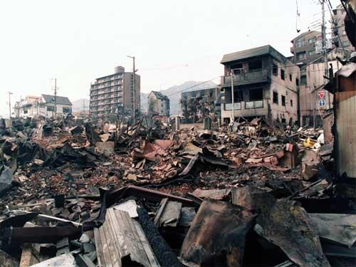

Earthquakes don’t kill people…

…Buildings do

2016

Gautam Sachdeva

The Heritage School

8/8/2016

# Acknowledgement

I would like to take this opportunity to thank all those that helped me with the making and execution of this project. My sincere gratitude towards my geography teacher Ms. Nishta ma’am for helping me and providing me with the opportunity to work on this project.

I would like to thank my family and friends in supporting me during the compilation of the project and also for their great suggestions regarding the project and the questionnaire, a special thanks to my brother who helped me bring this to life on the computer with his great formatting and typing speed.

I also thank all the people that answered my tedious questions with utmost patience and to the CBSE board for providing the opportunity to students to work on and develop projects.

Thank You

*Gautam Sachdeva*

# Index

Task 1: Understanding Disaster Management 3-5

Classification of Disasters 3

Social and Economic Effects of a disaster on a Community and a Nation 4

Disaster management I present Times 5

*Task 2: Disaster Preparedness (Survey in the Study Area)* *6-26*

Earthquakes 6

Questionnaires 7-25

Report 26

*Task 3: Mapping the Study Area* *27-33*

Social map 27-29

Park Area, Retreat Zone 27

Nearest Hospital (Max Super Specialty Hospital), Nearest Police Station 28

Fire Station 29

Vulnerable Locations map 30-31

Resource map 32

Evacuation Map 33

*Task 4: Building Safe Environment 34-40*

India’s Disaster Management 34

Some Terrestrial Disasters 35

Government Agencies in Disaster Management 36-37

How Do We Prepare Against Disasters? 38-39

Safe Community Builds Safe Nations 40

*Task 5: Generating Awareness 41*

Blog

*Annexure 42*

Questionnaire

*Bibliography 43*

Websites

Online PDF’S

Books

# Task 1: Understanding Disaster Management

*A disaster is a defined as a sudden accident or natural catastrophe that causes great damage or loss of life.*

*~Oxford Dictionary*

A disaster as defined by the Oxford dictionary as a sudden accident or natural catastrophe that causes great damage or loss of life.

## Classification of Disasters

|  |  |  |
| --- | --- | --- |
| Type of Disaster | Disaster Category | Examples |
| Natural Disasters | Geophysical | Earthquakes, Mass movement, Volcanic Activity |
| Meteorological | Extreme temperature, Fog, Storm |
| Hydrological | Flood, Landslide, Wave action |
| Climatological | Drought, Glacial lake outburst, wildfire |
| Biological | Insect Infestation, Epidemic, Animal Accident |
| Extraterrestrial | Impact, Space whether |
| Manmade Disasters | Industrial Accident | Chemical spill, collapse, explosion, fire, gas leak, poisoning, radiation |
| Transport Accident | Air, Road, Rail, Water |
| Miscellaneous accident | Collapse, explosion, fire, |

## C:\Users\Family\Desktop\earthquakes\e2.jpgSocial and Economic effects of Disasters on a Community and on a Nation

A disaster severely affects the growth and development of a region by halting it and also adversely affecting the progressive graph. It doesn’t call for a lot of aid, rather causes a lot of damage to the growing economic sector, calls for a migration and also desertion of many key businesses and industries causing a social decline in the lives of the people who have chosen to stay at the site of the disaster totally rendering their potential incapacitated and the area underwhelmed by investment ceasing all growth.

People are affected adversely in disaster struck regions. On experiencing a disaster firsthand which often accompanies the loss of family members or friends, economic losses, loss of a personal property like one’s house or car can cause severe psychological aggravation. Children can often be traumatized by such close contact with a disaster leaving them very frightened or in a state of panic. This may also cause them to develop certain phobias.

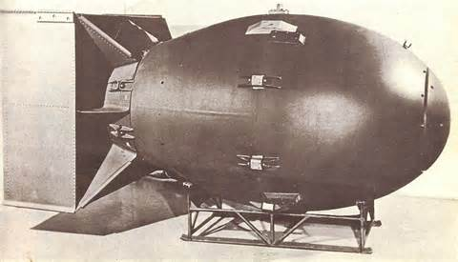Certain disasters can cause a prolonged effect on the affected region that can last for a much longer time than the imminent disaster lasts, e.g. a volcanic activity on any soil can leave that piece of land covered with solidified magma decreasing the economic value of the land and hence causing precious wastage of acres of land. The Hiroshima Nagasaki nuclear bombing of August 1945 has left the affected regions contaminated of nuclear resin which is still decaying at a very slow rate and even after containment has caused the mutation of many newborns in Japan for more than 70 years to come. This is how disasters can affect a piece of land economically and socially.

The outcomes of any disaster as we can see are unpleasant and degrading for the society and its development. Hence we need to integrate disaster risk reduction into development programs.

Development programs relate to the construction of buildings, urban complexes, malls, city planning, funds allocation to the various government institutes, water planning, gas pipeline planning etc. This planning needs to be made with respect to the population to cater their needs and also be integrated with disaster management to make them withstand the disasters, both natural and manmade. They need to be able to survive the disasters impact or in a worst case scenario they need to be completely shut down in case of any failure. The Bhopal tragedy was a manmade disaster that was caused by the faulty valve which did not close in case of emergency and led tones of water racing into the gas tanks causing it to expand exothermically and eventually explode, hence a machinery or system should not only be designed to face disaster, but also know how to shut down to prevent inadvertently causing it.

*We cannot stop natural disasters but we can arm ourselves with knowledge: so many lives wouldn't have to be lost if there was enough disaster preparedness.*

*~Petra Nemcova*

## Disaster management in Present Times

Disasters can strike at a highly unpredictable rate, although now we have the sophisticated machinery that can predict disasters such as wind storms, hurricanes and earthquakes to some extent, but that only gives us some extra time to evacuate, but we don’t have any tools to stop a natural disaster from taking place. This makes it important for us to have a contingency plan and be prepared.

We use several sophisticated methods I disaster risk reduction in the present times, such as fireproof paint and lacquer which when applied to walls prevents it from catching fire and can make any home or building completely fireproof.

Tall buildings deploy lightning cables that run to the Earth using a thick copper cable, which disperses the charge in the Earth and protects the building and its surroundings from lightning.

Another device that has recently been invented is the weight that is placed in a casket using a spring or suspended in a non-permeable liquid in a box on top of tall buildings to help them through earthquakes. The heavy blocks start to oscillate with the buildings, but due to their Inertia factor their oscillations are delayed and act against those of the building cancelling out the effect and reducing the effect.

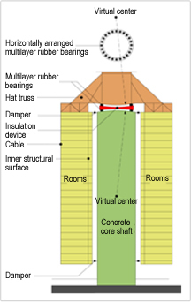The need to integrate the disaster risk reduction programs with general architecture and everyday tasks is very high as we need to be prepared against these disasters which can surface almost unpredictably.

There are several advantages of disaster risk reduction, primarily being the general safety of the people and citizens of the city and country. The disaster risk management reduces mortality rate, protects the infrastructure and keeps the intangible social structure of society intact even when some of our buildings have fallen, as the infrastructure for the mitigation of such disasters will be well in place and will kick into action as soon as the disaster has befallen, but if this government infrastructure is strong enough it will easily provide for the families that had to suffer in this disaster and will be quickly solved bringing the normal social equilibrium back into balance.

Hence we as concerned citizens and the government of their respective nations should be prepared for any disasters and should have a plan of mitigation for the worst that is possible which won’t ensure or safety, but give us peace of mind that we are prepared and not alone.

# Task 2: Disaster Preparedness

## Earthquakes

An earthquake is the perceptible shaking of the surface of the Earth, resulting from the sudden release of energy in the Earth's crust that creates seismic waves. Earthquakes can be violent enough to toss people around and destroy whole cities. At the Earth's surface, earthquakes manifest themselves by shaking and sometimes displacement of the ground. When the epicenter of a large earthquake is located offshore, the seabed may be displaced sufficiently to cause a tsunami. Earthquakes can also trigger landslides, and occasionally volcanic activity.

*Why did the earthquake and tsunami occur in Japan? Was it the act of an angry God? No, it was the result of the movement and collision of the earth's tectonic plates - a process driven by the earth's need to regulate its own internal temperature. Without the process that creates earthquake, our planet could not sustain life.  
~ Adam Hamilton*

In its most general sense, the word *earthquake* is used to describe any seismic event — whether natural or caused by humans — that generates seismic waves. Earthquakes are caused mostly by rupture of geological [faults](https://en.wikipedia.org/wiki/Fault_(geology)), but also by other events such as volcanic activity, landslides, mine blasts, and [nuclear tests](https://en.wikipedia.org/wiki/Underground_nuclear_testing). An earthquake's point of initial rupture is called its [focus](https://en.wikipedia.org/wiki/Focus_(earthquake)) or hypocenter. The [epicenter](https://en.wikipedia.org/wiki/Epicenter) is the point at ground level directly above the hypocenter.

The earth is composed of 7 tectonic plates and many intercontinental tectonic plates which slide on constantly m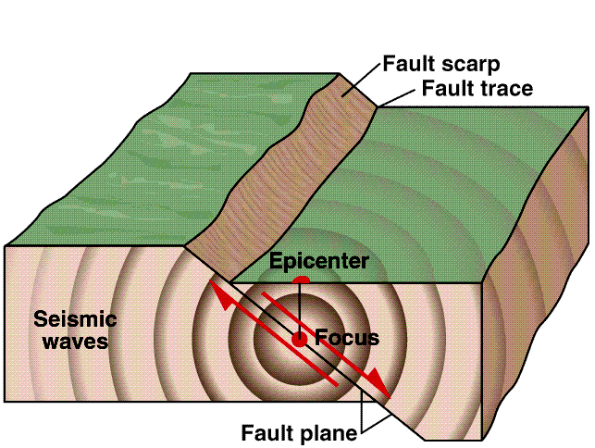oving currents of magma and molten metals. This creates tension, faults and collisions with other tectonic plates which sometimes leads to sliding over or sliding under releasing massive amounts of energy from the surface of the Earth causing seismic activity or Earthquakes.

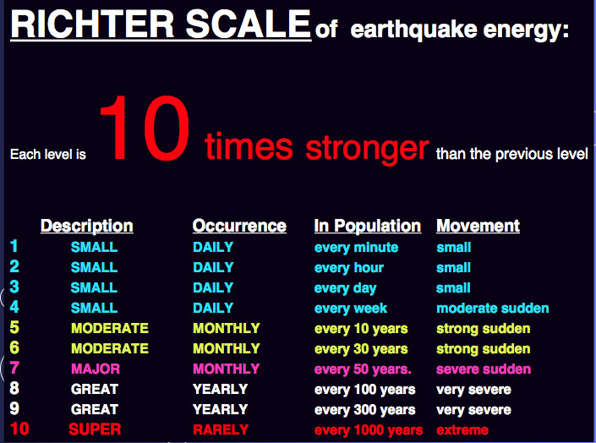The earthquakes and their magnitudes are measured on the Richter scale The Richter magnitude scale (also Richter scale) assigns a magnitude number to quantify the energy released by an [earthquake](https://en.wikipedia.org/wiki/Earthquake). The Richter scale, developed in the 1930s, is a [base-10](https://en.wikipedia.org/wiki/Decimal)[logarithmic scale](https://en.wikipedia.org/wiki/Logarithmic_scale), which defines magnitude as the logarithm of the ratio of the [amplitude](https://en.wikipedia.org/wiki/Amplitude) of the [seismic waves](https://en.wikipedia.org/wiki/Seismic_wave) to an arbitrary, minor amplitude.

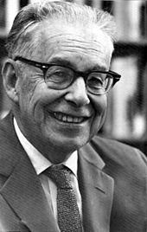As measured with a [seismometer](https://en.wikipedia.org/wiki/Seismometer), an earthquake that registers 5.0 on the Richter scale has shaking amplitude 10 times that of an earthquake that registered 4.0, and thus corresponds to a release of energy 31.6 times that released by the lesser earthquake. The Richter scale was succeeded in the 1970s by the [moment magnitude scale](https://en.wikipedia.org/wiki/Moment_magnitude_scale). The moment magnitude scale is now the scale used by the United States Geological Survey to estimate magnitudes for all modern large earthquakes.

Charles Francis Richter

## Questionnaire #1

Full Name\_\_\_\_\_\_\_\_\_\_\_\_\_\_\_\_\_\_\_\_\_\_\_\_\_\_\_\_\_\_\_\_\_\_\_\_\_\_\_\_\_\_\_\_\_\_\_\_\_\_\_\_\_\_\_\_\_\_\_\_\_\_\_\_\_\_\_\_\_\_\_\_\_\_\_\_\_\_\_\_\_\_\_\_\_

Age \_\_\_\_\_\_\_\_\_\_\_\_\_

Address\_\_\_\_\_\_\_\_\_\_\_\_\_\_\_\_\_\_\_\_\_\_\_\_\_\_\_\_\_\_\_\_\_\_\_\_\_\_\_\_\_\_\_\_\_\_\_\_\_\_\_\_\_\_\_\_\_\_\_\_\_\_\_\_\_\_\_\_\_\_\_\_\_\_\_\_\_\_\_\_\_\_\_\_\_\_\_\_

Job Occupation\_\_\_\_\_\_\_\_\_\_\_\_\_\_\_\_\_\_\_\_\_\_\_\_\_\_\_\_\_\_\_\_\_\_\_\_\_\_\_\_\_\_\_\_\_\_\_\_\_\_\_\_\_\_\_\_\_\_\_\_\_\_\_\_\_\_\_\_\_\_\_\_\_\_\_\_\_\_\_\_\_\_

What do you know about Earthquakes and the disaster that they can cause? \_\_\_\_\_\_\_\_\_\_\_\_\_\_\_\_\_\_\_\_\_\_\_\_\_\_\_\_\_\_\_\_\_\_\_\_\_\_\_\_\_\_\_\_\_\_\_\_\_\_\_\_\_\_\_\_\_\_\_\_\_\_\_\_\_\_\_\_\_\_\_\_\_\_\_\_\_\_\_\_\_\_\_\_\_\_\_\_\_\_\_\_\_\_\_\_\_\_\_\_\_\_\_\_\_\_\_\_\_\_\_\_\_\_\_\_\_\_\_\_\_\_\_\_\_\_\_\_\_\_\_\_\_\_\_\_\_\_\_\_\_\_\_\_\_\_\_\_\_\_\_\_\_\_\_\_\_\_\_\_\_\_\_\_\_\_\_\_\_\_\_\_\_\_\_\_\_\_\_\_\_\_\_\_\_\_\_\_\_\_\_\_\_\_\_\_\_\_\_\_\_\_\_\_\_\_\_\_\_\_\_\_\_\_\_\_\_\_\_\_\_\_\_\_\_\_\_\_\_\_\_\_\_\_\_\_\_\_\_\_\_\_\_\_\_\_\_\_\_\_\_\_\_\_\_\_\_\_\_\_\_\_\_\_\_\_\_\_\_\_\_\_\_\_\_\_\_\_\_\_\_\_

Is your shop/home prone to earthquakes?\_\_\_\_\_\_\_\_\_\_\_\_\_\_\_\_\_\_\_\_\_\_\_\_\_\_\_\_\_\_\_\_\_\_\_\_\_\_\_\_\_\_\_\_\_\_\_\_\_\_\_\_\_\_\_\_\_\_\_\_

Have you ever experienced any tremors in your lifetime? How did you respond to the situation? Did you panic? What did you do, please describe? \_\_\_\_\_\_\_\_\_\_\_\_\_\_\_\_\_\_\_\_\_\_\_\_\_\_\_\_\_\_\_\_\_\_\_\_\_\_\_\_\_\_\_\_\_\_\_\_\_\_\_\_\_\_\_\_\_\_\_\_\_\_\_\_\_\_\_\_\_\_\_\_\_\_\_\_\_\_\_\_\_\_\_\_\_\_\_\_\_\_\_\_\_\_\_\_\_\_\_\_\_\_\_\_\_\_\_\_\_\_\_\_\_\_\_\_\_\_\_\_\_\_\_\_\_\_\_\_\_\_\_\_\_\_\_\_\_\_\_\_\_\_\_\_\_\_\_\_\_\_\_\_\_\_\_\_\_\_\_\_\_\_\_\_\_\_\_\_\_\_\_\_\_\_\_\_\_\_\_\_\_\_\_\_\_\_\_\_\_\_\_\_\_\_\_\_\_\_\_\_\_\_\_\_\_\_\_\_\_\_\_\_\_\_\_\_\_\_\_\_\_\_\_\_\_\_\_\_\_\_\_\_\_\_\_\_\_\_\_\_\_\_\_\_\_\_\_\_\_\_\_\_\_\_\_\_\_\_\_\_\_\_\_\_\_\_\_\_\_\_\_\_\_\_\_\_\_\_\_\_\_\_\_\_\_\_\_\_\_\_\_\_\_\_\_\_\_\_\_\_\_\_\_\_\_\_\_\_\_\_\_\_\_\_\_\_\_\_\_\_\_\_\_\_\_\_\_\_\_\_\_\_\_\_\_\_\_\_\_\_\_\_\_\_\_\_\_\_\_\_\_\_\_\_\_\_\_\_\_\_\_\_\_\_\_\_\_\_\_\_\_\_\_\_\_\_

What would you do if you ever felt tremors at your shop? \_\_\_\_\_\_\_\_\_\_\_\_\_\_\_\_\_\_\_\_\_\_\_\_\_\_\_\_\_\_\_\_\_\_\_\_\_\_\_\_\_\_\_\_\_\_\_\_\_\_\_\_\_\_\_\_\_\_\_\_\_\_\_\_\_\_\_\_\_\_\_\_\_\_\_\_\_\_\_\_\_\_\_\_\_\_\_\_\_\_\_\_\_\_\_\_\_\_\_\_\_\_\_\_\_\_\_\_\_\_\_\_\_\_\_\_\_\_\_\_\_\_\_\_\_\_\_\_\_\_\_\_\_\_\_\_\_\_\_\_\_\_\_\_\_\_\_\_\_\_\_\_\_\_\_\_\_\_\_\_\_\_\_\_\_\_\_\_\_\_\_\_\_\_\_\_\_\_\_\_\_\_\_\_\_\_\_\_\_\_\_\_\_\_\_\_\_\_\_\_\_\_\_\_\_\_\_\_\_\_\_\_\_\_\_\_\_\_\_\_\_\_\_\_\_\_\_\_\_\_\_\_\_\_\_\_\_\_\_\_\_\_\_\_\_\_\_\_\_\_\_\_\_\_\_\_\_\_\_\_\_\_\_\_\_\_\_\_\_\_\_\_\_\_\_\_\_\_\_\_\_\_

Do you have any evacuation plan or any other contingency for such a happening? \_\_\_\_\_\_\_\_\_\_\_\_\_\_\_\_\_\_\_\_\_\_\_\_\_\_\_\_\_\_\_\_\_\_\_\_\_\_\_\_\_\_\_\_\_\_\_\_\_\_\_\_\_\_\_\_\_\_\_\_\_\_\_\_\_\_\_\_\_\_\_\_\_\_\_\_\_\_\_\_\_\_\_\_\_\_\_\_\_\_\_\_\_\_\_\_\_\_\_\_\_\_\_\_\_\_\_\_\_\_\_\_\_\_\_\_\_\_\_\_\_\_\_\_\_\_\_\_\_\_\_\_\_\_\_\_\_\_\_\_\_\_\_\_\_\_\_\_\_\_\_\_\_\_\_\_\_\_\_\_\_\_\_\_\_\_\_\_\_\_\_\_\_\_\_\_\_\_\_\_\_\_\_\_\_\_\_\_\_\_\_\_\_\_\_\_\_\_\_\_\_\_\_\_\_\_\_\_\_\_\_\_\_\_\_\_\_\_\_\_\_\_\_\_\_\_\_\_\_\_\_\_\_\_\_\_\_\_\_\_\_\_\_\_\_\_\_\_\_\_\_\_\_\_\_\_\_\_\_\_\_\_\_\_\_\_\_\_\_\_\_\_\_\_\_\_\_\_\_\_\_\_

Are you aware of the Richter scale and what do the readings mean? \_\_\_\_\_\_\_\_\_\_\_\_\_\_\_\_\_\_\_\_\_\_\_\_\_\_\_\_\_\_\_\_\_\_\_\_\_\_

What damage would an average earthquake of 5 Richter scale cause to your unit/home? \_\_\_\_\_\_\_\_\_\_\_\_\_\_\_\_\_\_\_\_\_\_\_\_\_\_\_\_\_\_\_\_\_\_\_\_\_\_\_\_\_\_\_\_\_\_\_\_\_\_\_\_\_\_\_\_\_\_\_\_\_\_\_\_\_\_\_\_\_\_\_\_\_\_\_\_\_\_\_\_\_\_\_\_\_\_\_\_\_\_\_\_\_\_\_\_\_\_\_\_\_\_\_\_\_\_\_\_\_\_\_\_\_\_\_\_\_\_\_\_\_\_\_\_\_\_\_\_\_\_\_\_\_\_\_\_\_\_\_\_\_\_\_\_\_\_\_\_\_\_\_\_\_\_\_\_\_\_\_\_\_\_\_\_\_\_\_\_\_\_\_\_\_\_\_\_\_\_\_\_\_\_\_\_\_\_\_\_

Have you ever taken part of a mock drill in your society or educational institute? ­­­­­­­­­­­­­­­­­­­­­­­­­­­­­­­­­­­­­­­­­­­­\_\_\_\_\_\_\_\_\_\_\_\_\_\_\_\_\_\_\_\_\_\_\_\_\_\_\_\_

Have you ever discussed disaster preparedness with your family and kids? \_\_\_\_\_\_\_\_\_\_\_\_\_\_\_\_\_\_\_\_\_\_\_\_\_\_\_\_\_\_\_\_\_

Do you have any resource in the building that can be used in case of a disaster emergency? \_\_\_\_\_\_\_\_\_\_\_\_\_\_\_\_\_\_\_\_\_\_\_\_\_\_\_\_\_\_\_\_\_\_\_\_\_\_\_\_\_\_\_\_\_\_\_\_\_\_\_\_\_\_\_\_\_\_\_\_\_\_\_\_\_\_\_\_\_\_\_\_\_\_\_\_\_\_\_\_\_\_\_\_\_\_\_\_\_\_\_\_\_\_\_\_\_\_\_\_\_\_\_\_\_\_\_\_\_\_\_\_\_\_\_\_\_\_\_\_\_\_\_\_\_\_\_\_\_\_\_\_\_\_\_\_\_\_\_\_\_\_\_\_\_\_\_\_\_\_\_\_\_\_\_\_\_\_\_\_\_\_\_\_\_\_\_\_\_\_\_\_\_\_\_\_\_\_\_\_\_\_\_\_\_\_\_\_\_\_\_\_\_\_\_\_\_\_\_\_\_\_\_\_\_\_\_\_\_\_\_\_\_\_\_\_\_\_\_\_\_\_\_\_\_\_\_\_\_\_\_\_\_\_\_\_\_\_\_\_\_\_\_\_\_\_\_\_\_\_\_\_\_\_\_\_\_\_

## Questionnaire #2

Full Name\_\_\_\_\_\_\_\_\_\_\_\_\_\_\_\_\_\_\_\_\_\_\_\_\_\_\_\_\_\_\_\_\_\_\_\_\_\_\_\_\_\_\_\_\_\_\_\_\_\_\_\_\_\_\_\_\_\_\_\_\_\_\_\_\_\_\_\_\_\_\_\_\_\_\_\_\_\_\_\_\_\_\_\_\_

Age \_\_\_\_\_\_\_\_\_\_\_\_\_

Address\_\_\_\_\_\_\_\_\_\_\_\_\_\_\_\_\_\_\_\_\_\_\_\_\_\_\_\_\_\_\_\_\_\_\_\_\_\_\_\_\_\_\_\_\_\_\_\_\_\_\_\_\_\_\_\_\_\_\_\_\_\_\_\_\_\_\_\_\_\_\_\_\_\_\_\_\_\_\_\_\_\_\_\_\_\_\_\_

Job Occupation\_\_\_\_\_\_\_\_\_\_\_\_\_\_\_\_\_\_\_\_\_\_\_\_\_\_\_\_\_\_\_\_\_\_\_\_\_\_\_\_\_\_\_\_\_\_\_\_\_\_\_\_\_\_\_\_\_\_\_\_\_\_\_\_\_\_\_\_\_\_\_\_\_\_\_\_\_\_\_\_\_\_

What do you know about Earthquakes and the disaster that they can cause? \_\_\_\_\_\_\_\_\_\_\_\_\_\_\_\_\_\_\_\_\_\_\_\_\_\_\_\_\_\_\_\_\_\_\_\_\_\_\_\_\_\_\_\_\_\_\_\_\_\_\_\_\_\_\_\_\_\_\_\_\_\_\_\_\_\_\_\_\_\_\_\_\_\_\_\_\_\_\_\_\_\_\_\_\_\_\_\_\_\_\_\_\_\_\_\_\_\_\_\_\_\_\_\_\_\_\_\_\_\_\_\_\_\_\_\_\_\_\_\_\_\_\_\_\_\_\_\_\_\_\_\_\_\_\_\_\_\_\_\_\_\_\_\_\_\_\_\_\_\_\_\_\_\_\_\_\_\_\_\_\_\_\_\_\_\_\_\_\_\_\_\_\_\_\_\_\_\_\_\_\_\_\_\_\_\_\_\_\_\_\_\_\_\_\_\_\_\_\_\_\_\_\_\_\_\_\_\_\_\_\_\_\_\_\_\_\_\_\_\_\_\_\_\_\_\_\_\_\_\_\_\_\_\_\_\_\_\_\_\_\_\_\_\_\_\_\_\_\_\_\_\_\_\_\_\_\_\_\_\_\_\_\_\_\_\_\_\_\_\_\_\_\_\_\_\_\_\_\_\_\_\_

Is your shop/home prone to earthquakes?\_\_\_\_\_\_\_\_\_\_\_\_\_\_\_\_\_\_\_\_\_\_\_\_\_\_\_\_\_\_\_\_\_\_\_\_\_\_\_\_\_\_\_\_\_\_\_\_\_\_\_\_\_\_\_\_\_\_\_\_

Have you ever experienced any tremors in your lifetime? How did you respond to the situation? Did you panic? What did you do, please describe? \_\_\_\_\_\_\_\_\_\_\_\_\_\_\_\_\_\_\_\_\_\_\_\_\_\_\_\_\_\_\_\_\_\_\_\_\_\_\_\_\_\_\_\_\_\_\_\_\_\_\_\_\_\_\_\_\_\_\_\_\_\_\_\_\_\_\_\_\_\_\_\_\_\_\_\_\_\_\_\_\_\_\_\_\_\_\_\_\_\_\_\_\_\_\_\_\_\_\_\_\_\_\_\_\_\_\_\_\_\_\_\_\_\_\_\_\_\_\_\_\_\_\_\_\_\_\_\_\_\_\_\_\_\_\_\_\_\_\_\_\_\_\_\_\_\_\_\_\_\_\_\_\_\_\_\_\_\_\_\_\_\_\_\_\_\_\_\_\_\_\_\_\_\_\_\_\_\_\_\_\_\_\_\_\_\_\_\_\_\_\_\_\_\_\_\_\_\_\_\_\_\_\_\_\_\_\_\_\_\_\_\_\_\_\_\_\_\_\_\_\_\_\_\_\_\_\_\_\_\_\_\_\_\_\_\_\_\_\_\_\_\_\_\_\_\_\_\_\_\_\_\_\_\_\_\_\_\_\_\_\_\_\_\_\_\_\_\_\_\_\_\_\_\_\_\_\_\_\_\_\_\_\_\_\_\_\_\_\_\_\_\_\_\_\_\_\_\_\_\_\_\_\_\_\_\_\_\_\_\_\_\_\_\_\_\_\_\_\_\_\_\_\_\_\_\_\_\_\_\_\_\_\_\_\_\_\_\_\_\_\_\_\_\_\_\_\_\_\_\_\_\_\_\_\_\_\_\_\_\_\_\_\_\_\_\_\_\_\_\_\_\_\_\_\_\_

What would you do if you ever felt tremors at your shop? \_\_\_\_\_\_\_\_\_\_\_\_\_\_\_\_\_\_\_\_\_\_\_\_\_\_\_\_\_\_\_\_\_\_\_\_\_\_\_\_\_\_\_\_\_\_\_\_\_\_\_\_\_\_\_\_\_\_\_\_\_\_\_\_\_\_\_\_\_\_\_\_\_\_\_\_\_\_\_\_\_\_\_\_\_\_\_\_\_\_\_\_\_\_\_\_\_\_\_\_\_\_\_\_\_\_\_\_\_\_\_\_\_\_\_\_\_\_\_\_\_\_\_\_\_\_\_\_\_\_\_\_\_\_\_\_\_\_\_\_\_\_\_\_\_\_\_\_\_\_\_\_\_\_\_\_\_\_\_\_\_\_\_\_\_\_\_\_\_\_\_\_\_\_\_\_\_\_\_\_\_\_\_\_\_\_\_\_\_\_\_\_\_\_\_\_\_\_\_\_\_\_\_\_\_\_\_\_\_\_\_\_\_\_\_\_\_\_\_\_\_\_\_\_\_\_\_\_\_\_\_\_\_\_\_\_\_\_\_\_\_\_\_\_\_\_\_\_\_\_\_\_\_\_\_\_\_\_\_\_\_\_\_\_\_\_\_\_\_\_\_\_\_\_\_\_\_\_\_\_\_\_

Do you have any evacuation plan or any other contingency for such a happening? \_\_\_\_\_\_\_\_\_\_\_\_\_\_\_\_\_\_\_\_\_\_\_\_\_\_\_\_\_\_\_\_\_\_\_\_\_\_\_\_\_\_\_\_\_\_\_\_\_\_\_\_\_\_\_\_\_\_\_\_\_\_\_\_\_\_\_\_\_\_\_\_\_\_\_\_\_\_\_\_\_\_\_\_\_\_\_\_\_\_\_\_\_\_\_\_\_\_\_\_\_\_\_\_\_\_\_\_\_\_\_\_\_\_\_\_\_\_\_\_\_\_\_\_\_\_\_\_\_\_\_\_\_\_\_\_\_\_\_\_\_\_\_\_\_\_\_\_\_\_\_\_\_\_\_\_\_\_\_\_\_\_\_\_\_\_\_\_\_\_\_\_\_\_\_\_\_\_\_\_\_\_\_\_\_\_\_\_\_\_\_\_\_\_\_\_\_\_\_\_\_\_\_\_\_\_\_\_\_\_\_\_\_\_\_\_\_\_\_\_\_\_\_\_\_\_\_\_\_\_\_\_\_\_\_\_\_\_\_\_\_\_\_\_\_\_\_\_\_\_\_\_\_\_\_\_\_\_\_\_\_\_\_\_\_\_\_\_\_\_\_\_\_\_\_\_\_\_\_\_\_\_

Are you aware of the Richter scale and what do the readings mean? \_\_\_\_\_\_\_\_\_\_\_\_\_\_\_\_\_\_\_\_\_\_\_\_\_\_\_\_\_\_\_\_\_\_\_\_\_\_

What damage would an average earthquake of 5 Richter scale cause to your unit/home? \_\_\_\_\_\_\_\_\_\_\_\_\_\_\_\_\_\_\_\_\_\_\_\_\_\_\_\_\_\_\_\_\_\_\_\_\_\_\_\_\_\_\_\_\_\_\_\_\_\_\_\_\_\_\_\_\_\_\_\_\_\_\_\_\_\_\_\_\_\_\_\_\_\_\_\_\_\_\_\_\_\_\_\_\_\_\_\_\_\_\_\_\_\_\_\_\_\_\_\_\_\_\_\_\_\_\_\_\_\_\_\_\_\_\_\_\_\_\_\_\_\_\_\_\_\_\_\_\_\_\_\_\_\_\_\_\_\_\_\_\_\_\_\_\_\_\_\_\_\_\_\_\_\_\_\_\_\_\_\_\_\_\_\_\_\_\_\_\_\_\_\_\_\_\_\_\_\_\_\_\_\_\_\_\_\_\_\_

Have you ever taken part of a mock drill in your society or educational institute? ­­­­­­­­­­­­­­­­­­­­­­­­­­­­­­­­­­­­­­­­­­­­\_\_\_\_\_\_\_\_\_\_\_\_\_\_\_\_\_\_\_\_\_\_\_\_\_\_\_\_

Have you ever discussed disaster preparedness with your family and kids? \_\_\_\_\_\_\_\_\_\_\_\_\_\_\_\_\_\_\_\_\_\_\_\_\_\_\_\_\_\_\_\_\_

Do you have any resource in the building that can be used in case of a disaster emergency? \_\_\_\_\_\_\_\_\_\_\_\_\_\_\_\_\_\_\_\_\_\_\_\_\_\_\_\_\_\_\_\_\_\_\_\_\_\_\_\_\_\_\_\_\_\_\_\_\_\_\_\_\_\_\_\_\_\_\_\_\_\_\_\_\_\_\_\_\_\_\_\_\_\_\_\_\_\_\_\_\_\_\_\_\_\_\_\_\_\_\_\_\_\_\_\_\_\_\_\_\_\_\_\_\_\_\_\_\_\_\_\_\_\_\_\_\_\_\_\_\_\_\_\_\_\_\_\_\_\_\_\_\_\_\_\_\_\_\_\_\_\_\_\_\_\_\_\_\_\_\_\_\_\_\_\_\_\_\_\_\_\_\_\_\_\_\_\_\_\_\_\_\_\_\_\_\_\_\_\_\_\_\_\_\_\_\_\_\_\_\_\_\_\_\_\_\_\_\_\_\_\_\_\_\_\_\_\_\_\_\_\_\_\_\_\_\_\_\_\_\_\_\_\_\_\_\_\_\_\_\_\_\_\_\_\_\_\_\_\_\_\_\_\_\_\_\_\_\_\_\_\_\_\_\_\_\_\_

## Questionnaire #3

Full Name\_\_\_\_\_\_\_\_\_\_\_\_\_\_\_\_\_\_\_\_\_\_\_\_\_\_\_\_\_\_\_\_\_\_\_\_\_\_\_\_\_\_\_\_\_\_\_\_\_\_\_\_\_\_\_\_\_\_\_\_\_\_\_\_\_\_\_\_\_\_\_\_\_\_\_\_\_\_\_\_\_\_\_\_\_

Age \_\_\_\_\_\_\_\_\_\_\_\_\_

Address\_\_\_\_\_\_\_\_\_\_\_\_\_\_\_\_\_\_\_\_\_\_\_\_\_\_\_\_\_\_\_\_\_\_\_\_\_\_\_\_\_\_\_\_\_\_\_\_\_\_\_\_\_\_\_\_\_\_\_\_\_\_\_\_\_\_\_\_\_\_\_\_\_\_\_\_\_\_\_\_\_\_\_\_\_\_\_\_

Job Occupation\_\_\_\_\_\_\_\_\_\_\_\_\_\_\_\_\_\_\_\_\_\_\_\_\_\_\_\_\_\_\_\_\_\_\_\_\_\_\_\_\_\_\_\_\_\_\_\_\_\_\_\_\_\_\_\_\_\_\_\_\_\_\_\_\_\_\_\_\_\_\_\_\_\_\_\_\_\_\_\_\_\_

What do you know about Earthquakes and the disaster that they can cause? \_\_\_\_\_\_\_\_\_\_\_\_\_\_\_\_\_\_\_\_\_\_\_\_\_\_\_\_\_\_\_\_\_\_\_\_\_\_\_\_\_\_\_\_\_\_\_\_\_\_\_\_\_\_\_\_\_\_\_\_\_\_\_\_\_\_\_\_\_\_\_\_\_\_\_\_\_\_\_\_\_\_\_\_\_\_\_\_\_\_\_\_\_\_\_\_\_\_\_\_\_\_\_\_\_\_\_\_\_\_\_\_\_\_\_\_\_\_\_\_\_\_\_\_\_\_\_\_\_\_\_\_\_\_\_\_\_\_\_\_\_\_\_\_\_\_\_\_\_\_\_\_\_\_\_\_\_\_\_\_\_\_\_\_\_\_\_\_\_\_\_\_\_\_\_\_\_\_\_\_\_\_\_\_\_\_\_\_\_\_\_\_\_\_\_\_\_\_\_\_\_\_\_\_\_\_\_\_\_\_\_\_\_\_\_\_\_\_\_\_\_\_\_\_\_\_\_\_\_\_\_\_\_\_\_\_\_\_\_\_\_\_\_\_\_\_\_\_\_\_\_\_\_\_\_\_\_\_\_\_\_\_\_\_\_\_\_\_\_\_\_\_\_\_\_\_\_\_\_\_\_\_

Is your shop/home prone to earthquakes?\_\_\_\_\_\_\_\_\_\_\_\_\_\_\_\_\_\_\_\_\_\_\_\_\_\_\_\_\_\_\_\_\_\_\_\_\_\_\_\_\_\_\_\_\_\_\_\_\_\_\_\_\_\_\_\_\_\_\_\_

Have you ever experienced any tremors in your lifetime? How did you respond to the situation? Did you panic? What did you do, please describe? \_\_\_\_\_\_\_\_\_\_\_\_\_\_\_\_\_\_\_\_\_\_\_\_\_\_\_\_\_\_\_\_\_\_\_\_\_\_\_\_\_\_\_\_\_\_\_\_\_\_\_\_\_\_\_\_\_\_\_\_\_\_\_\_\_\_\_\_\_\_\_\_\_\_\_\_\_\_\_\_\_\_\_\_\_\_\_\_\_\_\_\_\_\_\_\_\_\_\_\_\_\_\_\_\_\_\_\_\_\_\_\_\_\_\_\_\_\_\_\_\_\_\_\_\_\_\_\_\_\_\_\_\_\_\_\_\_\_\_\_\_\_\_\_\_\_\_\_\_\_\_\_\_\_\_\_\_\_\_\_\_\_\_\_\_\_\_\_\_\_\_\_\_\_\_\_\_\_\_\_\_\_\_\_\_\_\_\_\_\_\_\_\_\_\_\_\_\_\_\_\_\_\_\_\_\_\_\_\_\_\_\_\_\_\_\_\_\_\_\_\_\_\_\_\_\_\_\_\_\_\_\_\_\_\_\_\_\_\_\_\_\_\_\_\_\_\_\_\_\_\_\_\_\_\_\_\_\_\_\_\_\_\_\_\_\_\_\_\_\_\_\_\_\_\_\_\_\_\_\_\_\_\_\_\_\_\_\_\_\_\_\_\_\_\_\_\_\_\_\_\_\_\_\_\_\_\_\_\_\_\_\_\_\_\_\_\_\_\_\_\_\_\_\_\_\_\_\_\_\_\_\_\_\_\_\_\_\_\_\_\_\_\_\_\_\_\_\_\_\_\_\_\_\_\_\_\_\_\_\_\_\_\_\_\_\_\_\_\_\_\_\_\_\_\_\_

What would you do if you ever felt tremors at your shop? \_\_\_\_\_\_\_\_\_\_\_\_\_\_\_\_\_\_\_\_\_\_\_\_\_\_\_\_\_\_\_\_\_\_\_\_\_\_\_\_\_\_\_\_\_\_\_\_\_\_\_\_\_\_\_\_\_\_\_\_\_\_\_\_\_\_\_\_\_\_\_\_\_\_\_\_\_\_\_\_\_\_\_\_\_\_\_\_\_\_\_\_\_\_\_\_\_\_\_\_\_\_\_\_\_\_\_\_\_\_\_\_\_\_\_\_\_\_\_\_\_\_\_\_\_\_\_\_\_\_\_\_\_\_\_\_\_\_\_\_\_\_\_\_\_\_\_\_\_\_\_\_\_\_\_\_\_\_\_\_\_\_\_\_\_\_\_\_\_\_\_\_\_\_\_\_\_\_\_\_\_\_\_\_\_\_\_\_\_\_\_\_\_\_\_\_\_\_\_\_\_\_\_\_\_\_\_\_\_\_\_\_\_\_\_\_\_\_\_\_\_\_\_\_\_\_\_\_\_\_\_\_\_\_\_\_\_\_\_\_\_\_\_\_\_\_\_\_\_\_\_\_\_\_\_\_\_\_\_\_\_\_\_\_\_\_\_\_\_\_\_\_\_\_\_\_\_\_\_\_\_\_

Do you have any evacuation plan or any other contingency for such a happening? \_\_\_\_\_\_\_\_\_\_\_\_\_\_\_\_\_\_\_\_\_\_\_\_\_\_\_\_\_\_\_\_\_\_\_\_\_\_\_\_\_\_\_\_\_\_\_\_\_\_\_\_\_\_\_\_\_\_\_\_\_\_\_\_\_\_\_\_\_\_\_\_\_\_\_\_\_\_\_\_\_\_\_\_\_\_\_\_\_\_\_\_\_\_\_\_\_\_\_\_\_\_\_\_\_\_\_\_\_\_\_\_\_\_\_\_\_\_\_\_\_\_\_\_\_\_\_\_\_\_\_\_\_\_\_\_\_\_\_\_\_\_\_\_\_\_\_\_\_\_\_\_\_\_\_\_\_\_\_\_\_\_\_\_\_\_\_\_\_\_\_\_\_\_\_\_\_\_\_\_\_\_\_\_\_\_\_\_\_\_\_\_\_\_\_\_\_\_\_\_\_\_\_\_\_\_\_\_\_\_\_\_\_\_\_\_\_\_\_\_\_\_\_\_\_\_\_\_\_\_\_\_\_\_\_\_\_\_\_\_\_\_\_\_\_\_\_\_\_\_\_\_\_\_\_\_\_\_\_\_\_\_\_\_\_\_\_\_\_\_\_\_\_\_\_\_\_\_\_\_\_\_

Are you aware of the Richter scale and what do the readings mean? \_\_\_\_\_\_\_\_\_\_\_\_\_\_\_\_\_\_\_\_\_\_\_\_\_\_\_\_\_\_\_\_\_\_\_\_\_\_

What damage would an average earthquake of 5 Richter scale cause to your unit/home? \_\_\_\_\_\_\_\_\_\_\_\_\_\_\_\_\_\_\_\_\_\_\_\_\_\_\_\_\_\_\_\_\_\_\_\_\_\_\_\_\_\_\_\_\_\_\_\_\_\_\_\_\_\_\_\_\_\_\_\_\_\_\_\_\_\_\_\_\_\_\_\_\_\_\_\_\_\_\_\_\_\_\_\_\_\_\_\_\_\_\_\_\_\_\_\_\_\_\_\_\_\_\_\_\_\_\_\_\_\_\_\_\_\_\_\_\_\_\_\_\_\_\_\_\_\_\_\_\_\_\_\_\_\_\_\_\_\_\_\_\_\_\_\_\_\_\_\_\_\_\_\_\_\_\_\_\_\_\_\_\_\_\_\_\_\_\_\_\_\_\_\_\_\_\_\_\_\_\_\_\_\_\_\_\_\_\_\_

Have you ever taken part of a mock drill in your society or educational institute? ­­­­­­­­­­­­­­­­­­­­­­­­­­­­­­­­­­­­­­­­­­­­\_\_\_\_\_\_\_\_\_\_\_\_\_\_\_\_\_\_\_\_\_\_\_\_\_\_\_\_

Have you ever discussed disaster preparedness with your family and kids? \_\_\_\_\_\_\_\_\_\_\_\_\_\_\_\_\_\_\_\_\_\_\_\_\_\_\_\_\_\_\_\_\_

Do you have any resource in the building that can be used in case of a disaster emergency? \_\_\_\_\_\_\_\_\_\_\_\_\_\_\_\_\_\_\_\_\_\_\_\_\_\_\_\_\_\_\_\_\_\_\_\_\_\_\_\_\_\_\_\_\_\_\_\_\_\_\_\_\_\_\_\_\_\_\_\_\_\_\_\_\_\_\_\_\_\_\_\_\_\_\_\_\_\_\_\_\_\_\_\_\_\_\_\_\_\_\_\_\_\_\_\_\_\_\_\_\_\_\_\_\_\_\_\_\_\_\_\_\_\_\_\_\_\_\_\_\_\_\_\_\_\_\_\_\_\_\_\_\_\_\_\_\_\_\_\_\_\_\_\_\_\_\_\_\_\_\_\_\_\_\_\_\_\_\_\_\_\_\_\_\_\_\_\_\_\_\_\_\_\_\_\_\_\_\_\_\_\_\_\_\_\_\_\_\_\_\_\_\_\_\_\_\_\_\_\_\_\_\_\_\_\_\_\_\_\_\_\_\_\_\_\_\_\_\_\_\_\_\_\_\_\_\_\_\_\_\_\_\_\_\_\_\_\_\_\_\_\_\_\_\_\_\_\_\_\_\_\_\_\_\_\_\_\_

## Questionnaire #4

Full Name\_\_\_\_\_\_\_\_\_\_\_\_\_\_\_\_\_\_\_\_\_\_\_\_\_\_\_\_\_\_\_\_\_\_\_\_\_\_\_\_\_\_\_\_\_\_\_\_\_\_\_\_\_\_\_\_\_\_\_\_\_\_\_\_\_\_\_\_\_\_\_\_\_\_\_\_\_\_\_\_\_\_\_\_\_

Age \_\_\_\_\_\_\_\_\_\_\_\_\_

Address\_\_\_\_\_\_\_\_\_\_\_\_\_\_\_\_\_\_\_\_\_\_\_\_\_\_\_\_\_\_\_\_\_\_\_\_\_\_\_\_\_\_\_\_\_\_\_\_\_\_\_\_\_\_\_\_\_\_\_\_\_\_\_\_\_\_\_\_\_\_\_\_\_\_\_\_\_\_\_\_\_\_\_\_\_\_\_\_

Job Occupation\_\_\_\_\_\_\_\_\_\_\_\_\_\_\_\_\_\_\_\_\_\_\_\_\_\_\_\_\_\_\_\_\_\_\_\_\_\_\_\_\_\_\_\_\_\_\_\_\_\_\_\_\_\_\_\_\_\_\_\_\_\_\_\_\_\_\_\_\_\_\_\_\_\_\_\_\_\_\_\_\_\_

What do you know about Earthquakes and the disaster that they can cause? \_\_\_\_\_\_\_\_\_\_\_\_\_\_\_\_\_\_\_\_\_\_\_\_\_\_\_\_\_\_\_\_\_\_\_\_\_\_\_\_\_\_\_\_\_\_\_\_\_\_\_\_\_\_\_\_\_\_\_\_\_\_\_\_\_\_\_\_\_\_\_\_\_\_\_\_\_\_\_\_\_\_\_\_\_\_\_\_\_\_\_\_\_\_\_\_\_\_\_\_\_\_\_\_\_\_\_\_\_\_\_\_\_\_\_\_\_\_\_\_\_\_\_\_\_\_\_\_\_\_\_\_\_\_\_\_\_\_\_\_\_\_\_\_\_\_\_\_\_\_\_\_\_\_\_\_\_\_\_\_\_\_\_\_\_\_\_\_\_\_\_\_\_\_\_\_\_\_\_\_\_\_\_\_\_\_\_\_\_\_\_\_\_\_\_\_\_\_\_\_\_\_\_\_\_\_\_\_\_\_\_\_\_\_\_\_\_\_\_\_\_\_\_\_\_\_\_\_\_\_\_\_\_\_\_\_\_\_\_\_\_\_\_\_\_\_\_\_\_\_\_\_\_\_\_\_\_\_\_\_\_\_\_\_\_\_\_\_\_\_\_\_\_\_\_\_\_\_\_\_\_\_

Is your shop/home prone to earthquakes?\_\_\_\_\_\_\_\_\_\_\_\_\_\_\_\_\_\_\_\_\_\_\_\_\_\_\_\_\_\_\_\_\_\_\_\_\_\_\_\_\_\_\_\_\_\_\_\_\_\_\_\_\_\_\_\_\_\_\_\_

Have you ever experienced any tremors in your lifetime? How did you respond to the situation? Did you panic? What did you do, please describe? \_\_\_\_\_\_\_\_\_\_\_\_\_\_\_\_\_\_\_\_\_\_\_\_\_\_\_\_\_\_\_\_\_\_\_\_\_\_\_\_\_\_\_\_\_\_\_\_\_\_\_\_\_\_\_\_\_\_\_\_\_\_\_\_\_\_\_\_\_\_\_\_\_\_\_\_\_\_\_\_\_\_\_\_\_\_\_\_\_\_\_\_\_\_\_\_\_\_\_\_\_\_\_\_\_\_\_\_\_\_\_\_\_\_\_\_\_\_\_\_\_\_\_\_\_\_\_\_\_\_\_\_\_\_\_\_\_\_\_\_\_\_\_\_\_\_\_\_\_\_\_\_\_\_\_\_\_\_\_\_\_\_\_\_\_\_\_\_\_\_\_\_\_\_\_\_\_\_\_\_\_\_\_\_\_\_\_\_\_\_\_\_\_\_\_\_\_\_\_\_\_\_\_\_\_\_\_\_\_\_\_\_\_\_\_\_\_\_\_\_\_\_\_\_\_\_\_\_\_\_\_\_\_\_\_\_\_\_\_\_\_\_\_\_\_\_\_\_\_\_\_\_\_\_\_\_\_\_\_\_\_\_\_\_\_\_\_\_\_\_\_\_\_\_\_\_\_\_\_\_\_\_\_\_\_\_\_\_\_\_\_\_\_\_\_\_\_\_\_\_\_\_\_\_\_\_\_\_\_\_\_\_\_\_\_\_\_\_\_\_\_\_\_\_\_\_\_\_\_\_\_\_\_\_\_\_\_\_\_\_\_\_\_\_\_\_\_\_\_\_\_\_\_\_\_\_\_\_\_\_\_\_\_\_\_\_\_\_\_\_\_\_\_\_\_\_

What would you do if you ever felt tremors at your shop? \_\_\_\_\_\_\_\_\_\_\_\_\_\_\_\_\_\_\_\_\_\_\_\_\_\_\_\_\_\_\_\_\_\_\_\_\_\_\_\_\_\_\_\_\_\_\_\_\_\_\_\_\_\_\_\_\_\_\_\_\_\_\_\_\_\_\_\_\_\_\_\_\_\_\_\_\_\_\_\_\_\_\_\_\_\_\_\_\_\_\_\_\_\_\_\_\_\_\_\_\_\_\_\_\_\_\_\_\_\_\_\_\_\_\_\_\_\_\_\_\_\_\_\_\_\_\_\_\_\_\_\_\_\_\_\_\_\_\_\_\_\_\_\_\_\_\_\_\_\_\_\_\_\_\_\_\_\_\_\_\_\_\_\_\_\_\_\_\_\_\_\_\_\_\_\_\_\_\_\_\_\_\_\_\_\_\_\_\_\_\_\_\_\_\_\_\_\_\_\_\_\_\_\_\_\_\_\_\_\_\_\_\_\_\_\_\_\_\_\_\_\_\_\_\_\_\_\_\_\_\_\_\_\_\_\_\_\_\_\_\_\_\_\_\_\_\_\_\_\_\_\_\_\_\_\_\_\_\_\_\_\_\_\_\_\_\_\_\_\_\_\_\_\_\_\_\_\_\_\_\_\_

Do you have any evacuation plan or any other contingency for such a happening? \_\_\_\_\_\_\_\_\_\_\_\_\_\_\_\_\_\_\_\_\_\_\_\_\_\_\_\_\_\_\_\_\_\_\_\_\_\_\_\_\_\_\_\_\_\_\_\_\_\_\_\_\_\_\_\_\_\_\_\_\_\_\_\_\_\_\_\_\_\_\_\_\_\_\_\_\_\_\_\_\_\_\_\_\_\_\_\_\_\_\_\_\_\_\_\_\_\_\_\_\_\_\_\_\_\_\_\_\_\_\_\_\_\_\_\_\_\_\_\_\_\_\_\_\_\_\_\_\_\_\_\_\_\_\_\_\_\_\_\_\_\_\_\_\_\_\_\_\_\_\_\_\_\_\_\_\_\_\_\_\_\_\_\_\_\_\_\_\_\_\_\_\_\_\_\_\_\_\_\_\_\_\_\_\_\_\_\_\_\_\_\_\_\_\_\_\_\_\_\_\_\_\_\_\_\_\_\_\_\_\_\_\_\_\_\_\_\_\_\_\_\_\_\_\_\_\_\_\_\_\_\_\_\_\_\_\_\_\_\_\_\_\_\_\_\_\_\_\_\_\_\_\_\_\_\_\_\_\_\_\_\_\_\_\_\_\_\_\_\_\_\_\_\_\_\_\_\_\_\_\_\_

Are you aware of the Richter scale and what do the readings mean? \_\_\_\_\_\_\_\_\_\_\_\_\_\_\_\_\_\_\_\_\_\_\_\_\_\_\_\_\_\_\_\_\_\_\_\_\_\_

What damage would an average earthquake of 5 Richter scale cause to your unit/home? \_\_\_\_\_\_\_\_\_\_\_\_\_\_\_\_\_\_\_\_\_\_\_\_\_\_\_\_\_\_\_\_\_\_\_\_\_\_\_\_\_\_\_\_\_\_\_\_\_\_\_\_\_\_\_\_\_\_\_\_\_\_\_\_\_\_\_\_\_\_\_\_\_\_\_\_\_\_\_\_\_\_\_\_\_\_\_\_\_\_\_\_\_\_\_\_\_\_\_\_\_\_\_\_\_\_\_\_\_\_\_\_\_\_\_\_\_\_\_\_\_\_\_\_\_\_\_\_\_\_\_\_\_\_\_\_\_\_\_\_\_\_\_\_\_\_\_\_\_\_\_\_\_\_\_\_\_\_\_\_\_\_\_\_\_\_\_\_\_\_\_\_\_\_\_\_\_\_\_\_\_\_\_\_\_\_\_\_

Have you ever taken part of a mock drill in your society or educational institute? ­­­­­­­­­­­­­­­­­­­­­­­­­­­­­­­­­­­­­­­­­­­­\_\_\_\_\_\_\_\_\_\_\_\_\_\_\_\_\_\_\_\_\_\_\_\_\_\_\_\_

Have you ever discussed disaster preparedness with your family and kids? \_\_\_\_\_\_\_\_\_\_\_\_\_\_\_\_\_\_\_\_\_\_\_\_\_\_\_\_\_\_\_\_\_

Do you have any resource in the building that can be used in case of a disaster emergency? \_\_\_\_\_\_\_\_\_\_\_\_\_\_\_\_\_\_\_\_\_\_\_\_\_\_\_\_\_\_\_\_\_\_\_\_\_\_\_\_\_\_\_\_\_\_\_\_\_\_\_\_\_\_\_\_\_\_\_\_\_\_\_\_\_\_\_\_\_\_\_\_\_\_\_\_\_\_\_\_\_\_\_\_\_\_\_\_\_\_\_\_\_\_\_\_\_\_\_\_\_\_\_\_\_\_\_\_\_\_\_\_\_\_\_\_\_\_\_\_\_\_\_\_\_\_\_\_\_\_\_\_\_\_\_\_\_\_\_\_\_\_\_\_\_\_\_\_\_\_\_\_\_\_\_\_\_\_\_\_\_\_\_\_\_\_\_\_\_\_\_\_\_\_\_\_\_\_\_\_\_\_\_\_\_\_\_\_\_\_\_\_\_\_\_\_\_\_\_\_\_\_\_\_\_\_\_\_\_\_\_\_\_\_\_\_\_\_\_\_\_\_\_\_\_\_\_\_\_\_\_\_\_\_\_\_\_\_\_\_\_\_\_\_\_\_\_\_\_\_\_\_\_\_\_\_\_\_

## Questionnaire #5

Full Name\_\_\_\_\_\_\_\_\_\_\_\_\_\_\_\_\_\_\_\_\_\_\_\_\_\_\_\_\_\_\_\_\_\_\_\_\_\_\_\_\_\_\_\_\_\_\_\_\_\_\_\_\_\_\_\_\_\_\_\_\_\_\_\_\_\_\_\_\_\_\_\_\_\_\_\_\_\_\_\_\_\_\_\_\_

Age \_\_\_\_\_\_\_\_\_\_\_\_\_

Address\_\_\_\_\_\_\_\_\_\_\_\_\_\_\_\_\_\_\_\_\_\_\_\_\_\_\_\_\_\_\_\_\_\_\_\_\_\_\_\_\_\_\_\_\_\_\_\_\_\_\_\_\_\_\_\_\_\_\_\_\_\_\_\_\_\_\_\_\_\_\_\_\_\_\_\_\_\_\_\_\_\_\_\_\_\_\_\_

Job Occupation\_\_\_\_\_\_\_\_\_\_\_\_\_\_\_\_\_\_\_\_\_\_\_\_\_\_\_\_\_\_\_\_\_\_\_\_\_\_\_\_\_\_\_\_\_\_\_\_\_\_\_\_\_\_\_\_\_\_\_\_\_\_\_\_\_\_\_\_\_\_\_\_\_\_\_\_\_\_\_\_\_\_

What do you know about Earthquakes and the disaster that they can cause? \_\_\_\_\_\_\_\_\_\_\_\_\_\_\_\_\_\_\_\_\_\_\_\_\_\_\_\_\_\_\_\_\_\_\_\_\_\_\_\_\_\_\_\_\_\_\_\_\_\_\_\_\_\_\_\_\_\_\_\_\_\_\_\_\_\_\_\_\_\_\_\_\_\_\_\_\_\_\_\_\_\_\_\_\_\_\_\_\_\_\_\_\_\_\_\_\_\_\_\_\_\_\_\_\_\_\_\_\_\_\_\_\_\_\_\_\_\_\_\_\_\_\_\_\_\_\_\_\_\_\_\_\_\_\_\_\_\_\_\_\_\_\_\_\_\_\_\_\_\_\_\_\_\_\_\_\_\_\_\_\_\_\_\_\_\_\_\_\_\_\_\_\_\_\_\_\_\_\_\_\_\_\_\_\_\_\_\_\_\_\_\_\_\_\_\_\_\_\_\_\_\_\_\_\_\_\_\_\_\_\_\_\_\_\_\_\_\_\_\_\_\_\_\_\_\_\_\_\_\_\_\_\_\_\_\_\_\_\_\_\_\_\_\_\_\_\_\_\_\_\_\_\_\_\_\_\_\_\_\_\_\_\_\_\_\_\_\_\_\_\_\_\_\_\_\_\_\_\_\_\_\_

Is your shop/home prone to earthquakes?\_\_\_\_\_\_\_\_\_\_\_\_\_\_\_\_\_\_\_\_\_\_\_\_\_\_\_\_\_\_\_\_\_\_\_\_\_\_\_\_\_\_\_\_\_\_\_\_\_\_\_\_\_\_\_\_\_\_\_\_

Have you ever experienced any tremors in your lifetime? How did you respond to the situation? Did you panic? What did you do, please describe? \_\_\_\_\_\_\_\_\_\_\_\_\_\_\_\_\_\_\_\_\_\_\_\_\_\_\_\_\_\_\_\_\_\_\_\_\_\_\_\_\_\_\_\_\_\_\_\_\_\_\_\_\_\_\_\_\_\_\_\_\_\_\_\_\_\_\_\_\_\_\_\_\_\_\_\_\_\_\_\_\_\_\_\_\_\_\_\_\_\_\_\_\_\_\_\_\_\_\_\_\_\_\_\_\_\_\_\_\_\_\_\_\_\_\_\_\_\_\_\_\_\_\_\_\_\_\_\_\_\_\_\_\_\_\_\_\_\_\_\_\_\_\_\_\_\_\_\_\_\_\_\_\_\_\_\_\_\_\_\_\_\_\_\_\_\_\_\_\_\_\_\_\_\_\_\_\_\_\_\_\_\_\_\_\_\_\_\_\_\_\_\_\_\_\_\_\_\_\_\_\_\_\_\_\_\_\_\_\_\_\_\_\_\_\_\_\_\_\_\_\_\_\_\_\_\_\_\_\_\_\_\_\_\_\_\_\_\_\_\_\_\_\_\_\_\_\_\_\_\_\_\_\_\_\_\_\_\_\_\_\_\_\_\_\_\_\_\_\_\_\_\_\_\_\_\_\_\_\_\_\_\_\_\_\_\_\_\_\_\_\_\_\_\_\_\_\_\_\_\_\_\_\_\_\_\_\_\_\_\_\_\_\_\_\_\_\_\_\_\_\_\_\_\_\_\_\_\_\_\_\_\_\_\_\_\_\_\_\_\_\_\_\_\_\_\_\_\_\_\_\_\_\_\_\_\_\_\_\_\_\_\_\_\_\_\_\_\_\_\_\_\_\_\_\_\_

What would you do if you ever felt tremors at your shop? \_\_\_\_\_\_\_\_\_\_\_\_\_\_\_\_\_\_\_\_\_\_\_\_\_\_\_\_\_\_\_\_\_\_\_\_\_\_\_\_\_\_\_\_\_\_\_\_\_\_\_\_\_\_\_\_\_\_\_\_\_\_\_\_\_\_\_\_\_\_\_\_\_\_\_\_\_\_\_\_\_\_\_\_\_\_\_\_\_\_\_\_\_\_\_\_\_\_\_\_\_\_\_\_\_\_\_\_\_\_\_\_\_\_\_\_\_\_\_\_\_\_\_\_\_\_\_\_\_\_\_\_\_\_\_\_\_\_\_\_\_\_\_\_\_\_\_\_\_\_\_\_\_\_\_\_\_\_\_\_\_\_\_\_\_\_\_\_\_\_\_\_\_\_\_\_\_\_\_\_\_\_\_\_\_\_\_\_\_\_\_\_\_\_\_\_\_\_\_\_\_\_\_\_\_\_\_\_\_\_\_\_\_\_\_\_\_\_\_\_\_\_\_\_\_\_\_\_\_\_\_\_\_\_\_\_\_\_\_\_\_\_\_\_\_\_\_\_\_\_\_\_\_\_\_\_\_\_\_\_\_\_\_\_\_\_\_\_\_\_\_\_\_\_\_\_\_\_\_\_\_\_

Do you have any evacuation plan or any other contingency for such a happening? \_\_\_\_\_\_\_\_\_\_\_\_\_\_\_\_\_\_\_\_\_\_\_\_\_\_\_\_\_\_\_\_\_\_\_\_\_\_\_\_\_\_\_\_\_\_\_\_\_\_\_\_\_\_\_\_\_\_\_\_\_\_\_\_\_\_\_\_\_\_\_\_\_\_\_\_\_\_\_\_\_\_\_\_\_\_\_\_\_\_\_\_\_\_\_\_\_\_\_\_\_\_\_\_\_\_\_\_\_\_\_\_\_\_\_\_\_\_\_\_\_\_\_\_\_\_\_\_\_\_\_\_\_\_\_\_\_\_\_\_\_\_\_\_\_\_\_\_\_\_\_\_\_\_\_\_\_\_\_\_\_\_\_\_\_\_\_\_\_\_\_\_\_\_\_\_\_\_\_\_\_\_\_\_\_\_\_\_\_\_\_\_\_\_\_\_\_\_\_\_\_\_\_\_\_\_\_\_\_\_\_\_\_\_\_\_\_\_\_\_\_\_\_\_\_\_\_\_\_\_\_\_\_\_\_\_\_\_\_\_\_\_\_\_\_\_\_\_\_\_\_\_\_\_\_\_\_\_\_\_\_\_\_\_\_\_\_\_\_\_\_\_\_\_\_\_\_\_\_\_\_\_

Are you aware of the Richter scale and what do the readings mean? \_\_\_\_\_\_\_\_\_\_\_\_\_\_\_\_\_\_\_\_\_\_\_\_\_\_\_\_\_\_\_\_\_\_\_\_\_\_

What damage would an average earthquake of 5 Richter scale cause to your unit/home? \_\_\_\_\_\_\_\_\_\_\_\_\_\_\_\_\_\_\_\_\_\_\_\_\_\_\_\_\_\_\_\_\_\_\_\_\_\_\_\_\_\_\_\_\_\_\_\_\_\_\_\_\_\_\_\_\_\_\_\_\_\_\_\_\_\_\_\_\_\_\_\_\_\_\_\_\_\_\_\_\_\_\_\_\_\_\_\_\_\_\_\_\_\_\_\_\_\_\_\_\_\_\_\_\_\_\_\_\_\_\_\_\_\_\_\_\_\_\_\_\_\_\_\_\_\_\_\_\_\_\_\_\_\_\_\_\_\_\_\_\_\_\_\_\_\_\_\_\_\_\_\_\_\_\_\_\_\_\_\_\_\_\_\_\_\_\_\_\_\_\_\_\_\_\_\_\_\_\_\_\_\_\_\_\_\_\_\_

Have you ever taken part of a mock drill in your society or educational institute? ­­­­­­­­­­­­­­­­­­­­­­­­­­­­­­­­­­­­­­­­­­­­\_\_\_\_\_\_\_\_\_\_\_\_\_\_\_\_\_\_\_\_\_\_\_\_\_\_\_\_

Have you ever discussed disaster preparedness with your family and kids? \_\_\_\_\_\_\_\_\_\_\_\_\_\_\_\_\_\_\_\_\_\_\_\_\_\_\_\_\_\_\_\_\_

Do you have any resource in the building that can be used in case of a disaster emergency? \_\_\_\_\_\_\_\_\_\_\_\_\_\_\_\_\_\_\_\_\_\_\_\_\_\_\_\_\_\_\_\_\_\_\_\_\_\_\_\_\_\_\_\_\_\_\_\_\_\_\_\_\_\_\_\_\_\_\_\_\_\_\_\_\_\_\_\_\_\_\_\_\_\_\_\_\_\_\_\_\_\_\_\_\_\_\_\_\_\_\_\_\_\_\_\_\_\_\_\_\_\_\_\_\_\_\_\_\_\_\_\_\_\_\_\_\_\_\_\_\_\_\_\_\_\_\_\_\_\_\_\_\_\_\_\_\_\_\_\_\_\_\_\_\_\_\_\_\_\_\_\_\_\_\_\_\_\_\_\_\_\_\_\_\_\_\_\_\_\_\_\_\_\_\_\_\_\_\_\_\_\_\_\_\_\_\_\_\_\_\_\_\_\_\_\_\_\_\_\_\_\_\_\_\_\_\_\_\_\_\_\_\_\_\_\_\_\_\_\_\_\_\_\_\_\_\_\_\_\_\_\_\_\_\_\_\_\_\_\_\_\_\_\_\_\_\_\_\_\_\_\_\_\_\_\_\_\_

## Questionnaire #6

Full Name\_\_\_\_\_\_\_\_\_\_\_\_\_\_\_\_\_\_\_\_\_\_\_\_\_\_\_\_\_\_\_\_\_\_\_\_\_\_\_\_\_\_\_\_\_\_\_\_\_\_\_\_\_\_\_\_\_\_\_\_\_\_\_\_\_\_\_\_\_\_\_\_\_\_\_\_\_\_\_\_\_\_\_\_\_

Age \_\_\_\_\_\_\_\_\_\_\_\_\_

Address\_\_\_\_\_\_\_\_\_\_\_\_\_\_\_\_\_\_\_\_\_\_\_\_\_\_\_\_\_\_\_\_\_\_\_\_\_\_\_\_\_\_\_\_\_\_\_\_\_\_\_\_\_\_\_\_\_\_\_\_\_\_\_\_\_\_\_\_\_\_\_\_\_\_\_\_\_\_\_\_\_\_\_\_\_\_\_\_

Job Occupation\_\_\_\_\_\_\_\_\_\_\_\_\_\_\_\_\_\_\_\_\_\_\_\_\_\_\_\_\_\_\_\_\_\_\_\_\_\_\_\_\_\_\_\_\_\_\_\_\_\_\_\_\_\_\_\_\_\_\_\_\_\_\_\_\_\_\_\_\_\_\_\_\_\_\_\_\_\_\_\_\_\_

What do you know about Earthquakes and the disaster that they can cause? \_\_\_\_\_\_\_\_\_\_\_\_\_\_\_\_\_\_\_\_\_\_\_\_\_\_\_\_\_\_\_\_\_\_\_\_\_\_\_\_\_\_\_\_\_\_\_\_\_\_\_\_\_\_\_\_\_\_\_\_\_\_\_\_\_\_\_\_\_\_\_\_\_\_\_\_\_\_\_\_\_\_\_\_\_\_\_\_\_\_\_\_\_\_\_\_\_\_\_\_\_\_\_\_\_\_\_\_\_\_\_\_\_\_\_\_\_\_\_\_\_\_\_\_\_\_\_\_\_\_\_\_\_\_\_\_\_\_\_\_\_\_\_\_\_\_\_\_\_\_\_\_\_\_\_\_\_\_\_\_\_\_\_\_\_\_\_\_\_\_\_\_\_\_\_\_\_\_\_\_\_\_\_\_\_\_\_\_\_\_\_\_\_\_\_\_\_\_\_\_\_\_\_\_\_\_\_\_\_\_\_\_\_\_\_\_\_\_\_\_\_\_\_\_\_\_\_\_\_\_\_\_\_\_\_\_\_\_\_\_\_\_\_\_\_\_\_\_\_\_\_\_\_\_\_\_\_\_\_\_\_\_\_\_\_\_\_\_\_\_\_\_\_\_\_\_\_\_\_\_\_\_

Is your shop/home prone to earthquakes?\_\_\_\_\_\_\_\_\_\_\_\_\_\_\_\_\_\_\_\_\_\_\_\_\_\_\_\_\_\_\_\_\_\_\_\_\_\_\_\_\_\_\_\_\_\_\_\_\_\_\_\_\_\_\_\_\_\_\_\_

Have you ever experienced any tremors in your lifetime? How did you respond to the situation? Did you panic? What did you do, please describe? \_\_\_\_\_\_\_\_\_\_\_\_\_\_\_\_\_\_\_\_\_\_\_\_\_\_\_\_\_\_\_\_\_\_\_\_\_\_\_\_\_\_\_\_\_\_\_\_\_\_\_\_\_\_\_\_\_\_\_\_\_\_\_\_\_\_\_\_\_\_\_\_\_\_\_\_\_\_\_\_\_\_\_\_\_\_\_\_\_\_\_\_\_\_\_\_\_\_\_\_\_\_\_\_\_\_\_\_\_\_\_\_\_\_\_\_\_\_\_\_\_\_\_\_\_\_\_\_\_\_\_\_\_\_\_\_\_\_\_\_\_\_\_\_\_\_\_\_\_\_\_\_\_\_\_\_\_\_\_\_\_\_\_\_\_\_\_\_\_\_\_\_\_\_\_\_\_\_\_\_\_\_\_\_\_\_\_\_\_\_\_\_\_\_\_\_\_\_\_\_\_\_\_\_\_\_\_\_\_\_\_\_\_\_\_\_\_\_\_\_\_\_\_\_\_\_\_\_\_\_\_\_\_\_\_\_\_\_\_\_\_\_\_\_\_\_\_\_\_\_\_\_\_\_\_\_\_\_\_\_\_\_\_\_\_\_\_\_\_\_\_\_\_\_\_\_\_\_\_\_\_\_\_\_\_\_\_\_\_\_\_\_\_\_\_\_\_\_\_\_\_\_\_\_\_\_\_\_\_\_\_\_\_\_\_\_\_\_\_\_\_\_\_\_\_\_\_\_\_\_\_\_\_\_\_\_\_\_\_\_\_\_\_\_\_\_\_\_\_\_\_\_\_\_\_\_\_\_\_\_\_\_\_\_\_\_\_\_\_\_\_\_\_\_\_\_

What would you do if you ever felt tremors at your shop? \_\_\_\_\_\_\_\_\_\_\_\_\_\_\_\_\_\_\_\_\_\_\_\_\_\_\_\_\_\_\_\_\_\_\_\_\_\_\_\_\_\_\_\_\_\_\_\_\_\_\_\_\_\_\_\_\_\_\_\_\_\_\_\_\_\_\_\_\_\_\_\_\_\_\_\_\_\_\_\_\_\_\_\_\_\_\_\_\_\_\_\_\_\_\_\_\_\_\_\_\_\_\_\_\_\_\_\_\_\_\_\_\_\_\_\_\_\_\_\_\_\_\_\_\_\_\_\_\_\_\_\_\_\_\_\_\_\_\_\_\_\_\_\_\_\_\_\_\_\_\_\_\_\_\_\_\_\_\_\_\_\_\_\_\_\_\_\_\_\_\_\_\_\_\_\_\_\_\_\_\_\_\_\_\_\_\_\_\_\_\_\_\_\_\_\_\_\_\_\_\_\_\_\_\_\_\_\_\_\_\_\_\_\_\_\_\_\_\_\_\_\_\_\_\_\_\_\_\_\_\_\_\_\_\_\_\_\_\_\_\_\_\_\_\_\_\_\_\_\_\_\_\_\_\_\_\_\_\_\_\_\_\_\_\_\_\_\_\_\_\_\_\_\_\_\_\_\_\_\_\_\_

Do you have any evacuation plan or any other contingency for such a happening? \_\_\_\_\_\_\_\_\_\_\_\_\_\_\_\_\_\_\_\_\_\_\_\_\_\_\_\_\_\_\_\_\_\_\_\_\_\_\_\_\_\_\_\_\_\_\_\_\_\_\_\_\_\_\_\_\_\_\_\_\_\_\_\_\_\_\_\_\_\_\_\_\_\_\_\_\_\_\_\_\_\_\_\_\_\_\_\_\_\_\_\_\_\_\_\_\_\_\_\_\_\_\_\_\_\_\_\_\_\_\_\_\_\_\_\_\_\_\_\_\_\_\_\_\_\_\_\_\_\_\_\_\_\_\_\_\_\_\_\_\_\_\_\_\_\_\_\_\_\_\_\_\_\_\_\_\_\_\_\_\_\_\_\_\_\_\_\_\_\_\_\_\_\_\_\_\_\_\_\_\_\_\_\_\_\_\_\_\_\_\_\_\_\_\_\_\_\_\_\_\_\_\_\_\_\_\_\_\_\_\_\_\_\_\_\_\_\_\_\_\_\_\_\_\_\_\_\_\_\_\_\_\_\_\_\_\_\_\_\_\_\_\_\_\_\_\_\_\_\_\_\_\_\_\_\_\_\_\_\_\_\_\_\_\_\_\_\_\_\_\_\_\_\_\_\_\_\_\_\_\_\_

Are you aware of the Richter scale and what do the readings mean? \_\_\_\_\_\_\_\_\_\_\_\_\_\_\_\_\_\_\_\_\_\_\_\_\_\_\_\_\_\_\_\_\_\_\_\_\_\_

What damage would an average earthquake of 5 Richter scale cause to your unit/home? \_\_\_\_\_\_\_\_\_\_\_\_\_\_\_\_\_\_\_\_\_\_\_\_\_\_\_\_\_\_\_\_\_\_\_\_\_\_\_\_\_\_\_\_\_\_\_\_\_\_\_\_\_\_\_\_\_\_\_\_\_\_\_\_\_\_\_\_\_\_\_\_\_\_\_\_\_\_\_\_\_\_\_\_\_\_\_\_\_\_\_\_\_\_\_\_\_\_\_\_\_\_\_\_\_\_\_\_\_\_\_\_\_\_\_\_\_\_\_\_\_\_\_\_\_\_\_\_\_\_\_\_\_\_\_\_\_\_\_\_\_\_\_\_\_\_\_\_\_\_\_\_\_\_\_\_\_\_\_\_\_\_\_\_\_\_\_\_\_\_\_\_\_\_\_\_\_\_\_\_\_\_\_\_\_\_\_\_

Have you ever taken part of a mock drill in your society or educational institute? ­­­­­­­­­­­­­­­­­­­­­­­­­­­­­­­­­­­­­­­­­­­­\_\_\_\_\_\_\_\_\_\_\_\_\_\_\_\_\_\_\_\_\_\_\_\_\_\_\_\_

Have you ever discussed disaster preparedness with your family and kids? \_\_\_\_\_\_\_\_\_\_\_\_\_\_\_\_\_\_\_\_\_\_\_\_\_\_\_\_\_\_\_\_\_

Do you have any resource in the building that can be used in case of a disaster emergency? \_\_\_\_\_\_\_\_\_\_\_\_\_\_\_\_\_\_\_\_\_\_\_\_\_\_\_\_\_\_\_\_\_\_\_\_\_\_\_\_\_\_\_\_\_\_\_\_\_\_\_\_\_\_\_\_\_\_\_\_\_\_\_\_\_\_\_\_\_\_\_\_\_\_\_\_\_\_\_\_\_\_\_\_\_\_\_\_\_\_\_\_\_\_\_\_\_\_\_\_\_\_\_\_\_\_\_\_\_\_\_\_\_\_\_\_\_\_\_\_\_\_\_\_\_\_\_\_\_\_\_\_\_\_\_\_\_\_\_\_\_\_\_\_\_\_\_\_\_\_\_\_\_\_\_\_\_\_\_\_\_\_\_\_\_\_\_\_\_\_\_\_\_\_\_\_\_\_\_\_\_\_\_\_\_\_\_\_\_\_\_\_\_\_\_\_\_\_\_\_\_\_\_\_\_\_\_\_\_\_\_\_\_\_\_\_\_\_\_\_\_\_\_\_\_\_\_\_\_\_\_\_\_\_\_\_\_\_\_\_\_\_\_\_\_\_\_\_\_\_\_\_\_\_\_\_\_\_

## Questionnaire #7

Full Name\_\_\_\_\_\_\_\_\_\_\_\_\_\_\_\_\_\_\_\_\_\_\_\_\_\_\_\_\_\_\_\_\_\_\_\_\_\_\_\_\_\_\_\_\_\_\_\_\_\_\_\_\_\_\_\_\_\_\_\_\_\_\_\_\_\_\_\_\_\_\_\_\_\_\_\_\_\_\_\_\_\_\_\_\_

Age \_\_\_\_\_\_\_\_\_\_\_\_\_

Address\_\_\_\_\_\_\_\_\_\_\_\_\_\_\_\_\_\_\_\_\_\_\_\_\_\_\_\_\_\_\_\_\_\_\_\_\_\_\_\_\_\_\_\_\_\_\_\_\_\_\_\_\_\_\_\_\_\_\_\_\_\_\_\_\_\_\_\_\_\_\_\_\_\_\_\_\_\_\_\_\_\_\_\_\_\_\_\_

Job Occupation\_\_\_\_\_\_\_\_\_\_\_\_\_\_\_\_\_\_\_\_\_\_\_\_\_\_\_\_\_\_\_\_\_\_\_\_\_\_\_\_\_\_\_\_\_\_\_\_\_\_\_\_\_\_\_\_\_\_\_\_\_\_\_\_\_\_\_\_\_\_\_\_\_\_\_\_\_\_\_\_\_\_

What do you know about Earthquakes and the disaster that they can cause? \_\_\_\_\_\_\_\_\_\_\_\_\_\_\_\_\_\_\_\_\_\_\_\_\_\_\_\_\_\_\_\_\_\_\_\_\_\_\_\_\_\_\_\_\_\_\_\_\_\_\_\_\_\_\_\_\_\_\_\_\_\_\_\_\_\_\_\_\_\_\_\_\_\_\_\_\_\_\_\_\_\_\_\_\_\_\_\_\_\_\_\_\_\_\_\_\_\_\_\_\_\_\_\_\_\_\_\_\_\_\_\_\_\_\_\_\_\_\_\_\_\_\_\_\_\_\_\_\_\_\_\_\_\_\_\_\_\_\_\_\_\_\_\_\_\_\_\_\_\_\_\_\_\_\_\_\_\_\_\_\_\_\_\_\_\_\_\_\_\_\_\_\_\_\_\_\_\_\_\_\_\_\_\_\_\_\_\_\_\_\_\_\_\_\_\_\_\_\_\_\_\_\_\_\_\_\_\_\_\_\_\_\_\_\_\_\_\_\_\_\_\_\_\_\_\_\_\_\_\_\_\_\_\_\_\_\_\_\_\_\_\_\_\_\_\_\_\_\_\_\_\_\_\_\_\_\_\_\_\_\_\_\_\_\_\_\_\_\_\_\_\_\_\_\_\_\_\_\_\_\_\_

Is your shop/home prone to earthquakes?\_\_\_\_\_\_\_\_\_\_\_\_\_\_\_\_\_\_\_\_\_\_\_\_\_\_\_\_\_\_\_\_\_\_\_\_\_\_\_\_\_\_\_\_\_\_\_\_\_\_\_\_\_\_\_\_\_\_\_\_

Have you ever experienced any tremors in your lifetime? How did you respond to the situation? Did you panic? What did you do, please describe? \_\_\_\_\_\_\_\_\_\_\_\_\_\_\_\_\_\_\_\_\_\_\_\_\_\_\_\_\_\_\_\_\_\_\_\_\_\_\_\_\_\_\_\_\_\_\_\_\_\_\_\_\_\_\_\_\_\_\_\_\_\_\_\_\_\_\_\_\_\_\_\_\_\_\_\_\_\_\_\_\_\_\_\_\_\_\_\_\_\_\_\_\_\_\_\_\_\_\_\_\_\_\_\_\_\_\_\_\_\_\_\_\_\_\_\_\_\_\_\_\_\_\_\_\_\_\_\_\_\_\_\_\_\_\_\_\_\_\_\_\_\_\_\_\_\_\_\_\_\_\_\_\_\_\_\_\_\_\_\_\_\_\_\_\_\_\_\_\_\_\_\_\_\_\_\_\_\_\_\_\_\_\_\_\_\_\_\_\_\_\_\_\_\_\_\_\_\_\_\_\_\_\_\_\_\_\_\_\_\_\_\_\_\_\_\_\_\_\_\_\_\_\_\_\_\_\_\_\_\_\_\_\_\_\_\_\_\_\_\_\_\_\_\_\_\_\_\_\_\_\_\_\_\_\_\_\_\_\_\_\_\_\_\_\_\_\_\_\_\_\_\_\_\_\_\_\_\_\_\_\_\_\_\_\_\_\_\_\_\_\_\_\_\_\_\_\_\_\_\_\_\_\_\_\_\_\_\_\_\_\_\_\_\_\_\_\_\_\_\_\_\_\_\_\_\_\_\_\_\_\_\_\_\_\_\_\_\_\_\_\_\_\_\_\_\_\_\_\_\_\_\_\_\_\_\_\_\_\_\_\_\_\_\_\_\_\_\_\_\_\_\_\_\_\_\_

What would you do if you ever felt tremors at your shop? \_\_\_\_\_\_\_\_\_\_\_\_\_\_\_\_\_\_\_\_\_\_\_\_\_\_\_\_\_\_\_\_\_\_\_\_\_\_\_\_\_\_\_\_\_\_\_\_\_\_\_\_\_\_\_\_\_\_\_\_\_\_\_\_\_\_\_\_\_\_\_\_\_\_\_\_\_\_\_\_\_\_\_\_\_\_\_\_\_\_\_\_\_\_\_\_\_\_\_\_\_\_\_\_\_\_\_\_\_\_\_\_\_\_\_\_\_\_\_\_\_\_\_\_\_\_\_\_\_\_\_\_\_\_\_\_\_\_\_\_\_\_\_\_\_\_\_\_\_\_\_\_\_\_\_\_\_\_\_\_\_\_\_\_\_\_\_\_\_\_\_\_\_\_\_\_\_\_\_\_\_\_\_\_\_\_\_\_\_\_\_\_\_\_\_\_\_\_\_\_\_\_\_\_\_\_\_\_\_\_\_\_\_\_\_\_\_\_\_\_\_\_\_\_\_\_\_\_\_\_\_\_\_\_\_\_\_\_\_\_\_\_\_\_\_\_\_\_\_\_\_\_\_\_\_\_\_\_\_\_\_\_\_\_\_\_\_\_\_\_\_\_\_\_\_\_\_\_\_\_\_\_

Do you have any evacuation plan or any other contingency for such a happening? \_\_\_\_\_\_\_\_\_\_\_\_\_\_\_\_\_\_\_\_\_\_\_\_\_\_\_\_\_\_\_\_\_\_\_\_\_\_\_\_\_\_\_\_\_\_\_\_\_\_\_\_\_\_\_\_\_\_\_\_\_\_\_\_\_\_\_\_\_\_\_\_\_\_\_\_\_\_\_\_\_\_\_\_\_\_\_\_\_\_\_\_\_\_\_\_\_\_\_\_\_\_\_\_\_\_\_\_\_\_\_\_\_\_\_\_\_\_\_\_\_\_\_\_\_\_\_\_\_\_\_\_\_\_\_\_\_\_\_\_\_\_\_\_\_\_\_\_\_\_\_\_\_\_\_\_\_\_\_\_\_\_\_\_\_\_\_\_\_\_\_\_\_\_\_\_\_\_\_\_\_\_\_\_\_\_\_\_\_\_\_\_\_\_\_\_\_\_\_\_\_\_\_\_\_\_\_\_\_\_\_\_\_\_\_\_\_\_\_\_\_\_\_\_\_\_\_\_\_\_\_\_\_\_\_\_\_\_\_\_\_\_\_\_\_\_\_\_\_\_\_\_\_\_\_\_\_\_\_\_\_\_\_\_\_\_\_\_\_\_\_\_\_\_\_\_\_\_\_\_\_\_

Are you aware of the Richter scale and what do the readings mean? \_\_\_\_\_\_\_\_\_\_\_\_\_\_\_\_\_\_\_\_\_\_\_\_\_\_\_\_\_\_\_\_\_\_\_\_\_\_

What damage would an average earthquake of 5 Richter scale cause to your unit/home? \_\_\_\_\_\_\_\_\_\_\_\_\_\_\_\_\_\_\_\_\_\_\_\_\_\_\_\_\_\_\_\_\_\_\_\_\_\_\_\_\_\_\_\_\_\_\_\_\_\_\_\_\_\_\_\_\_\_\_\_\_\_\_\_\_\_\_\_\_\_\_\_\_\_\_\_\_\_\_\_\_\_\_\_\_\_\_\_\_\_\_\_\_\_\_\_\_\_\_\_\_\_\_\_\_\_\_\_\_\_\_\_\_\_\_\_\_\_\_\_\_\_\_\_\_\_\_\_\_\_\_\_\_\_\_\_\_\_\_\_\_\_\_\_\_\_\_\_\_\_\_\_\_\_\_\_\_\_\_\_\_\_\_\_\_\_\_\_\_\_\_\_\_\_\_\_\_\_\_\_\_\_\_\_\_\_\_\_

Have you ever taken part of a mock drill in your society or educational institute? ­­­­­­­­­­­­­­­­­­­­­­­­­­­­­­­­­­­­­­­­­­­­\_\_\_\_\_\_\_\_\_\_\_\_\_\_\_\_\_\_\_\_\_\_\_\_\_\_\_\_

Have you ever discussed disaster preparedness with your family and kids? \_\_\_\_\_\_\_\_\_\_\_\_\_\_\_\_\_\_\_\_\_\_\_\_\_\_\_\_\_\_\_\_\_

Do you have any resource in the building that can be used in case of a disaster emergency? \_\_\_\_\_\_\_\_\_\_\_\_\_\_\_\_\_\_\_\_\_\_\_\_\_\_\_\_\_\_\_\_\_\_\_\_\_\_\_\_\_\_\_\_\_\_\_\_\_\_\_\_\_\_\_\_\_\_\_\_\_\_\_\_\_\_\_\_\_\_\_\_\_\_\_\_\_\_\_\_\_\_\_\_\_\_\_\_\_\_\_\_\_\_\_\_\_\_\_\_\_\_\_\_\_\_\_\_\_\_\_\_\_\_\_\_\_\_\_\_\_\_\_\_\_\_\_\_\_\_\_\_\_\_\_\_\_\_\_\_\_\_\_\_\_\_\_\_\_\_\_\_\_\_\_\_\_\_\_\_\_\_\_\_\_\_\_\_\_\_\_\_\_\_\_\_\_\_\_\_\_\_\_\_\_\_\_\_\_\_\_\_\_\_\_\_\_\_\_\_\_\_\_\_\_\_\_\_\_\_\_\_\_\_\_\_\_\_\_\_\_\_\_\_\_\_\_\_\_\_\_\_\_\_\_\_\_\_\_\_\_\_\_\_\_\_\_\_\_\_\_\_\_\_\_\_\_\_

## Questionnaire #8

Full Name\_\_\_\_\_\_\_\_\_\_\_\_\_\_\_\_\_\_\_\_\_\_\_\_\_\_\_\_\_\_\_\_\_\_\_\_\_\_\_\_\_\_\_\_\_\_\_\_\_\_\_\_\_\_\_\_\_\_\_\_\_\_\_\_\_\_\_\_\_\_\_\_\_\_\_\_\_\_\_\_\_\_\_\_\_

Age \_\_\_\_\_\_\_\_\_\_\_\_\_

Address\_\_\_\_\_\_\_\_\_\_\_\_\_\_\_\_\_\_\_\_\_\_\_\_\_\_\_\_\_\_\_\_\_\_\_\_\_\_\_\_\_\_\_\_\_\_\_\_\_\_\_\_\_\_\_\_\_\_\_\_\_\_\_\_\_\_\_\_\_\_\_\_\_\_\_\_\_\_\_\_\_\_\_\_\_\_\_\_

Job Occupation\_\_\_\_\_\_\_\_\_\_\_\_\_\_\_\_\_\_\_\_\_\_\_\_\_\_\_\_\_\_\_\_\_\_\_\_\_\_\_\_\_\_\_\_\_\_\_\_\_\_\_\_\_\_\_\_\_\_\_\_\_\_\_\_\_\_\_\_\_\_\_\_\_\_\_\_\_\_\_\_\_\_

What do you know about Earthquakes and the disaster that they can cause? \_\_\_\_\_\_\_\_\_\_\_\_\_\_\_\_\_\_\_\_\_\_\_\_\_\_\_\_\_\_\_\_\_\_\_\_\_\_\_\_\_\_\_\_\_\_\_\_\_\_\_\_\_\_\_\_\_\_\_\_\_\_\_\_\_\_\_\_\_\_\_\_\_\_\_\_\_\_\_\_\_\_\_\_\_\_\_\_\_\_\_\_\_\_\_\_\_\_\_\_\_\_\_\_\_\_\_\_\_\_\_\_\_\_\_\_\_\_\_\_\_\_\_\_\_\_\_\_\_\_\_\_\_\_\_\_\_\_\_\_\_\_\_\_\_\_\_\_\_\_\_\_\_\_\_\_\_\_\_\_\_\_\_\_\_\_\_\_\_\_\_\_\_\_\_\_\_\_\_\_\_\_\_\_\_\_\_\_\_\_\_\_\_\_\_\_\_\_\_\_\_\_\_\_\_\_\_\_\_\_\_\_\_\_\_\_\_\_\_\_\_\_\_\_\_\_\_\_\_\_\_\_\_\_\_\_\_\_\_\_\_\_\_\_\_\_\_\_\_\_\_\_\_\_\_\_\_\_\_\_\_\_\_\_\_\_\_\_\_\_\_\_\_\_\_\_\_\_\_\_\_\_

Is your shop/home prone to earthquakes?\_\_\_\_\_\_\_\_\_\_\_\_\_\_\_\_\_\_\_\_\_\_\_\_\_\_\_\_\_\_\_\_\_\_\_\_\_\_\_\_\_\_\_\_\_\_\_\_\_\_\_\_\_\_\_\_\_\_\_\_

Have you ever experienced any tremors in your lifetime? How did you respond to the situation? Did you panic? What did you do, please describe? \_\_\_\_\_\_\_\_\_\_\_\_\_\_\_\_\_\_\_\_\_\_\_\_\_\_\_\_\_\_\_\_\_\_\_\_\_\_\_\_\_\_\_\_\_\_\_\_\_\_\_\_\_\_\_\_\_\_\_\_\_\_\_\_\_\_\_\_\_\_\_\_\_\_\_\_\_\_\_\_\_\_\_\_\_\_\_\_\_\_\_\_\_\_\_\_\_\_\_\_\_\_\_\_\_\_\_\_\_\_\_\_\_\_\_\_\_\_\_\_\_\_\_\_\_\_\_\_\_\_\_\_\_\_\_\_\_\_\_\_\_\_\_\_\_\_\_\_\_\_\_\_\_\_\_\_\_\_\_\_\_\_\_\_\_\_\_\_\_\_\_\_\_\_\_\_\_\_\_\_\_\_\_\_\_\_\_\_\_\_\_\_\_\_\_\_\_\_\_\_\_\_\_\_\_\_\_\_\_\_\_\_\_\_\_\_\_\_\_\_\_\_\_\_\_\_\_\_\_\_\_\_\_\_\_\_\_\_\_\_\_\_\_\_\_\_\_\_\_\_\_\_\_\_\_\_\_\_\_\_\_\_\_\_\_\_\_\_\_\_\_\_\_\_\_\_\_\_\_\_\_\_\_\_\_\_\_\_\_\_\_\_\_\_\_\_\_\_\_\_\_\_\_\_\_\_\_\_\_\_\_\_\_\_\_\_\_\_\_\_\_\_\_\_\_\_\_\_\_\_\_\_\_\_\_\_\_\_\_\_\_\_\_\_\_\_\_\_\_\_\_\_\_\_\_\_\_\_\_\_\_\_\_\_\_\_\_\_\_\_\_\_\_\_\_\_

What would you do if you ever felt tremors at your shop? \_\_\_\_\_\_\_\_\_\_\_\_\_\_\_\_\_\_\_\_\_\_\_\_\_\_\_\_\_\_\_\_\_\_\_\_\_\_\_\_\_\_\_\_\_\_\_\_\_\_\_\_\_\_\_\_\_\_\_\_\_\_\_\_\_\_\_\_\_\_\_\_\_\_\_\_\_\_\_\_\_\_\_\_\_\_\_\_\_\_\_\_\_\_\_\_\_\_\_\_\_\_\_\_\_\_\_\_\_\_\_\_\_\_\_\_\_\_\_\_\_\_\_\_\_\_\_\_\_\_\_\_\_\_\_\_\_\_\_\_\_\_\_\_\_\_\_\_\_\_\_\_\_\_\_\_\_\_\_\_\_\_\_\_\_\_\_\_\_\_\_\_\_\_\_\_\_\_\_\_\_\_\_\_\_\_\_\_\_\_\_\_\_\_\_\_\_\_\_\_\_\_\_\_\_\_\_\_\_\_\_\_\_\_\_\_\_\_\_\_\_\_\_\_\_\_\_\_\_\_\_\_\_\_\_\_\_\_\_\_\_\_\_\_\_\_\_\_\_\_\_\_\_\_\_\_\_\_\_\_\_\_\_\_\_\_\_\_\_\_\_\_\_\_\_\_\_\_\_\_\_\_

Do you have any evacuation plan or any other contingency for such a happening? \_\_\_\_\_\_\_\_\_\_\_\_\_\_\_\_\_\_\_\_\_\_\_\_\_\_\_\_\_\_\_\_\_\_\_\_\_\_\_\_\_\_\_\_\_\_\_\_\_\_\_\_\_\_\_\_\_\_\_\_\_\_\_\_\_\_\_\_\_\_\_\_\_\_\_\_\_\_\_\_\_\_\_\_\_\_\_\_\_\_\_\_\_\_\_\_\_\_\_\_\_\_\_\_\_\_\_\_\_\_\_\_\_\_\_\_\_\_\_\_\_\_\_\_\_\_\_\_\_\_\_\_\_\_\_\_\_\_\_\_\_\_\_\_\_\_\_\_\_\_\_\_\_\_\_\_\_\_\_\_\_\_\_\_\_\_\_\_\_\_\_\_\_\_\_\_\_\_\_\_\_\_\_\_\_\_\_\_\_\_\_\_\_\_\_\_\_\_\_\_\_\_\_\_\_\_\_\_\_\_\_\_\_\_\_\_\_\_\_\_\_\_\_\_\_\_\_\_\_\_\_\_\_\_\_\_\_\_\_\_\_\_\_\_\_\_\_\_\_\_\_\_\_\_\_\_\_\_\_\_\_\_\_\_\_\_\_\_\_\_\_\_\_\_\_\_\_\_\_\_\_\_

Are you aware of the Richter scale and what do the readings mean? \_\_\_\_\_\_\_\_\_\_\_\_\_\_\_\_\_\_\_\_\_\_\_\_\_\_\_\_\_\_\_\_\_\_\_\_\_\_

What damage would an average earthquake of 5 Richter scale cause to your unit/home? \_\_\_\_\_\_\_\_\_\_\_\_\_\_\_\_\_\_\_\_\_\_\_\_\_\_\_\_\_\_\_\_\_\_\_\_\_\_\_\_\_\_\_\_\_\_\_\_\_\_\_\_\_\_\_\_\_\_\_\_\_\_\_\_\_\_\_\_\_\_\_\_\_\_\_\_\_\_\_\_\_\_\_\_\_\_\_\_\_\_\_\_\_\_\_\_\_\_\_\_\_\_\_\_\_\_\_\_\_\_\_\_\_\_\_\_\_\_\_\_\_\_\_\_\_\_\_\_\_\_\_\_\_\_\_\_\_\_\_\_\_\_\_\_\_\_\_\_\_\_\_\_\_\_\_\_\_\_\_\_\_\_\_\_\_\_\_\_\_\_\_\_\_\_\_\_\_\_\_\_\_\_\_\_\_\_\_\_

Have you ever taken part of a mock drill in your society or educational institute? ­­­­­­­­­­­­­­­­­­­­­­­­­­­­­­­­­­­­­­­­­­­­\_\_\_\_\_\_\_\_\_\_\_\_\_\_\_\_\_\_\_\_\_\_\_\_\_\_\_\_

Have you ever discussed disaster preparedness with your family and kids? \_\_\_\_\_\_\_\_\_\_\_\_\_\_\_\_\_\_\_\_\_\_\_\_\_\_\_\_\_\_\_\_\_

Do you have any resource in the building that can be used in case of a disaster emergency? \_\_\_\_\_\_\_\_\_\_\_\_\_\_\_\_\_\_\_\_\_\_\_\_\_\_\_\_\_\_\_\_\_\_\_\_\_\_\_\_\_\_\_\_\_\_\_\_\_\_\_\_\_\_\_\_\_\_\_\_\_\_\_\_\_\_\_\_\_\_\_\_\_\_\_\_\_\_\_\_\_\_\_\_\_\_\_\_\_\_\_\_\_\_\_\_\_\_\_\_\_\_\_\_\_\_\_\_\_\_\_\_\_\_\_\_\_\_\_\_\_\_\_\_\_\_\_\_\_\_\_\_\_\_\_\_\_\_\_\_\_\_\_\_\_\_\_\_\_\_\_\_\_\_\_\_\_\_\_\_\_\_\_\_\_\_\_\_\_\_\_\_\_\_\_\_\_\_\_\_\_\_\_\_\_\_\_\_\_\_\_\_\_\_\_\_\_\_\_\_\_\_\_\_\_\_\_\_\_\_\_\_\_\_\_\_\_\_\_\_\_\_\_\_\_\_\_\_\_\_\_\_\_\_\_\_\_\_\_\_\_\_\_\_\_\_\_\_\_\_\_\_\_\_\_\_\_\_

## Questionnaire #9

Full Name\_\_\_\_\_\_\_\_\_\_\_\_\_\_\_\_\_\_\_\_\_\_\_\_\_\_\_\_\_\_\_\_\_\_\_\_\_\_\_\_\_\_\_\_\_\_\_\_\_\_\_\_\_\_\_\_\_\_\_\_\_\_\_\_\_\_\_\_\_\_\_\_\_\_\_\_\_\_\_\_\_\_\_\_\_

Age \_\_\_\_\_\_\_\_\_\_\_\_\_

Address\_\_\_\_\_\_\_\_\_\_\_\_\_\_\_\_\_\_\_\_\_\_\_\_\_\_\_\_\_\_\_\_\_\_\_\_\_\_\_\_\_\_\_\_\_\_\_\_\_\_\_\_\_\_\_\_\_\_\_\_\_\_\_\_\_\_\_\_\_\_\_\_\_\_\_\_\_\_\_\_\_\_\_\_\_\_\_\_

Job Occupation\_\_\_\_\_\_\_\_\_\_\_\_\_\_\_\_\_\_\_\_\_\_\_\_\_\_\_\_\_\_\_\_\_\_\_\_\_\_\_\_\_\_\_\_\_\_\_\_\_\_\_\_\_\_\_\_\_\_\_\_\_\_\_\_\_\_\_\_\_\_\_\_\_\_\_\_\_\_\_\_\_\_

What do you know about Earthquakes and the disaster that they can cause? \_\_\_\_\_\_\_\_\_\_\_\_\_\_\_\_\_\_\_\_\_\_\_\_\_\_\_\_\_\_\_\_\_\_\_\_\_\_\_\_\_\_\_\_\_\_\_\_\_\_\_\_\_\_\_\_\_\_\_\_\_\_\_\_\_\_\_\_\_\_\_\_\_\_\_\_\_\_\_\_\_\_\_\_\_\_\_\_\_\_\_\_\_\_\_\_\_\_\_\_\_\_\_\_\_\_\_\_\_\_\_\_\_\_\_\_\_\_\_\_\_\_\_\_\_\_\_\_\_\_\_\_\_\_\_\_\_\_\_\_\_\_\_\_\_\_\_\_\_\_\_\_\_\_\_\_\_\_\_\_\_\_\_\_\_\_\_\_\_\_\_\_\_\_\_\_\_\_\_\_\_\_\_\_\_\_\_\_\_\_\_\_\_\_\_\_\_\_\_\_\_\_\_\_\_\_\_\_\_\_\_\_\_\_\_\_\_\_\_\_\_\_\_\_\_\_\_\_\_\_\_\_\_\_\_\_\_\_\_\_\_\_\_\_\_\_\_\_\_\_\_\_\_\_\_\_\_\_\_\_\_\_\_\_\_\_\_\_\_\_\_\_\_\_\_\_\_\_\_\_\_\_

Is your shop/home prone to earthquakes?\_\_\_\_\_\_\_\_\_\_\_\_\_\_\_\_\_\_\_\_\_\_\_\_\_\_\_\_\_\_\_\_\_\_\_\_\_\_\_\_\_\_\_\_\_\_\_\_\_\_\_\_\_\_\_\_\_\_\_\_

Have you ever experienced any tremors in your lifetime? How did you respond to the situation? Did you panic? What did you do, please describe? \_\_\_\_\_\_\_\_\_\_\_\_\_\_\_\_\_\_\_\_\_\_\_\_\_\_\_\_\_\_\_\_\_\_\_\_\_\_\_\_\_\_\_\_\_\_\_\_\_\_\_\_\_\_\_\_\_\_\_\_\_\_\_\_\_\_\_\_\_\_\_\_\_\_\_\_\_\_\_\_\_\_\_\_\_\_\_\_\_\_\_\_\_\_\_\_\_\_\_\_\_\_\_\_\_\_\_\_\_\_\_\_\_\_\_\_\_\_\_\_\_\_\_\_\_\_\_\_\_\_\_\_\_\_\_\_\_\_\_\_\_\_\_\_\_\_\_\_\_\_\_\_\_\_\_\_\_\_\_\_\_\_\_\_\_\_\_\_\_\_\_\_\_\_\_\_\_\_\_\_\_\_\_\_\_\_\_\_\_\_\_\_\_\_\_\_\_\_\_\_\_\_\_\_\_\_\_\_\_\_\_\_\_\_\_\_\_\_\_\_\_\_\_\_\_\_\_\_\_\_\_\_\_\_\_\_\_\_\_\_\_\_\_\_\_\_\_\_\_\_\_\_\_\_\_\_\_\_\_\_\_\_\_\_\_\_\_\_\_\_\_\_\_\_\_\_\_\_\_\_\_\_\_\_\_\_\_\_\_\_\_\_\_\_\_\_\_\_\_\_\_\_\_\_\_\_\_\_\_\_\_\_\_\_\_\_\_\_\_\_\_\_\_\_\_\_\_\_\_\_\_\_\_\_\_\_\_\_\_\_\_\_\_\_\_\_\_\_\_\_\_\_\_\_\_\_\_\_\_\_\_\_\_\_\_\_\_\_\_\_\_\_\_\_\_\_

What would you do if you ever felt tremors at your shop? \_\_\_\_\_\_\_\_\_\_\_\_\_\_\_\_\_\_\_\_\_\_\_\_\_\_\_\_\_\_\_\_\_\_\_\_\_\_\_\_\_\_\_\_\_\_\_\_\_\_\_\_\_\_\_\_\_\_\_\_\_\_\_\_\_\_\_\_\_\_\_\_\_\_\_\_\_\_\_\_\_\_\_\_\_\_\_\_\_\_\_\_\_\_\_\_\_\_\_\_\_\_\_\_\_\_\_\_\_\_\_\_\_\_\_\_\_\_\_\_\_\_\_\_\_\_\_\_\_\_\_\_\_\_\_\_\_\_\_\_\_\_\_\_\_\_\_\_\_\_\_\_\_\_\_\_\_\_\_\_\_\_\_\_\_\_\_\_\_\_\_\_\_\_\_\_\_\_\_\_\_\_\_\_\_\_\_\_\_\_\_\_\_\_\_\_\_\_\_\_\_\_\_\_\_\_\_\_\_\_\_\_\_\_\_\_\_\_\_\_\_\_\_\_\_\_\_\_\_\_\_\_\_\_\_\_\_\_\_\_\_\_\_\_\_\_\_\_\_\_\_\_\_\_\_\_\_\_\_\_\_\_\_\_\_\_\_\_\_\_\_\_\_\_\_\_\_\_\_\_\_\_

Do you have any evacuation plan or any other contingency for such a happening? \_\_\_\_\_\_\_\_\_\_\_\_\_\_\_\_\_\_\_\_\_\_\_\_\_\_\_\_\_\_\_\_\_\_\_\_\_\_\_\_\_\_\_\_\_\_\_\_\_\_\_\_\_\_\_\_\_\_\_\_\_\_\_\_\_\_\_\_\_\_\_\_\_\_\_\_\_\_\_\_\_\_\_\_\_\_\_\_\_\_\_\_\_\_\_\_\_\_\_\_\_\_\_\_\_\_\_\_\_\_\_\_\_\_\_\_\_\_\_\_\_\_\_\_\_\_\_\_\_\_\_\_\_\_\_\_\_\_\_\_\_\_\_\_\_\_\_\_\_\_\_\_\_\_\_\_\_\_\_\_\_\_\_\_\_\_\_\_\_\_\_\_\_\_\_\_\_\_\_\_\_\_\_\_\_\_\_\_\_\_\_\_\_\_\_\_\_\_\_\_\_\_\_\_\_\_\_\_\_\_\_\_\_\_\_\_\_\_\_\_\_\_\_\_\_\_\_\_\_\_\_\_\_\_\_\_\_\_\_\_\_\_\_\_\_\_\_\_\_\_\_\_\_\_\_\_\_\_\_\_\_\_\_\_\_\_\_\_\_\_\_\_\_\_\_\_\_\_\_\_\_\_

Are you aware of the Richter scale and what do the readings mean? \_\_\_\_\_\_\_\_\_\_\_\_\_\_\_\_\_\_\_\_\_\_\_\_\_\_\_\_\_\_\_\_\_\_\_\_\_\_

What damage would an average earthquake of 5 Richter scale cause to your unit/home? \_\_\_\_\_\_\_\_\_\_\_\_\_\_\_\_\_\_\_\_\_\_\_\_\_\_\_\_\_\_\_\_\_\_\_\_\_\_\_\_\_\_\_\_\_\_\_\_\_\_\_\_\_\_\_\_\_\_\_\_\_\_\_\_\_\_\_\_\_\_\_\_\_\_\_\_\_\_\_\_\_\_\_\_\_\_\_\_\_\_\_\_\_\_\_\_\_\_\_\_\_\_\_\_\_\_\_\_\_\_\_\_\_\_\_\_\_\_\_\_\_\_\_\_\_\_\_\_\_\_\_\_\_\_\_\_\_\_\_\_\_\_\_\_\_\_\_\_\_\_\_\_\_\_\_\_\_\_\_\_\_\_\_\_\_\_\_\_\_\_\_\_\_\_\_\_\_\_\_\_\_\_\_\_\_\_\_\_

Have you ever taken part of a mock drill in your society or educational institute? ­­­­­­­­­­­­­­­­­­­­­­­­­­­­­­­­­­­­­­­­­­­­\_\_\_\_\_\_\_\_\_\_\_\_\_\_\_\_\_\_\_\_\_\_\_\_\_\_\_\_

Have you ever discussed disaster preparedness with your family and kids? \_\_\_\_\_\_\_\_\_\_\_\_\_\_\_\_\_\_\_\_\_\_\_\_\_\_\_\_\_\_\_\_\_

Do you have any resource in the building that can be used in case of a disaster emergency? \_\_\_\_\_\_\_\_\_\_\_\_\_\_\_\_\_\_\_\_\_\_\_\_\_\_\_\_\_\_\_\_\_\_\_\_\_\_\_\_\_\_\_\_\_\_\_\_\_\_\_\_\_\_\_\_\_\_\_\_\_\_\_\_\_\_\_\_\_\_\_\_\_\_\_\_\_\_\_\_\_\_\_\_\_\_\_\_\_\_\_\_\_\_\_\_\_\_\_\_\_\_\_\_\_\_\_\_\_\_\_\_\_\_\_\_\_\_\_\_\_\_\_\_\_\_\_\_\_\_\_\_\_\_\_\_\_\_\_\_\_\_\_\_\_\_\_\_\_\_\_\_\_\_\_\_\_\_\_\_\_\_\_\_\_\_\_\_\_\_\_\_\_\_\_\_\_\_\_\_\_\_\_\_\_\_\_\_\_\_\_\_\_\_\_\_\_\_\_\_\_\_\_\_\_\_\_\_\_\_\_\_\_\_\_\_\_\_\_\_\_\_\_\_\_\_\_\_\_\_\_\_\_\_\_\_\_\_\_\_\_\_\_\_\_\_\_\_\_\_\_\_\_\_\_\_\_\_

## Questionnaire #10

Full Name\_\_\_\_\_\_\_\_\_\_\_\_\_\_\_\_\_\_\_\_\_\_\_\_\_\_\_\_\_\_\_\_\_\_\_\_\_\_\_\_\_\_\_\_\_\_\_\_\_\_\_\_\_\_\_\_\_\_\_\_\_\_\_\_\_\_\_\_\_\_\_\_\_\_\_\_\_\_\_\_\_\_\_\_\_

Age \_\_\_\_\_\_\_\_\_\_\_\_\_

Address\_\_\_\_\_\_\_\_\_\_\_\_\_\_\_\_\_\_\_\_\_\_\_\_\_\_\_\_\_\_\_\_\_\_\_\_\_\_\_\_\_\_\_\_\_\_\_\_\_\_\_\_\_\_\_\_\_\_\_\_\_\_\_\_\_\_\_\_\_\_\_\_\_\_\_\_\_\_\_\_\_\_\_\_\_\_\_\_

Job Occupation\_\_\_\_\_\_\_\_\_\_\_\_\_\_\_\_\_\_\_\_\_\_\_\_\_\_\_\_\_\_\_\_\_\_\_\_\_\_\_\_\_\_\_\_\_\_\_\_\_\_\_\_\_\_\_\_\_\_\_\_\_\_\_\_\_\_\_\_\_\_\_\_\_\_\_\_\_\_\_\_\_\_

What do you know about Earthquakes and the disaster that they can cause? \_\_\_\_\_\_\_\_\_\_\_\_\_\_\_\_\_\_\_\_\_\_\_\_\_\_\_\_\_\_\_\_\_\_\_\_\_\_\_\_\_\_\_\_\_\_\_\_\_\_\_\_\_\_\_\_\_\_\_\_\_\_\_\_\_\_\_\_\_\_\_\_\_\_\_\_\_\_\_\_\_\_\_\_\_\_\_\_\_\_\_\_\_\_\_\_\_\_\_\_\_\_\_\_\_\_\_\_\_\_\_\_\_\_\_\_\_\_\_\_\_\_\_\_\_\_\_\_\_\_\_\_\_\_\_\_\_\_\_\_\_\_\_\_\_\_\_\_\_\_\_\_\_\_\_\_\_\_\_\_\_\_\_\_\_\_\_\_\_\_\_\_\_\_\_\_\_\_\_\_\_\_\_\_\_\_\_\_\_\_\_\_\_\_\_\_\_\_\_\_\_\_\_\_\_\_\_\_\_\_\_\_\_\_\_\_\_\_\_\_\_\_\_\_\_\_\_\_\_\_\_\_\_\_\_\_\_\_\_\_\_\_\_\_\_\_\_\_\_\_\_\_\_\_\_\_\_\_\_\_\_\_\_\_\_\_\_\_\_\_\_\_\_\_\_\_\_\_\_\_\_\_

Is your shop/home prone to earthquakes?\_\_\_\_\_\_\_\_\_\_\_\_\_\_\_\_\_\_\_\_\_\_\_\_\_\_\_\_\_\_\_\_\_\_\_\_\_\_\_\_\_\_\_\_\_\_\_\_\_\_\_\_\_\_\_\_\_\_\_\_

Have you ever experienced any tremors in your lifetime? How did you respond to the situation? Did you panic? What did you do, please describe? \_\_\_\_\_\_\_\_\_\_\_\_\_\_\_\_\_\_\_\_\_\_\_\_\_\_\_\_\_\_\_\_\_\_\_\_\_\_\_\_\_\_\_\_\_\_\_\_\_\_\_\_\_\_\_\_\_\_\_\_\_\_\_\_\_\_\_\_\_\_\_\_\_\_\_\_\_\_\_\_\_\_\_\_\_\_\_\_\_\_\_\_\_\_\_\_\_\_\_\_\_\_\_\_\_\_\_\_\_\_\_\_\_\_\_\_\_\_\_\_\_\_\_\_\_\_\_\_\_\_\_\_\_\_\_\_\_\_\_\_\_\_\_\_\_\_\_\_\_\_\_\_\_\_\_\_\_\_\_\_\_\_\_\_\_\_\_\_\_\_\_\_\_\_\_\_\_\_\_\_\_\_\_\_\_\_\_\_\_\_\_\_\_\_\_\_\_\_\_\_\_\_\_\_\_\_\_\_\_\_\_\_\_\_\_\_\_\_\_\_\_\_\_\_\_\_\_\_\_\_\_\_\_\_\_\_\_\_\_\_\_\_\_\_\_\_\_\_\_\_\_\_\_\_\_\_\_\_\_\_\_\_\_\_\_\_\_\_\_\_\_\_\_\_\_\_\_\_\_\_\_\_\_\_\_\_\_\_\_\_\_\_\_\_\_\_\_\_\_\_\_\_\_\_\_\_\_\_\_\_\_\_\_\_\_\_\_\_\_\_\_\_\_\_\_\_\_\_\_\_\_\_\_\_\_\_\_\_\_\_\_\_\_\_\_\_\_\_\_\_\_\_\_\_\_\_\_\_\_\_\_\_\_\_\_\_\_\_\_\_\_\_\_\_\_\_

What would you do if you ever felt tremors at your shop? \_\_\_\_\_\_\_\_\_\_\_\_\_\_\_\_\_\_\_\_\_\_\_\_\_\_\_\_\_\_\_\_\_\_\_\_\_\_\_\_\_\_\_\_\_\_\_\_\_\_\_\_\_\_\_\_\_\_\_\_\_\_\_\_\_\_\_\_\_\_\_\_\_\_\_\_\_\_\_\_\_\_\_\_\_\_\_\_\_\_\_\_\_\_\_\_\_\_\_\_\_\_\_\_\_\_\_\_\_\_\_\_\_\_\_\_\_\_\_\_\_\_\_\_\_\_\_\_\_\_\_\_\_\_\_\_\_\_\_\_\_\_\_\_\_\_\_\_\_\_\_\_\_\_\_\_\_\_\_\_\_\_\_\_\_\_\_\_\_\_\_\_\_\_\_\_\_\_\_\_\_\_\_\_\_\_\_\_\_\_\_\_\_\_\_\_\_\_\_\_\_\_\_\_\_\_\_\_\_\_\_\_\_\_\_\_\_\_\_\_\_\_\_\_\_\_\_\_\_\_\_\_\_\_\_\_\_\_\_\_\_\_\_\_\_\_\_\_\_\_\_\_\_\_\_\_\_\_\_\_\_\_\_\_\_\_\_\_\_\_\_\_\_\_\_\_\_\_\_\_\_\_

Do you have any evacuation plan or any other contingency for such a happening? \_\_\_\_\_\_\_\_\_\_\_\_\_\_\_\_\_\_\_\_\_\_\_\_\_\_\_\_\_\_\_\_\_\_\_\_\_\_\_\_\_\_\_\_\_\_\_\_\_\_\_\_\_\_\_\_\_\_\_\_\_\_\_\_\_\_\_\_\_\_\_\_\_\_\_\_\_\_\_\_\_\_\_\_\_\_\_\_\_\_\_\_\_\_\_\_\_\_\_\_\_\_\_\_\_\_\_\_\_\_\_\_\_\_\_\_\_\_\_\_\_\_\_\_\_\_\_\_\_\_\_\_\_\_\_\_\_\_\_\_\_\_\_\_\_\_\_\_\_\_\_\_\_\_\_\_\_\_\_\_\_\_\_\_\_\_\_\_\_\_\_\_\_\_\_\_\_\_\_\_\_\_\_\_\_\_\_\_\_\_\_\_\_\_\_\_\_\_\_\_\_\_\_\_\_\_\_\_\_\_\_\_\_\_\_\_\_\_\_\_\_\_\_\_\_\_\_\_\_\_\_\_\_\_\_\_\_\_\_\_\_\_\_\_\_\_\_\_\_\_\_\_\_\_\_\_\_\_\_\_\_\_\_\_\_\_\_\_\_\_\_\_\_\_\_\_\_\_\_\_\_\_

Are you aware of the Richter scale and what do the readings mean? \_\_\_\_\_\_\_\_\_\_\_\_\_\_\_\_\_\_\_\_\_\_\_\_\_\_\_\_\_\_\_\_\_\_\_\_\_\_

What damage would an average earthquake of 5 Richter scale cause to your unit/home? \_\_\_\_\_\_\_\_\_\_\_\_\_\_\_\_\_\_\_\_\_\_\_\_\_\_\_\_\_\_\_\_\_\_\_\_\_\_\_\_\_\_\_\_\_\_\_\_\_\_\_\_\_\_\_\_\_\_\_\_\_\_\_\_\_\_\_\_\_\_\_\_\_\_\_\_\_\_\_\_\_\_\_\_\_\_\_\_\_\_\_\_\_\_\_\_\_\_\_\_\_\_\_\_\_\_\_\_\_\_\_\_\_\_\_\_\_\_\_\_\_\_\_\_\_\_\_\_\_\_\_\_\_\_\_\_\_\_\_\_\_\_\_\_\_\_\_\_\_\_\_\_\_\_\_\_\_\_\_\_\_\_\_\_\_\_\_\_\_\_\_\_\_\_\_\_\_\_\_\_\_\_\_\_\_\_\_\_

Have you ever taken part of a mock drill in your society or educational institute? ­­­­­­­­­­­­­­­­­­­­­­­­­­­­­­­­­­­­­­­­­­­­\_\_\_\_\_\_\_\_\_\_\_\_\_\_\_\_\_\_\_\_\_\_\_\_\_\_\_\_

Have you ever discussed disaster preparedness with your family and kids? \_\_\_\_\_\_\_\_\_\_\_\_\_\_\_\_\_\_\_\_\_\_\_\_\_\_\_\_\_\_\_\_\_

Do you have any resource in the building that can be used in case of a disaster emergency? \_\_\_\_\_\_\_\_\_\_\_\_\_\_\_\_\_\_\_\_\_\_\_\_\_\_\_\_\_\_\_\_\_\_\_\_\_\_\_\_\_\_\_\_\_\_\_\_\_\_\_\_\_\_\_\_\_\_\_\_\_\_\_\_\_\_\_\_\_\_\_\_\_\_\_\_\_\_\_\_\_\_\_\_\_\_\_\_\_\_\_\_\_\_\_\_\_\_\_\_\_\_\_\_\_\_\_\_\_\_\_\_\_\_\_\_\_\_\_\_\_\_\_\_\_\_\_\_\_\_\_\_\_\_\_\_\_\_\_\_\_\_\_\_\_\_\_\_\_\_\_\_\_\_\_\_\_\_\_\_\_\_\_\_\_\_\_\_\_\_\_\_\_\_\_\_\_\_\_\_\_\_\_\_\_\_\_\_\_\_\_\_\_\_\_\_\_\_\_\_\_\_\_\_\_\_\_\_\_\_\_\_\_\_\_\_\_\_\_\_\_\_\_\_\_\_\_\_\_\_\_\_\_\_\_\_\_\_\_\_\_\_\_\_\_\_\_\_\_\_\_\_\_\_\_\_\_\_

## Questionnaire #11

Full Name\_\_\_\_\_\_\_\_\_\_\_\_\_\_\_\_\_\_\_\_\_\_\_\_\_\_\_\_\_\_\_\_\_\_\_\_\_\_\_\_\_\_\_\_\_\_\_\_\_\_\_\_\_\_\_\_\_\_\_\_\_\_\_\_\_\_\_\_\_\_\_\_\_\_\_\_\_\_\_\_\_\_\_\_\_

Age \_\_\_\_\_\_\_\_\_\_\_\_\_

Address\_\_\_\_\_\_\_\_\_\_\_\_\_\_\_\_\_\_\_\_\_\_\_\_\_\_\_\_\_\_\_\_\_\_\_\_\_\_\_\_\_\_\_\_\_\_\_\_\_\_\_\_\_\_\_\_\_\_\_\_\_\_\_\_\_\_\_\_\_\_\_\_\_\_\_\_\_\_\_\_\_\_\_\_\_\_\_\_

Job Occupation\_\_\_\_\_\_\_\_\_\_\_\_\_\_\_\_\_\_\_\_\_\_\_\_\_\_\_\_\_\_\_\_\_\_\_\_\_\_\_\_\_\_\_\_\_\_\_\_\_\_\_\_\_\_\_\_\_\_\_\_\_\_\_\_\_\_\_\_\_\_\_\_\_\_\_\_\_\_\_\_\_\_

What do you know about Earthquakes and the disaster that they can cause? \_\_\_\_\_\_\_\_\_\_\_\_\_\_\_\_\_\_\_\_\_\_\_\_\_\_\_\_\_\_\_\_\_\_\_\_\_\_\_\_\_\_\_\_\_\_\_\_\_\_\_\_\_\_\_\_\_\_\_\_\_\_\_\_\_\_\_\_\_\_\_\_\_\_\_\_\_\_\_\_\_\_\_\_\_\_\_\_\_\_\_\_\_\_\_\_\_\_\_\_\_\_\_\_\_\_\_\_\_\_\_\_\_\_\_\_\_\_\_\_\_\_\_\_\_\_\_\_\_\_\_\_\_\_\_\_\_\_\_\_\_\_\_\_\_\_\_\_\_\_\_\_\_\_\_\_\_\_\_\_\_\_\_\_\_\_\_\_\_\_\_\_\_\_\_\_\_\_\_\_\_\_\_\_\_\_\_\_\_\_\_\_\_\_\_\_\_\_\_\_\_\_\_\_\_\_\_\_\_\_\_\_\_\_\_\_\_\_\_\_\_\_\_\_\_\_\_\_\_\_\_\_\_\_\_\_\_\_\_\_\_\_\_\_\_\_\_\_\_\_\_\_\_\_\_\_\_\_\_\_\_\_\_\_\_\_\_\_\_\_\_\_\_\_\_\_\_\_\_\_\_\_

Is your shop/home prone to earthquakes?\_\_\_\_\_\_\_\_\_\_\_\_\_\_\_\_\_\_\_\_\_\_\_\_\_\_\_\_\_\_\_\_\_\_\_\_\_\_\_\_\_\_\_\_\_\_\_\_\_\_\_\_\_\_\_\_\_\_\_\_

Have you ever experienced any tremors in your lifetime? How did you respond to the situation? Did you panic? What did you do, please describe? \_\_\_\_\_\_\_\_\_\_\_\_\_\_\_\_\_\_\_\_\_\_\_\_\_\_\_\_\_\_\_\_\_\_\_\_\_\_\_\_\_\_\_\_\_\_\_\_\_\_\_\_\_\_\_\_\_\_\_\_\_\_\_\_\_\_\_\_\_\_\_\_\_\_\_\_\_\_\_\_\_\_\_\_\_\_\_\_\_\_\_\_\_\_\_\_\_\_\_\_\_\_\_\_\_\_\_\_\_\_\_\_\_\_\_\_\_\_\_\_\_\_\_\_\_\_\_\_\_\_\_\_\_\_\_\_\_\_\_\_\_\_\_\_\_\_\_\_\_\_\_\_\_\_\_\_\_\_\_\_\_\_\_\_\_\_\_\_\_\_\_\_\_\_\_\_\_\_\_\_\_\_\_\_\_\_\_\_\_\_\_\_\_\_\_\_\_\_\_\_\_\_\_\_\_\_\_\_\_\_\_\_\_\_\_\_\_\_\_\_\_\_\_\_\_\_\_\_\_\_\_\_\_\_\_\_\_\_\_\_\_\_\_\_\_\_\_\_\_\_\_\_\_\_\_\_\_\_\_\_\_\_\_\_\_\_\_\_\_\_\_\_\_\_\_\_\_\_\_\_\_\_\_\_\_\_\_\_\_\_\_\_\_\_\_\_\_\_\_\_\_\_\_\_\_\_\_\_\_\_\_\_\_\_\_\_\_\_\_\_\_\_\_\_\_\_\_\_\_\_\_\_\_\_\_\_\_\_\_\_\_\_\_\_\_\_\_\_\_\_\_\_\_\_\_\_\_\_\_\_\_\_\_\_\_\_\_\_\_\_\_\_\_\_\_\_

What would you do if you ever felt tremors at your shop? \_\_\_\_\_\_\_\_\_\_\_\_\_\_\_\_\_\_\_\_\_\_\_\_\_\_\_\_\_\_\_\_\_\_\_\_\_\_\_\_\_\_\_\_\_\_\_\_\_\_\_\_\_\_\_\_\_\_\_\_\_\_\_\_\_\_\_\_\_\_\_\_\_\_\_\_\_\_\_\_\_\_\_\_\_\_\_\_\_\_\_\_\_\_\_\_\_\_\_\_\_\_\_\_\_\_\_\_\_\_\_\_\_\_\_\_\_\_\_\_\_\_\_\_\_\_\_\_\_\_\_\_\_\_\_\_\_\_\_\_\_\_\_\_\_\_\_\_\_\_\_\_\_\_\_\_\_\_\_\_\_\_\_\_\_\_\_\_\_\_\_\_\_\_\_\_\_\_\_\_\_\_\_\_\_\_\_\_\_\_\_\_\_\_\_\_\_\_\_\_\_\_\_\_\_\_\_\_\_\_\_\_\_\_\_\_\_\_\_\_\_\_\_\_\_\_\_\_\_\_\_\_\_\_\_\_\_\_\_\_\_\_\_\_\_\_\_\_\_\_\_\_\_\_\_\_\_\_\_\_\_\_\_\_\_\_\_\_\_\_\_\_\_\_\_\_\_\_\_\_\_\_

Do you have any evacuation plan or any other contingency for such a happening? \_\_\_\_\_\_\_\_\_\_\_\_\_\_\_\_\_\_\_\_\_\_\_\_\_\_\_\_\_\_\_\_\_\_\_\_\_\_\_\_\_\_\_\_\_\_\_\_\_\_\_\_\_\_\_\_\_\_\_\_\_\_\_\_\_\_\_\_\_\_\_\_\_\_\_\_\_\_\_\_\_\_\_\_\_\_\_\_\_\_\_\_\_\_\_\_\_\_\_\_\_\_\_\_\_\_\_\_\_\_\_\_\_\_\_\_\_\_\_\_\_\_\_\_\_\_\_\_\_\_\_\_\_\_\_\_\_\_\_\_\_\_\_\_\_\_\_\_\_\_\_\_\_\_\_\_\_\_\_\_\_\_\_\_\_\_\_\_\_\_\_\_\_\_\_\_\_\_\_\_\_\_\_\_\_\_\_\_\_\_\_\_\_\_\_\_\_\_\_\_\_\_\_\_\_\_\_\_\_\_\_\_\_\_\_\_\_\_\_\_\_\_\_\_\_\_\_\_\_\_\_\_\_\_\_\_\_\_\_\_\_\_\_\_\_\_\_\_\_\_\_\_\_\_\_\_\_\_\_\_\_\_\_\_\_\_\_\_\_\_\_\_\_\_\_\_\_\_\_\_\_\_

Are you aware of the Richter scale and what do the readings mean? \_\_\_\_\_\_\_\_\_\_\_\_\_\_\_\_\_\_\_\_\_\_\_\_\_\_\_\_\_\_\_\_\_\_\_\_\_\_

What damage would an average earthquake of 5 Richter scale cause to your unit/home? \_\_\_\_\_\_\_\_\_\_\_\_\_\_\_\_\_\_\_\_\_\_\_\_\_\_\_\_\_\_\_\_\_\_\_\_\_\_\_\_\_\_\_\_\_\_\_\_\_\_\_\_\_\_\_\_\_\_\_\_\_\_\_\_\_\_\_\_\_\_\_\_\_\_\_\_\_\_\_\_\_\_\_\_\_\_\_\_\_\_\_\_\_\_\_\_\_\_\_\_\_\_\_\_\_\_\_\_\_\_\_\_\_\_\_\_\_\_\_\_\_\_\_\_\_\_\_\_\_\_\_\_\_\_\_\_\_\_\_\_\_\_\_\_\_\_\_\_\_\_\_\_\_\_\_\_\_\_\_\_\_\_\_\_\_\_\_\_\_\_\_\_\_\_\_\_\_\_\_\_\_\_\_\_\_\_\_\_

Have you ever taken part of a mock drill in your society or educational institute? ­­­­­­­­­­­­­­­­­­­­­­­­­­­­­­­­­­­­­­­­­­­­\_\_\_\_\_\_\_\_\_\_\_\_\_\_\_\_\_\_\_\_\_\_\_\_\_\_\_\_

Have you ever discussed disaster preparedness with your family and kids? \_\_\_\_\_\_\_\_\_\_\_\_\_\_\_\_\_\_\_\_\_\_\_\_\_\_\_\_\_\_\_\_\_

Do you have any resource in the building that can be used in case of a disaster emergency? \_\_\_\_\_\_\_\_\_\_\_\_\_\_\_\_\_\_\_\_\_\_\_\_\_\_\_\_\_\_\_\_\_\_\_\_\_\_\_\_\_\_\_\_\_\_\_\_\_\_\_\_\_\_\_\_\_\_\_\_\_\_\_\_\_\_\_\_\_\_\_\_\_\_\_\_\_\_\_\_\_\_\_\_\_\_\_\_\_\_\_\_\_\_\_\_\_\_\_\_\_\_\_\_\_\_\_\_\_\_\_\_\_\_\_\_\_\_\_\_\_\_\_\_\_\_\_\_\_\_\_\_\_\_\_\_\_\_\_\_\_\_\_\_\_\_\_\_\_\_\_\_\_\_\_\_\_\_\_\_\_\_\_\_\_\_\_\_\_\_\_\_\_\_\_\_\_\_\_\_\_\_\_\_\_\_\_\_\_\_\_\_\_\_\_\_\_\_\_\_\_\_\_\_\_\_\_\_\_\_\_\_\_\_\_\_\_\_\_\_\_\_\_\_\_\_\_\_\_\_\_\_\_\_\_\_\_\_\_\_\_\_\_\_\_\_\_\_\_\_\_\_\_\_\_\_\_\_

## Questionnaire #12

Full Name\_\_\_\_\_\_\_\_\_\_\_\_\_\_\_\_\_\_\_\_\_\_\_\_\_\_\_\_\_\_\_\_\_\_\_\_\_\_\_\_\_\_\_\_\_\_\_\_\_\_\_\_\_\_\_\_\_\_\_\_\_\_\_\_\_\_\_\_\_\_\_\_\_\_\_\_\_\_\_\_\_\_\_\_\_

Age \_\_\_\_\_\_\_\_\_\_\_\_\_

Address\_\_\_\_\_\_\_\_\_\_\_\_\_\_\_\_\_\_\_\_\_\_\_\_\_\_\_\_\_\_\_\_\_\_\_\_\_\_\_\_\_\_\_\_\_\_\_\_\_\_\_\_\_\_\_\_\_\_\_\_\_\_\_\_\_\_\_\_\_\_\_\_\_\_\_\_\_\_\_\_\_\_\_\_\_\_\_\_

Job Occupation\_\_\_\_\_\_\_\_\_\_\_\_\_\_\_\_\_\_\_\_\_\_\_\_\_\_\_\_\_\_\_\_\_\_\_\_\_\_\_\_\_\_\_\_\_\_\_\_\_\_\_\_\_\_\_\_\_\_\_\_\_\_\_\_\_\_\_\_\_\_\_\_\_\_\_\_\_\_\_\_\_\_

What do you know about Earthquakes and the disaster that they can cause? \_\_\_\_\_\_\_\_\_\_\_\_\_\_\_\_\_\_\_\_\_\_\_\_\_\_\_\_\_\_\_\_\_\_\_\_\_\_\_\_\_\_\_\_\_\_\_\_\_\_\_\_\_\_\_\_\_\_\_\_\_\_\_\_\_\_\_\_\_\_\_\_\_\_\_\_\_\_\_\_\_\_\_\_\_\_\_\_\_\_\_\_\_\_\_\_\_\_\_\_\_\_\_\_\_\_\_\_\_\_\_\_\_\_\_\_\_\_\_\_\_\_\_\_\_\_\_\_\_\_\_\_\_\_\_\_\_\_\_\_\_\_\_\_\_\_\_\_\_\_\_\_\_\_\_\_\_\_\_\_\_\_\_\_\_\_\_\_\_\_\_\_\_\_\_\_\_\_\_\_\_\_\_\_\_\_\_\_\_\_\_\_\_\_\_\_\_\_\_\_\_\_\_\_\_\_\_\_\_\_\_\_\_\_\_\_\_\_\_\_\_\_\_\_\_\_\_\_\_\_\_\_\_\_\_\_\_\_\_\_\_\_\_\_\_\_\_\_\_\_\_\_\_\_\_\_\_\_\_\_\_\_\_\_\_\_\_\_\_\_\_\_\_\_\_\_\_\_\_\_\_\_

Is your shop/home prone to earthquakes?\_\_\_\_\_\_\_\_\_\_\_\_\_\_\_\_\_\_\_\_\_\_\_\_\_\_\_\_\_\_\_\_\_\_\_\_\_\_\_\_\_\_\_\_\_\_\_\_\_\_\_\_\_\_\_\_\_\_\_\_

Have you ever experienced any tremors in your lifetime? How did you respond to the situation? Did you panic? What did you do, please describe? \_\_\_\_\_\_\_\_\_\_\_\_\_\_\_\_\_\_\_\_\_\_\_\_\_\_\_\_\_\_\_\_\_\_\_\_\_\_\_\_\_\_\_\_\_\_\_\_\_\_\_\_\_\_\_\_\_\_\_\_\_\_\_\_\_\_\_\_\_\_\_\_\_\_\_\_\_\_\_\_\_\_\_\_\_\_\_\_\_\_\_\_\_\_\_\_\_\_\_\_\_\_\_\_\_\_\_\_\_\_\_\_\_\_\_\_\_\_\_\_\_\_\_\_\_\_\_\_\_\_\_\_\_\_\_\_\_\_\_\_\_\_\_\_\_\_\_\_\_\_\_\_\_\_\_\_\_\_\_\_\_\_\_\_\_\_\_\_\_\_\_\_\_\_\_\_\_\_\_\_\_\_\_\_\_\_\_\_\_\_\_\_\_\_\_\_\_\_\_\_\_\_\_\_\_\_\_\_\_\_\_\_\_\_\_\_\_\_\_\_\_\_\_\_\_\_\_\_\_\_\_\_\_\_\_\_\_\_\_\_\_\_\_\_\_\_\_\_\_\_\_\_\_\_\_\_\_\_\_\_\_\_\_\_\_\_\_\_\_\_\_\_\_\_\_\_\_\_\_\_\_\_\_\_\_\_\_\_\_\_\_\_\_\_\_\_\_\_\_\_\_\_\_\_\_\_\_\_\_\_\_\_\_\_\_\_\_\_\_\_\_\_\_\_\_\_\_\_\_\_\_\_\_\_\_\_\_\_\_\_\_\_\_\_\_\_\_\_\_\_\_\_\_\_\_\_\_\_\_\_\_\_\_\_\_\_\_\_\_\_\_\_\_\_\_\_

What would you do if you ever felt tremors at your shop? \_\_\_\_\_\_\_\_\_\_\_\_\_\_\_\_\_\_\_\_\_\_\_\_\_\_\_\_\_\_\_\_\_\_\_\_\_\_\_\_\_\_\_\_\_\_\_\_\_\_\_\_\_\_\_\_\_\_\_\_\_\_\_\_\_\_\_\_\_\_\_\_\_\_\_\_\_\_\_\_\_\_\_\_\_\_\_\_\_\_\_\_\_\_\_\_\_\_\_\_\_\_\_\_\_\_\_\_\_\_\_\_\_\_\_\_\_\_\_\_\_\_\_\_\_\_\_\_\_\_\_\_\_\_\_\_\_\_\_\_\_\_\_\_\_\_\_\_\_\_\_\_\_\_\_\_\_\_\_\_\_\_\_\_\_\_\_\_\_\_\_\_\_\_\_\_\_\_\_\_\_\_\_\_\_\_\_\_\_\_\_\_\_\_\_\_\_\_\_\_\_\_\_\_\_\_\_\_\_\_\_\_\_\_\_\_\_\_\_\_\_\_\_\_\_\_\_\_\_\_\_\_\_\_\_\_\_\_\_\_\_\_\_\_\_\_\_\_\_\_\_\_\_\_\_\_\_\_\_\_\_\_\_\_\_\_\_\_\_\_\_\_\_\_\_\_\_\_\_\_\_\_

Do you have any evacuation plan or any other contingency for such a happening? \_\_\_\_\_\_\_\_\_\_\_\_\_\_\_\_\_\_\_\_\_\_\_\_\_\_\_\_\_\_\_\_\_\_\_\_\_\_\_\_\_\_\_\_\_\_\_\_\_\_\_\_\_\_\_\_\_\_\_\_\_\_\_\_\_\_\_\_\_\_\_\_\_\_\_\_\_\_\_\_\_\_\_\_\_\_\_\_\_\_\_\_\_\_\_\_\_\_\_\_\_\_\_\_\_\_\_\_\_\_\_\_\_\_\_\_\_\_\_\_\_\_\_\_\_\_\_\_\_\_\_\_\_\_\_\_\_\_\_\_\_\_\_\_\_\_\_\_\_\_\_\_\_\_\_\_\_\_\_\_\_\_\_\_\_\_\_\_\_\_\_\_\_\_\_\_\_\_\_\_\_\_\_\_\_\_\_\_\_\_\_\_\_\_\_\_\_\_\_\_\_\_\_\_\_\_\_\_\_\_\_\_\_\_\_\_\_\_\_\_\_\_\_\_\_\_\_\_\_\_\_\_\_\_\_\_\_\_\_\_\_\_\_\_\_\_\_\_\_\_\_\_\_\_\_\_\_\_\_\_\_\_\_\_\_\_\_\_\_\_\_\_\_\_\_\_\_\_\_\_\_\_

Are you aware of the Richter scale and what do the readings mean? \_\_\_\_\_\_\_\_\_\_\_\_\_\_\_\_\_\_\_\_\_\_\_\_\_\_\_\_\_\_\_\_\_\_\_\_\_\_

What damage would an average earthquake of 5 Richter scale cause to your unit/home? \_\_\_\_\_\_\_\_\_\_\_\_\_\_\_\_\_\_\_\_\_\_\_\_\_\_\_\_\_\_\_\_\_\_\_\_\_\_\_\_\_\_\_\_\_\_\_\_\_\_\_\_\_\_\_\_\_\_\_\_\_\_\_\_\_\_\_\_\_\_\_\_\_\_\_\_\_\_\_\_\_\_\_\_\_\_\_\_\_\_\_\_\_\_\_\_\_\_\_\_\_\_\_\_\_\_\_\_\_\_\_\_\_\_\_\_\_\_\_\_\_\_\_\_\_\_\_\_\_\_\_\_\_\_\_\_\_\_\_\_\_\_\_\_\_\_\_\_\_\_\_\_\_\_\_\_\_\_\_\_\_\_\_\_\_\_\_\_\_\_\_\_\_\_\_\_\_\_\_\_\_\_\_\_\_\_\_\_

Have you ever taken part of a mock drill in your society or educational institute? ­­­­­­­­­­­­­­­­­­­­­­­­­­­­­­­­­­­­­­­­­­­­\_\_\_\_\_\_\_\_\_\_\_\_\_\_\_\_\_\_\_\_\_\_\_\_\_\_\_\_

Have you ever discussed disaster preparedness with your family and kids? \_\_\_\_\_\_\_\_\_\_\_\_\_\_\_\_\_\_\_\_\_\_\_\_\_\_\_\_\_\_\_\_\_

Do you have any resource in the building that can be used in case of a disaster emergency? \_\_\_\_\_\_\_\_\_\_\_\_\_\_\_\_\_\_\_\_\_\_\_\_\_\_\_\_\_\_\_\_\_\_\_\_\_\_\_\_\_\_\_\_\_\_\_\_\_\_\_\_\_\_\_\_\_\_\_\_\_\_\_\_\_\_\_\_\_\_\_\_\_\_\_\_\_\_\_\_\_\_\_\_\_\_\_\_\_\_\_\_\_\_\_\_\_\_\_\_\_\_\_\_\_\_\_\_\_\_\_\_\_\_\_\_\_\_\_\_\_\_\_\_\_\_\_\_\_\_\_\_\_\_\_\_\_\_\_\_\_\_\_\_\_\_\_\_\_\_\_\_\_\_\_\_\_\_\_\_\_\_\_\_\_\_\_\_\_\_\_\_\_\_\_\_\_\_\_\_\_\_\_\_\_\_\_\_\_\_\_\_\_\_\_\_\_\_\_\_\_\_\_\_\_\_\_\_\_\_\_\_\_\_\_\_\_\_\_\_\_\_\_\_\_\_\_\_\_\_\_\_\_\_\_\_\_\_\_\_\_\_\_\_\_\_\_\_\_\_\_\_\_\_\_\_\_\_

## Questionnaire #13

Full Name\_\_\_\_\_\_\_\_\_\_\_\_\_\_\_\_\_\_\_\_\_\_\_\_\_\_\_\_\_\_\_\_\_\_\_\_\_\_\_\_\_\_\_\_\_\_\_\_\_\_\_\_\_\_\_\_\_\_\_\_\_\_\_\_\_\_\_\_\_\_\_\_\_\_\_\_\_\_\_\_\_\_\_\_\_

Age \_\_\_\_\_\_\_\_\_\_\_\_\_

Address\_\_\_\_\_\_\_\_\_\_\_\_\_\_\_\_\_\_\_\_\_\_\_\_\_\_\_\_\_\_\_\_\_\_\_\_\_\_\_\_\_\_\_\_\_\_\_\_\_\_\_\_\_\_\_\_\_\_\_\_\_\_\_\_\_\_\_\_\_\_\_\_\_\_\_\_\_\_\_\_\_\_\_\_\_\_\_\_

Job Occupation\_\_\_\_\_\_\_\_\_\_\_\_\_\_\_\_\_\_\_\_\_\_\_\_\_\_\_\_\_\_\_\_\_\_\_\_\_\_\_\_\_\_\_\_\_\_\_\_\_\_\_\_\_\_\_\_\_\_\_\_\_\_\_\_\_\_\_\_\_\_\_\_\_\_\_\_\_\_\_\_\_\_

What do you know about Earthquakes and the disaster that they can cause? \_\_\_\_\_\_\_\_\_\_\_\_\_\_\_\_\_\_\_\_\_\_\_\_\_\_\_\_\_\_\_\_\_\_\_\_\_\_\_\_\_\_\_\_\_\_\_\_\_\_\_\_\_\_\_\_\_\_\_\_\_\_\_\_\_\_\_\_\_\_\_\_\_\_\_\_\_\_\_\_\_\_\_\_\_\_\_\_\_\_\_\_\_\_\_\_\_\_\_\_\_\_\_\_\_\_\_\_\_\_\_\_\_\_\_\_\_\_\_\_\_\_\_\_\_\_\_\_\_\_\_\_\_\_\_\_\_\_\_\_\_\_\_\_\_\_\_\_\_\_\_\_\_\_\_\_\_\_\_\_\_\_\_\_\_\_\_\_\_\_\_\_\_\_\_\_\_\_\_\_\_\_\_\_\_\_\_\_\_\_\_\_\_\_\_\_\_\_\_\_\_\_\_\_\_\_\_\_\_\_\_\_\_\_\_\_\_\_\_\_\_\_\_\_\_\_\_\_\_\_\_\_\_\_\_\_\_\_\_\_\_\_\_\_\_\_\_\_\_\_\_\_\_\_\_\_\_\_\_\_\_\_\_\_\_\_\_\_\_\_\_\_\_\_\_\_\_\_\_\_\_\_

Is your shop/home prone to earthquakes?\_\_\_\_\_\_\_\_\_\_\_\_\_\_\_\_\_\_\_\_\_\_\_\_\_\_\_\_\_\_\_\_\_\_\_\_\_\_\_\_\_\_\_\_\_\_\_\_\_\_\_\_\_\_\_\_\_\_\_\_

Have you ever experienced any tremors in your lifetime? How did you respond to the situation? Did you panic? What did you do, please describe? \_\_\_\_\_\_\_\_\_\_\_\_\_\_\_\_\_\_\_\_\_\_\_\_\_\_\_\_\_\_\_\_\_\_\_\_\_\_\_\_\_\_\_\_\_\_\_\_\_\_\_\_\_\_\_\_\_\_\_\_\_\_\_\_\_\_\_\_\_\_\_\_\_\_\_\_\_\_\_\_\_\_\_\_\_\_\_\_\_\_\_\_\_\_\_\_\_\_\_\_\_\_\_\_\_\_\_\_\_\_\_\_\_\_\_\_\_\_\_\_\_\_\_\_\_\_\_\_\_\_\_\_\_\_\_\_\_\_\_\_\_\_\_\_\_\_\_\_\_\_\_\_\_\_\_\_\_\_\_\_\_\_\_\_\_\_\_\_\_\_\_\_\_\_\_\_\_\_\_\_\_\_\_\_\_\_\_\_\_\_\_\_\_\_\_\_\_\_\_\_\_\_\_\_\_\_\_\_\_\_\_\_\_\_\_\_\_\_\_\_\_\_\_\_\_\_\_\_\_\_\_\_\_\_\_\_\_\_\_\_\_\_\_\_\_\_\_\_\_\_\_\_\_\_\_\_\_\_\_\_\_\_\_\_\_\_\_\_\_\_\_\_\_\_\_\_\_\_\_\_\_\_\_\_\_\_\_\_\_\_\_\_\_\_\_\_\_\_\_\_\_\_\_\_\_\_\_\_\_\_\_\_\_\_\_\_\_\_\_\_\_\_\_\_\_\_\_\_\_\_\_\_\_\_\_\_\_\_\_\_\_\_\_\_\_\_\_\_\_\_\_\_\_\_\_\_\_\_\_\_\_\_\_\_\_\_\_\_\_\_\_\_\_\_\_\_

What would you do if you ever felt tremors at your shop? \_\_\_\_\_\_\_\_\_\_\_\_\_\_\_\_\_\_\_\_\_\_\_\_\_\_\_\_\_\_\_\_\_\_\_\_\_\_\_\_\_\_\_\_\_\_\_\_\_\_\_\_\_\_\_\_\_\_\_\_\_\_\_\_\_\_\_\_\_\_\_\_\_\_\_\_\_\_\_\_\_\_\_\_\_\_\_\_\_\_\_\_\_\_\_\_\_\_\_\_\_\_\_\_\_\_\_\_\_\_\_\_\_\_\_\_\_\_\_\_\_\_\_\_\_\_\_\_\_\_\_\_\_\_\_\_\_\_\_\_\_\_\_\_\_\_\_\_\_\_\_\_\_\_\_\_\_\_\_\_\_\_\_\_\_\_\_\_\_\_\_\_\_\_\_\_\_\_\_\_\_\_\_\_\_\_\_\_\_\_\_\_\_\_\_\_\_\_\_\_\_\_\_\_\_\_\_\_\_\_\_\_\_\_\_\_\_\_\_\_\_\_\_\_\_\_\_\_\_\_\_\_\_\_\_\_\_\_\_\_\_\_\_\_\_\_\_\_\_\_\_\_\_\_\_\_\_\_\_\_\_\_\_\_\_\_\_\_\_\_\_\_\_\_\_\_\_\_\_\_\_\_

Do you have any evacuation plan or any other contingency for such a happening? \_\_\_\_\_\_\_\_\_\_\_\_\_\_\_\_\_\_\_\_\_\_\_\_\_\_\_\_\_\_\_\_\_\_\_\_\_\_\_\_\_\_\_\_\_\_\_\_\_\_\_\_\_\_\_\_\_\_\_\_\_\_\_\_\_\_\_\_\_\_\_\_\_\_\_\_\_\_\_\_\_\_\_\_\_\_\_\_\_\_\_\_\_\_\_\_\_\_\_\_\_\_\_\_\_\_\_\_\_\_\_\_\_\_\_\_\_\_\_\_\_\_\_\_\_\_\_\_\_\_\_\_\_\_\_\_\_\_\_\_\_\_\_\_\_\_\_\_\_\_\_\_\_\_\_\_\_\_\_\_\_\_\_\_\_\_\_\_\_\_\_\_\_\_\_\_\_\_\_\_\_\_\_\_\_\_\_\_\_\_\_\_\_\_\_\_\_\_\_\_\_\_\_\_\_\_\_\_\_\_\_\_\_\_\_\_\_\_\_\_\_\_\_\_\_\_\_\_\_\_\_\_\_\_\_\_\_\_\_\_\_\_\_\_\_\_\_\_\_\_\_\_\_\_\_\_\_\_\_\_\_\_\_\_\_\_\_\_\_\_\_\_\_\_\_\_\_\_\_\_\_\_

Are you aware of the Richter scale and what do the readings mean? \_\_\_\_\_\_\_\_\_\_\_\_\_\_\_\_\_\_\_\_\_\_\_\_\_\_\_\_\_\_\_\_\_\_\_\_\_\_

What damage would an average earthquake of 5 Richter scale cause to your unit/home? \_\_\_\_\_\_\_\_\_\_\_\_\_\_\_\_\_\_\_\_\_\_\_\_\_\_\_\_\_\_\_\_\_\_\_\_\_\_\_\_\_\_\_\_\_\_\_\_\_\_\_\_\_\_\_\_\_\_\_\_\_\_\_\_\_\_\_\_\_\_\_\_\_\_\_\_\_\_\_\_\_\_\_\_\_\_\_\_\_\_\_\_\_\_\_\_\_\_\_\_\_\_\_\_\_\_\_\_\_\_\_\_\_\_\_\_\_\_\_\_\_\_\_\_\_\_\_\_\_\_\_\_\_\_\_\_\_\_\_\_\_\_\_\_\_\_\_\_\_\_\_\_\_\_\_\_\_\_\_\_\_\_\_\_\_\_\_\_\_\_\_\_\_\_\_\_\_\_\_\_\_\_\_\_\_\_\_\_

Have you ever taken part of a mock drill in your society or educational institute? ­­­­­­­­­­­­­­­­­­­­­­­­­­­­­­­­­­­­­­­­­­­­\_\_\_\_\_\_\_\_\_\_\_\_\_\_\_\_\_\_\_\_\_\_\_\_\_\_\_\_

Have you ever discussed disaster preparedness with your family and kids? \_\_\_\_\_\_\_\_\_\_\_\_\_\_\_\_\_\_\_\_\_\_\_\_\_\_\_\_\_\_\_\_\_

Do you have any resource in the building that can be used in case of a disaster emergency? \_\_\_\_\_\_\_\_\_\_\_\_\_\_\_\_\_\_\_\_\_\_\_\_\_\_\_\_\_\_\_\_\_\_\_\_\_\_\_\_\_\_\_\_\_\_\_\_\_\_\_\_\_\_\_\_\_\_\_\_\_\_\_\_\_\_\_\_\_\_\_\_\_\_\_\_\_\_\_\_\_\_\_\_\_\_\_\_\_\_\_\_\_\_\_\_\_\_\_\_\_\_\_\_\_\_\_\_\_\_\_\_\_\_\_\_\_\_\_\_\_\_\_\_\_\_\_\_\_\_\_\_\_\_\_\_\_\_\_\_\_\_\_\_\_\_\_\_\_\_\_\_\_\_\_\_\_\_\_\_\_\_\_\_\_\_\_\_\_\_\_\_\_\_\_\_\_\_\_\_\_\_\_\_\_\_\_\_\_\_\_\_\_\_\_\_\_\_\_\_\_\_\_\_\_\_\_\_\_\_\_\_\_\_\_\_\_\_\_\_\_\_\_\_\_\_\_\_\_\_\_\_\_\_\_\_\_\_\_\_\_\_\_\_\_\_\_\_\_\_\_\_\_\_\_\_\_\_

## Questionnaire #14

Full Name\_\_\_\_\_\_\_\_\_\_\_\_\_\_\_\_\_\_\_\_\_\_\_\_\_\_\_\_\_\_\_\_\_\_\_\_\_\_\_\_\_\_\_\_\_\_\_\_\_\_\_\_\_\_\_\_\_\_\_\_\_\_\_\_\_\_\_\_\_\_\_\_\_\_\_\_\_\_\_\_\_\_\_\_\_

Age \_\_\_\_\_\_\_\_\_\_\_\_\_

Address\_\_\_\_\_\_\_\_\_\_\_\_\_\_\_\_\_\_\_\_\_\_\_\_\_\_\_\_\_\_\_\_\_\_\_\_\_\_\_\_\_\_\_\_\_\_\_\_\_\_\_\_\_\_\_\_\_\_\_\_\_\_\_\_\_\_\_\_\_\_\_\_\_\_\_\_\_\_\_\_\_\_\_\_\_\_\_\_

Job Occupation\_\_\_\_\_\_\_\_\_\_\_\_\_\_\_\_\_\_\_\_\_\_\_\_\_\_\_\_\_\_\_\_\_\_\_\_\_\_\_\_\_\_\_\_\_\_\_\_\_\_\_\_\_\_\_\_\_\_\_\_\_\_\_\_\_\_\_\_\_\_\_\_\_\_\_\_\_\_\_\_\_\_

What do you know about Earthquakes and the disaster that they can cause? \_\_\_\_\_\_\_\_\_\_\_\_\_\_\_\_\_\_\_\_\_\_\_\_\_\_\_\_\_\_\_\_\_\_\_\_\_\_\_\_\_\_\_\_\_\_\_\_\_\_\_\_\_\_\_\_\_\_\_\_\_\_\_\_\_\_\_\_\_\_\_\_\_\_\_\_\_\_\_\_\_\_\_\_\_\_\_\_\_\_\_\_\_\_\_\_\_\_\_\_\_\_\_\_\_\_\_\_\_\_\_\_\_\_\_\_\_\_\_\_\_\_\_\_\_\_\_\_\_\_\_\_\_\_\_\_\_\_\_\_\_\_\_\_\_\_\_\_\_\_\_\_\_\_\_\_\_\_\_\_\_\_\_\_\_\_\_\_\_\_\_\_\_\_\_\_\_\_\_\_\_\_\_\_\_\_\_\_\_\_\_\_\_\_\_\_\_\_\_\_\_\_\_\_\_\_\_\_\_\_\_\_\_\_\_\_\_\_\_\_\_\_\_\_\_\_\_\_\_\_\_\_\_\_\_\_\_\_\_\_\_\_\_\_\_\_\_\_\_\_\_\_\_\_\_\_\_\_\_\_\_\_\_\_\_\_\_\_\_\_\_\_\_\_\_\_\_\_\_\_\_\_

Is your shop/home prone to earthquakes?\_\_\_\_\_\_\_\_\_\_\_\_\_\_\_\_\_\_\_\_\_\_\_\_\_\_\_\_\_\_\_\_\_\_\_\_\_\_\_\_\_\_\_\_\_\_\_\_\_\_\_\_\_\_\_\_\_\_\_\_

Have you ever experienced any tremors in your lifetime? How did you respond to the situation? Did you panic? What did you do, please describe? \_\_\_\_\_\_\_\_\_\_\_\_\_\_\_\_\_\_\_\_\_\_\_\_\_\_\_\_\_\_\_\_\_\_\_\_\_\_\_\_\_\_\_\_\_\_\_\_\_\_\_\_\_\_\_\_\_\_\_\_\_\_\_\_\_\_\_\_\_\_\_\_\_\_\_\_\_\_\_\_\_\_\_\_\_\_\_\_\_\_\_\_\_\_\_\_\_\_\_\_\_\_\_\_\_\_\_\_\_\_\_\_\_\_\_\_\_\_\_\_\_\_\_\_\_\_\_\_\_\_\_\_\_\_\_\_\_\_\_\_\_\_\_\_\_\_\_\_\_\_\_\_\_\_\_\_\_\_\_\_\_\_\_\_\_\_\_\_\_\_\_\_\_\_\_\_\_\_\_\_\_\_\_\_\_\_\_\_\_\_\_\_\_\_\_\_\_\_\_\_\_\_\_\_\_\_\_\_\_\_\_\_\_\_\_\_\_\_\_\_\_\_\_\_\_\_\_\_\_\_\_\_\_\_\_\_\_\_\_\_\_\_\_\_\_\_\_\_\_\_\_\_\_\_\_\_\_\_\_\_\_\_\_\_\_\_\_\_\_\_\_\_\_\_\_\_\_\_\_\_\_\_\_\_\_\_\_\_\_\_\_\_\_\_\_\_\_\_\_\_\_\_\_\_\_\_\_\_\_\_\_\_\_\_\_\_\_\_\_\_\_\_\_\_\_\_\_\_\_\_\_\_\_\_\_\_\_\_\_\_\_\_\_\_\_\_\_\_\_\_\_\_\_\_\_\_\_\_\_\_\_\_\_\_\_\_\_\_\_\_\_\_\_\_\_\_

What would you do if you ever felt tremors at your shop? \_\_\_\_\_\_\_\_\_\_\_\_\_\_\_\_\_\_\_\_\_\_\_\_\_\_\_\_\_\_\_\_\_\_\_\_\_\_\_\_\_\_\_\_\_\_\_\_\_\_\_\_\_\_\_\_\_\_\_\_\_\_\_\_\_\_\_\_\_\_\_\_\_\_\_\_\_\_\_\_\_\_\_\_\_\_\_\_\_\_\_\_\_\_\_\_\_\_\_\_\_\_\_\_\_\_\_\_\_\_\_\_\_\_\_\_\_\_\_\_\_\_\_\_\_\_\_\_\_\_\_\_\_\_\_\_\_\_\_\_\_\_\_\_\_\_\_\_\_\_\_\_\_\_\_\_\_\_\_\_\_\_\_\_\_\_\_\_\_\_\_\_\_\_\_\_\_\_\_\_\_\_\_\_\_\_\_\_\_\_\_\_\_\_\_\_\_\_\_\_\_\_\_\_\_\_\_\_\_\_\_\_\_\_\_\_\_\_\_\_\_\_\_\_\_\_\_\_\_\_\_\_\_\_\_\_\_\_\_\_\_\_\_\_\_\_\_\_\_\_\_\_\_\_\_\_\_\_\_\_\_\_\_\_\_\_\_\_\_\_\_\_\_\_\_\_\_\_\_\_\_\_

Do you have any evacuation plan or any other contingency for such a happening? \_\_\_\_\_\_\_\_\_\_\_\_\_\_\_\_\_\_\_\_\_\_\_\_\_\_\_\_\_\_\_\_\_\_\_\_\_\_\_\_\_\_\_\_\_\_\_\_\_\_\_\_\_\_\_\_\_\_\_\_\_\_\_\_\_\_\_\_\_\_\_\_\_\_\_\_\_\_\_\_\_\_\_\_\_\_\_\_\_\_\_\_\_\_\_\_\_\_\_\_\_\_\_\_\_\_\_\_\_\_\_\_\_\_\_\_\_\_\_\_\_\_\_\_\_\_\_\_\_\_\_\_\_\_\_\_\_\_\_\_\_\_\_\_\_\_\_\_\_\_\_\_\_\_\_\_\_\_\_\_\_\_\_\_\_\_\_\_\_\_\_\_\_\_\_\_\_\_\_\_\_\_\_\_\_\_\_\_\_\_\_\_\_\_\_\_\_\_\_\_\_\_\_\_\_\_\_\_\_\_\_\_\_\_\_\_\_\_\_\_\_\_\_\_\_\_\_\_\_\_\_\_\_\_\_\_\_\_\_\_\_\_\_\_\_\_\_\_\_\_\_\_\_\_\_\_\_\_\_\_\_\_\_\_\_\_\_\_\_\_\_\_\_\_\_\_\_\_\_\_\_\_

Are you aware of the Richter scale and what do the readings mean? \_\_\_\_\_\_\_\_\_\_\_\_\_\_\_\_\_\_\_\_\_\_\_\_\_\_\_\_\_\_\_\_\_\_\_\_\_\_

What damage would an average earthquake of 5 Richter scale cause to your unit/home? \_\_\_\_\_\_\_\_\_\_\_\_\_\_\_\_\_\_\_\_\_\_\_\_\_\_\_\_\_\_\_\_\_\_\_\_\_\_\_\_\_\_\_\_\_\_\_\_\_\_\_\_\_\_\_\_\_\_\_\_\_\_\_\_\_\_\_\_\_\_\_\_\_\_\_\_\_\_\_\_\_\_\_\_\_\_\_\_\_\_\_\_\_\_\_\_\_\_\_\_\_\_\_\_\_\_\_\_\_\_\_\_\_\_\_\_\_\_\_\_\_\_\_\_\_\_\_\_\_\_\_\_\_\_\_\_\_\_\_\_\_\_\_\_\_\_\_\_\_\_\_\_\_\_\_\_\_\_\_\_\_\_\_\_\_\_\_\_\_\_\_\_\_\_\_\_\_\_\_\_\_\_\_\_\_\_\_\_

Have you ever taken part of a mock drill in your society or educational institute? ­­­­­­­­­­­­­­­­­­­­­­­­­­­­­­­­­­­­­­­­­­­­\_\_\_\_\_\_\_\_\_\_\_\_\_\_\_\_\_\_\_\_\_\_\_\_\_\_\_\_

Have you ever discussed disaster preparedness with your family and kids? \_\_\_\_\_\_\_\_\_\_\_\_\_\_\_\_\_\_\_\_\_\_\_\_\_\_\_\_\_\_\_\_\_

Do you have any resource in the building that can be used in case of a disaster emergency? \_\_\_\_\_\_\_\_\_\_\_\_\_\_\_\_\_\_\_\_\_\_\_\_\_\_\_\_\_\_\_\_\_\_\_\_\_\_\_\_\_\_\_\_\_\_\_\_\_\_\_\_\_\_\_\_\_\_\_\_\_\_\_\_\_\_\_\_\_\_\_\_\_\_\_\_\_\_\_\_\_\_\_\_\_\_\_\_\_\_\_\_\_\_\_\_\_\_\_\_\_\_\_\_\_\_\_\_\_\_\_\_\_\_\_\_\_\_\_\_\_\_\_\_\_\_\_\_\_\_\_\_\_\_\_\_\_\_\_\_\_\_\_\_\_\_\_\_\_\_\_\_\_\_\_\_\_\_\_\_\_\_\_\_\_\_\_\_\_\_\_\_\_\_\_\_\_\_\_\_\_\_\_\_\_\_\_\_\_\_\_\_\_\_\_\_\_\_\_\_\_\_\_\_\_\_\_\_\_\_\_\_\_\_\_\_\_\_\_\_\_\_\_\_\_\_\_\_\_\_\_\_\_\_\_\_\_\_\_\_\_\_\_\_\_\_\_\_\_\_\_\_\_\_\_\_\_\_

## Questionnaire #15

Full Name\_\_\_\_\_\_\_\_\_\_\_\_\_\_\_\_\_\_\_\_\_\_\_\_\_\_\_\_\_\_\_\_\_\_\_\_\_\_\_\_\_\_\_\_\_\_\_\_\_\_\_\_\_\_\_\_\_\_\_\_\_\_\_\_\_\_\_\_\_\_\_\_\_\_\_\_\_\_\_\_\_\_\_\_\_

Age \_\_\_\_\_\_\_\_\_\_\_\_\_

Address\_\_\_\_\_\_\_\_\_\_\_\_\_\_\_\_\_\_\_\_\_\_\_\_\_\_\_\_\_\_\_\_\_\_\_\_\_\_\_\_\_\_\_\_\_\_\_\_\_\_\_\_\_\_\_\_\_\_\_\_\_\_\_\_\_\_\_\_\_\_\_\_\_\_\_\_\_\_\_\_\_\_\_\_\_\_\_\_

Job Occupation\_\_\_\_\_\_\_\_\_\_\_\_\_\_\_\_\_\_\_\_\_\_\_\_\_\_\_\_\_\_\_\_\_\_\_\_\_\_\_\_\_\_\_\_\_\_\_\_\_\_\_\_\_\_\_\_\_\_\_\_\_\_\_\_\_\_\_\_\_\_\_\_\_\_\_\_\_\_\_\_\_\_

What do you know about Earthquakes and the disaster that they can cause? \_\_\_\_\_\_\_\_\_\_\_\_\_\_\_\_\_\_\_\_\_\_\_\_\_\_\_\_\_\_\_\_\_\_\_\_\_\_\_\_\_\_\_\_\_\_\_\_\_\_\_\_\_\_\_\_\_\_\_\_\_\_\_\_\_\_\_\_\_\_\_\_\_\_\_\_\_\_\_\_\_\_\_\_\_\_\_\_\_\_\_\_\_\_\_\_\_\_\_\_\_\_\_\_\_\_\_\_\_\_\_\_\_\_\_\_\_\_\_\_\_\_\_\_\_\_\_\_\_\_\_\_\_\_\_\_\_\_\_\_\_\_\_\_\_\_\_\_\_\_\_\_\_\_\_\_\_\_\_\_\_\_\_\_\_\_\_\_\_\_\_\_\_\_\_\_\_\_\_\_\_\_\_\_\_\_\_\_\_\_\_\_\_\_\_\_\_\_\_\_\_\_\_\_\_\_\_\_\_\_\_\_\_\_\_\_\_\_\_\_\_\_\_\_\_\_\_\_\_\_\_\_\_\_\_\_\_\_\_\_\_\_\_\_\_\_\_\_\_\_\_\_\_\_\_\_\_\_\_\_\_\_\_\_\_\_\_\_\_\_\_\_\_\_\_\_\_\_\_\_\_\_

Is your shop/home prone to earthquakes?\_\_\_\_\_\_\_\_\_\_\_\_\_\_\_\_\_\_\_\_\_\_\_\_\_\_\_\_\_\_\_\_\_\_\_\_\_\_\_\_\_\_\_\_\_\_\_\_\_\_\_\_\_\_\_\_\_\_\_\_

Have you ever experienced any tremors in your lifetime? How did you respond to the situation? Did you panic? What did you do, please describe? \_\_\_\_\_\_\_\_\_\_\_\_\_\_\_\_\_\_\_\_\_\_\_\_\_\_\_\_\_\_\_\_\_\_\_\_\_\_\_\_\_\_\_\_\_\_\_\_\_\_\_\_\_\_\_\_\_\_\_\_\_\_\_\_\_\_\_\_\_\_\_\_\_\_\_\_\_\_\_\_\_\_\_\_\_\_\_\_\_\_\_\_\_\_\_\_\_\_\_\_\_\_\_\_\_\_\_\_\_\_\_\_\_\_\_\_\_\_\_\_\_\_\_\_\_\_\_\_\_\_\_\_\_\_\_\_\_\_\_\_\_\_\_\_\_\_\_\_\_\_\_\_\_\_\_\_\_\_\_\_\_\_\_\_\_\_\_\_\_\_\_\_\_\_\_\_\_\_\_\_\_\_\_\_\_\_\_\_\_\_\_\_\_\_\_\_\_\_\_\_\_\_\_\_\_\_\_\_\_\_\_\_\_\_\_\_\_\_\_\_\_\_\_\_\_\_\_\_\_\_\_\_\_\_\_\_\_\_\_\_\_\_\_\_\_\_\_\_\_\_\_\_\_\_\_\_\_\_\_\_\_\_\_\_\_\_\_\_\_\_\_\_\_\_\_\_\_\_\_\_\_\_\_\_\_\_\_\_\_\_\_\_\_\_\_\_\_\_\_\_\_\_\_\_\_\_\_\_\_\_\_\_\_\_\_\_\_\_\_\_\_\_\_\_\_\_\_\_\_\_\_\_\_\_\_\_\_\_\_\_\_\_\_\_\_\_\_\_\_\_\_\_\_\_\_\_\_\_\_\_\_\_\_\_\_\_\_\_\_\_\_\_\_\_\_\_

What would you do if you ever felt tremors at your shop? \_\_\_\_\_\_\_\_\_\_\_\_\_\_\_\_\_\_\_\_\_\_\_\_\_\_\_\_\_\_\_\_\_\_\_\_\_\_\_\_\_\_\_\_\_\_\_\_\_\_\_\_\_\_\_\_\_\_\_\_\_\_\_\_\_\_\_\_\_\_\_\_\_\_\_\_\_\_\_\_\_\_\_\_\_\_\_\_\_\_\_\_\_\_\_\_\_\_\_\_\_\_\_\_\_\_\_\_\_\_\_\_\_\_\_\_\_\_\_\_\_\_\_\_\_\_\_\_\_\_\_\_\_\_\_\_\_\_\_\_\_\_\_\_\_\_\_\_\_\_\_\_\_\_\_\_\_\_\_\_\_\_\_\_\_\_\_\_\_\_\_\_\_\_\_\_\_\_\_\_\_\_\_\_\_\_\_\_\_\_\_\_\_\_\_\_\_\_\_\_\_\_\_\_\_\_\_\_\_\_\_\_\_\_\_\_\_\_\_\_\_\_\_\_\_\_\_\_\_\_\_\_\_\_\_\_\_\_\_\_\_\_\_\_\_\_\_\_\_\_\_\_\_\_\_\_\_\_\_\_\_\_\_\_\_\_\_\_\_\_\_\_\_\_\_\_\_\_\_\_\_\_

Do you have any evacuation plan or any other contingency for such a happening? \_\_\_\_\_\_\_\_\_\_\_\_\_\_\_\_\_\_\_\_\_\_\_\_\_\_\_\_\_\_\_\_\_\_\_\_\_\_\_\_\_\_\_\_\_\_\_\_\_\_\_\_\_\_\_\_\_\_\_\_\_\_\_\_\_\_\_\_\_\_\_\_\_\_\_\_\_\_\_\_\_\_\_\_\_\_\_\_\_\_\_\_\_\_\_\_\_\_\_\_\_\_\_\_\_\_\_\_\_\_\_\_\_\_\_\_\_\_\_\_\_\_\_\_\_\_\_\_\_\_\_\_\_\_\_\_\_\_\_\_\_\_\_\_\_\_\_\_\_\_\_\_\_\_\_\_\_\_\_\_\_\_\_\_\_\_\_\_\_\_\_\_\_\_\_\_\_\_\_\_\_\_\_\_\_\_\_\_\_\_\_\_\_\_\_\_\_\_\_\_\_\_\_\_\_\_\_\_\_\_\_\_\_\_\_\_\_\_\_\_\_\_\_\_\_\_\_\_\_\_\_\_\_\_\_\_\_\_\_\_\_\_\_\_\_\_\_\_\_\_\_\_\_\_\_\_\_\_\_\_\_\_\_\_\_\_\_\_\_\_\_\_\_\_\_\_\_\_\_\_\_\_

Are you aware of the Richter scale and what do the readings mean? \_\_\_\_\_\_\_\_\_\_\_\_\_\_\_\_\_\_\_\_\_\_\_\_\_\_\_\_\_\_\_\_\_\_\_\_\_\_

What damage would an average earthquake of 5 Richter scale cause to your unit/home? \_\_\_\_\_\_\_\_\_\_\_\_\_\_\_\_\_\_\_\_\_\_\_\_\_\_\_\_\_\_\_\_\_\_\_\_\_\_\_\_\_\_\_\_\_\_\_\_\_\_\_\_\_\_\_\_\_\_\_\_\_\_\_\_\_\_\_\_\_\_\_\_\_\_\_\_\_\_\_\_\_\_\_\_\_\_\_\_\_\_\_\_\_\_\_\_\_\_\_\_\_\_\_\_\_\_\_\_\_\_\_\_\_\_\_\_\_\_\_\_\_\_\_\_\_\_\_\_\_\_\_\_\_\_\_\_\_\_\_\_\_\_\_\_\_\_\_\_\_\_\_\_\_\_\_\_\_\_\_\_\_\_\_\_\_\_\_\_\_\_\_\_\_\_\_\_\_\_\_\_\_\_\_\_\_\_\_\_

Have you ever taken part of a mock drill in your society or educational institute? ­­­­­­­­­­­­­­­­­­­­­­­­­­­­­­­­­­­­­­­­­­­­\_\_\_\_\_\_\_\_\_\_\_\_\_\_\_\_\_\_\_\_\_\_\_\_\_\_\_\_

Have you ever discussed disaster preparedness with your family and kids? \_\_\_\_\_\_\_\_\_\_\_\_\_\_\_\_\_\_\_\_\_\_\_\_\_\_\_\_\_\_\_\_\_

Do you have any resource in the building that can be used in case of a disaster emergency? \_\_\_\_\_\_\_\_\_\_\_\_\_\_\_\_\_\_\_\_\_\_\_\_\_\_\_\_\_\_\_\_\_\_\_\_\_\_\_\_\_\_\_\_\_\_\_\_\_\_\_\_\_\_\_\_\_\_\_\_\_\_\_\_\_\_\_\_\_\_\_\_\_\_\_\_\_\_\_\_\_\_\_\_\_\_\_\_\_\_\_\_\_\_\_\_\_\_\_\_\_\_\_\_\_\_\_\_\_\_\_\_\_\_\_\_\_\_\_\_\_\_\_\_\_\_\_\_\_\_\_\_\_\_\_\_\_\_\_\_\_\_\_\_\_\_\_\_\_\_\_\_\_\_\_\_\_\_\_\_\_\_\_\_\_\_\_\_\_\_\_\_\_\_\_\_\_\_\_\_\_\_\_\_\_\_\_\_\_\_\_\_\_\_\_\_\_\_\_\_\_\_\_\_\_\_\_\_\_\_\_\_\_\_\_\_\_\_\_\_\_\_\_\_\_\_\_\_\_\_\_\_\_\_\_\_\_\_\_\_\_\_\_\_\_\_\_\_\_\_\_\_\_\_\_\_\_\_

## Questionnaire #16

Full Name\_\_\_\_\_\_\_\_\_\_\_\_\_\_\_\_\_\_\_\_\_\_\_\_\_\_\_\_\_\_\_\_\_\_\_\_\_\_\_\_\_\_\_\_\_\_\_\_\_\_\_\_\_\_\_\_\_\_\_\_\_\_\_\_\_\_\_\_\_\_\_\_\_\_\_\_\_\_\_\_\_\_\_\_\_

Age \_\_\_\_\_\_\_\_\_\_\_\_\_

Address\_\_\_\_\_\_\_\_\_\_\_\_\_\_\_\_\_\_\_\_\_\_\_\_\_\_\_\_\_\_\_\_\_\_\_\_\_\_\_\_\_\_\_\_\_\_\_\_\_\_\_\_\_\_\_\_\_\_\_\_\_\_\_\_\_\_\_\_\_\_\_\_\_\_\_\_\_\_\_\_\_\_\_\_\_\_\_\_

Job Occupation\_\_\_\_\_\_\_\_\_\_\_\_\_\_\_\_\_\_\_\_\_\_\_\_\_\_\_\_\_\_\_\_\_\_\_\_\_\_\_\_\_\_\_\_\_\_\_\_\_\_\_\_\_\_\_\_\_\_\_\_\_\_\_\_\_\_\_\_\_\_\_\_\_\_\_\_\_\_\_\_\_\_

What do you know about Earthquakes and the disaster that they can cause? \_\_\_\_\_\_\_\_\_\_\_\_\_\_\_\_\_\_\_\_\_\_\_\_\_\_\_\_\_\_\_\_\_\_\_\_\_\_\_\_\_\_\_\_\_\_\_\_\_\_\_\_\_\_\_\_\_\_\_\_\_\_\_\_\_\_\_\_\_\_\_\_\_\_\_\_\_\_\_\_\_\_\_\_\_\_\_\_\_\_\_\_\_\_\_\_\_\_\_\_\_\_\_\_\_\_\_\_\_\_\_\_\_\_\_\_\_\_\_\_\_\_\_\_\_\_\_\_\_\_\_\_\_\_\_\_\_\_\_\_\_\_\_\_\_\_\_\_\_\_\_\_\_\_\_\_\_\_\_\_\_\_\_\_\_\_\_\_\_\_\_\_\_\_\_\_\_\_\_\_\_\_\_\_\_\_\_\_\_\_\_\_\_\_\_\_\_\_\_\_\_\_\_\_\_\_\_\_\_\_\_\_\_\_\_\_\_\_\_\_\_\_\_\_\_\_\_\_\_\_\_\_\_\_\_\_\_\_\_\_\_\_\_\_\_\_\_\_\_\_\_\_\_\_\_\_\_\_\_\_\_\_\_\_\_\_\_\_\_\_\_\_\_\_\_\_\_\_\_\_\_\_

Is your shop/home prone to earthquakes?\_\_\_\_\_\_\_\_\_\_\_\_\_\_\_\_\_\_\_\_\_\_\_\_\_\_\_\_\_\_\_\_\_\_\_\_\_\_\_\_\_\_\_\_\_\_\_\_\_\_\_\_\_\_\_\_\_\_\_\_

Have you ever experienced any tremors in your lifetime? How did you respond to the situation? Did you panic? What did you do, please describe? \_\_\_\_\_\_\_\_\_\_\_\_\_\_\_\_\_\_\_\_\_\_\_\_\_\_\_\_\_\_\_\_\_\_\_\_\_\_\_\_\_\_\_\_\_\_\_\_\_\_\_\_\_\_\_\_\_\_\_\_\_\_\_\_\_\_\_\_\_\_\_\_\_\_\_\_\_\_\_\_\_\_\_\_\_\_\_\_\_\_\_\_\_\_\_\_\_\_\_\_\_\_\_\_\_\_\_\_\_\_\_\_\_\_\_\_\_\_\_\_\_\_\_\_\_\_\_\_\_\_\_\_\_\_\_\_\_\_\_\_\_\_\_\_\_\_\_\_\_\_\_\_\_\_\_\_\_\_\_\_\_\_\_\_\_\_\_\_\_\_\_\_\_\_\_\_\_\_\_\_\_\_\_\_\_\_\_\_\_\_\_\_\_\_\_\_\_\_\_\_\_\_\_\_\_\_\_\_\_\_\_\_\_\_\_\_\_\_\_\_\_\_\_\_\_\_\_\_\_\_\_\_\_\_\_\_\_\_\_\_\_\_\_\_\_\_\_\_\_\_\_\_\_\_\_\_\_\_\_\_\_\_\_\_\_\_\_\_\_\_\_\_\_\_\_\_\_\_\_\_\_\_\_\_\_\_\_\_\_\_\_\_\_\_\_\_\_\_\_\_\_\_\_\_\_\_\_\_\_\_\_\_\_\_\_\_\_\_\_\_\_\_\_\_\_\_\_\_\_\_\_\_\_\_\_\_\_\_\_\_\_\_\_\_\_\_\_\_\_\_\_\_\_\_\_\_\_\_\_\_\_\_\_\_\_\_\_\_\_\_\_\_\_\_\_\_

What would you do if you ever felt tremors at your shop? \_\_\_\_\_\_\_\_\_\_\_\_\_\_\_\_\_\_\_\_\_\_\_\_\_\_\_\_\_\_\_\_\_\_\_\_\_\_\_\_\_\_\_\_\_\_\_\_\_\_\_\_\_\_\_\_\_\_\_\_\_\_\_\_\_\_\_\_\_\_\_\_\_\_\_\_\_\_\_\_\_\_\_\_\_\_\_\_\_\_\_\_\_\_\_\_\_\_\_\_\_\_\_\_\_\_\_\_\_\_\_\_\_\_\_\_\_\_\_\_\_\_\_\_\_\_\_\_\_\_\_\_\_\_\_\_\_\_\_\_\_\_\_\_\_\_\_\_\_\_\_\_\_\_\_\_\_\_\_\_\_\_\_\_\_\_\_\_\_\_\_\_\_\_\_\_\_\_\_\_\_\_\_\_\_\_\_\_\_\_\_\_\_\_\_\_\_\_\_\_\_\_\_\_\_\_\_\_\_\_\_\_\_\_\_\_\_\_\_\_\_\_\_\_\_\_\_\_\_\_\_\_\_\_\_\_\_\_\_\_\_\_\_\_\_\_\_\_\_\_\_\_\_\_\_\_\_\_\_\_\_\_\_\_\_\_\_\_\_\_\_\_\_\_\_\_\_\_\_\_\_\_

Do you have any evacuation plan or any other contingency for such a happening? \_\_\_\_\_\_\_\_\_\_\_\_\_\_\_\_\_\_\_\_\_\_\_\_\_\_\_\_\_\_\_\_\_\_\_\_\_\_\_\_\_\_\_\_\_\_\_\_\_\_\_\_\_\_\_\_\_\_\_\_\_\_\_\_\_\_\_\_\_\_\_\_\_\_\_\_\_\_\_\_\_\_\_\_\_\_\_\_\_\_\_\_\_\_\_\_\_\_\_\_\_\_\_\_\_\_\_\_\_\_\_\_\_\_\_\_\_\_\_\_\_\_\_\_\_\_\_\_\_\_\_\_\_\_\_\_\_\_\_\_\_\_\_\_\_\_\_\_\_\_\_\_\_\_\_\_\_\_\_\_\_\_\_\_\_\_\_\_\_\_\_\_\_\_\_\_\_\_\_\_\_\_\_\_\_\_\_\_\_\_\_\_\_\_\_\_\_\_\_\_\_\_\_\_\_\_\_\_\_\_\_\_\_\_\_\_\_\_\_\_\_\_\_\_\_\_\_\_\_\_\_\_\_\_\_\_\_\_\_\_\_\_\_\_\_\_\_\_\_\_\_\_\_\_\_\_\_\_\_\_\_\_\_\_\_\_\_\_\_\_\_\_\_\_\_\_\_\_\_\_\_\_

Are you aware of the Richter scale and what do the readings mean? \_\_\_\_\_\_\_\_\_\_\_\_\_\_\_\_\_\_\_\_\_\_\_\_\_\_\_\_\_\_\_\_\_\_\_\_\_\_

What damage would an average earthquake of 5 Richter scale cause to your unit/home? \_\_\_\_\_\_\_\_\_\_\_\_\_\_\_\_\_\_\_\_\_\_\_\_\_\_\_\_\_\_\_\_\_\_\_\_\_\_\_\_\_\_\_\_\_\_\_\_\_\_\_\_\_\_\_\_\_\_\_\_\_\_\_\_\_\_\_\_\_\_\_\_\_\_\_\_\_\_\_\_\_\_\_\_\_\_\_\_\_\_\_\_\_\_\_\_\_\_\_\_\_\_\_\_\_\_\_\_\_\_\_\_\_\_\_\_\_\_\_\_\_\_\_\_\_\_\_\_\_\_\_\_\_\_\_\_\_\_\_\_\_\_\_\_\_\_\_\_\_\_\_\_\_\_\_\_\_\_\_\_\_\_\_\_\_\_\_\_\_\_\_\_\_\_\_\_\_\_\_\_\_\_\_\_\_\_\_\_

Have you ever taken part of a mock drill in your society or educational institute? ­­­­­­­­­­­­­­­­­­­­­­­­­­­­­­­­­­­­­­­­­­­­\_\_\_\_\_\_\_\_\_\_\_\_\_\_\_\_\_\_\_\_\_\_\_\_\_\_\_\_

Have you ever discussed disaster preparedness with your family and kids? \_\_\_\_\_\_\_\_\_\_\_\_\_\_\_\_\_\_\_\_\_\_\_\_\_\_\_\_\_\_\_\_\_

Do you have any resource in the building that can be used in case of a disaster emergency? \_\_\_\_\_\_\_\_\_\_\_\_\_\_\_\_\_\_\_\_\_\_\_\_\_\_\_\_\_\_\_\_\_\_\_\_\_\_\_\_\_\_\_\_\_\_\_\_\_\_\_\_\_\_\_\_\_\_\_\_\_\_\_\_\_\_\_\_\_\_\_\_\_\_\_\_\_\_\_\_\_\_\_\_\_\_\_\_\_\_\_\_\_\_\_\_\_\_\_\_\_\_\_\_\_\_\_\_\_\_\_\_\_\_\_\_\_\_\_\_\_\_\_\_\_\_\_\_\_\_\_\_\_\_\_\_\_\_\_\_\_\_\_\_\_\_\_\_\_\_\_\_\_\_\_\_\_\_\_\_\_\_\_\_\_\_\_\_\_\_\_\_\_\_\_\_\_\_\_\_\_\_\_\_\_\_\_\_\_\_\_\_\_\_\_\_\_\_\_\_\_\_\_\_\_\_\_\_\_\_\_\_\_\_\_\_\_\_\_\_\_\_\_\_\_\_\_\_\_\_\_\_\_\_\_\_\_\_\_\_\_\_\_\_\_\_\_\_\_\_\_\_\_\_\_\_\_\_

## Questionnaire #17

Full Name\_\_\_\_\_\_\_\_\_\_\_\_\_\_\_\_\_\_\_\_\_\_\_\_\_\_\_\_\_\_\_\_\_\_\_\_\_\_\_\_\_\_\_\_\_\_\_\_\_\_\_\_\_\_\_\_\_\_\_\_\_\_\_\_\_\_\_\_\_\_\_\_\_\_\_\_\_\_\_\_\_\_\_\_\_

Age \_\_\_\_\_\_\_\_\_\_\_\_\_

Address\_\_\_\_\_\_\_\_\_\_\_\_\_\_\_\_\_\_\_\_\_\_\_\_\_\_\_\_\_\_\_\_\_\_\_\_\_\_\_\_\_\_\_\_\_\_\_\_\_\_\_\_\_\_\_\_\_\_\_\_\_\_\_\_\_\_\_\_\_\_\_\_\_\_\_\_\_\_\_\_\_\_\_\_\_\_\_\_

Job Occupation\_\_\_\_\_\_\_\_\_\_\_\_\_\_\_\_\_\_\_\_\_\_\_\_\_\_\_\_\_\_\_\_\_\_\_\_\_\_\_\_\_\_\_\_\_\_\_\_\_\_\_\_\_\_\_\_\_\_\_\_\_\_\_\_\_\_\_\_\_\_\_\_\_\_\_\_\_\_\_\_\_\_

What do you know about Earthquakes and the disaster that they can cause? \_\_\_\_\_\_\_\_\_\_\_\_\_\_\_\_\_\_\_\_\_\_\_\_\_\_\_\_\_\_\_\_\_\_\_\_\_\_\_\_\_\_\_\_\_\_\_\_\_\_\_\_\_\_\_\_\_\_\_\_\_\_\_\_\_\_\_\_\_\_\_\_\_\_\_\_\_\_\_\_\_\_\_\_\_\_\_\_\_\_\_\_\_\_\_\_\_\_\_\_\_\_\_\_\_\_\_\_\_\_\_\_\_\_\_\_\_\_\_\_\_\_\_\_\_\_\_\_\_\_\_\_\_\_\_\_\_\_\_\_\_\_\_\_\_\_\_\_\_\_\_\_\_\_\_\_\_\_\_\_\_\_\_\_\_\_\_\_\_\_\_\_\_\_\_\_\_\_\_\_\_\_\_\_\_\_\_\_\_\_\_\_\_\_\_\_\_\_\_\_\_\_\_\_\_\_\_\_\_\_\_\_\_\_\_\_\_\_\_\_\_\_\_\_\_\_\_\_\_\_\_\_\_\_\_\_\_\_\_\_\_\_\_\_\_\_\_\_\_\_\_\_\_\_\_\_\_\_\_\_\_\_\_\_\_\_\_\_\_\_\_\_\_\_\_\_\_\_\_\_\_\_

Is your shop/home prone to earthquakes?\_\_\_\_\_\_\_\_\_\_\_\_\_\_\_\_\_\_\_\_\_\_\_\_\_\_\_\_\_\_\_\_\_\_\_\_\_\_\_\_\_\_\_\_\_\_\_\_\_\_\_\_\_\_\_\_\_\_\_\_

Have you ever experienced any tremors in your lifetime? How did you respond to the situation? Did you panic? What did you do, please describe? \_\_\_\_\_\_\_\_\_\_\_\_\_\_\_\_\_\_\_\_\_\_\_\_\_\_\_\_\_\_\_\_\_\_\_\_\_\_\_\_\_\_\_\_\_\_\_\_\_\_\_\_\_\_\_\_\_\_\_\_\_\_\_\_\_\_\_\_\_\_\_\_\_\_\_\_\_\_\_\_\_\_\_\_\_\_\_\_\_\_\_\_\_\_\_\_\_\_\_\_\_\_\_\_\_\_\_\_\_\_\_\_\_\_\_\_\_\_\_\_\_\_\_\_\_\_\_\_\_\_\_\_\_\_\_\_\_\_\_\_\_\_\_\_\_\_\_\_\_\_\_\_\_\_\_\_\_\_\_\_\_\_\_\_\_\_\_\_\_\_\_\_\_\_\_\_\_\_\_\_\_\_\_\_\_\_\_\_\_\_\_\_\_\_\_\_\_\_\_\_\_\_\_\_\_\_\_\_\_\_\_\_\_\_\_\_\_\_\_\_\_\_\_\_\_\_\_\_\_\_\_\_\_\_\_\_\_\_\_\_\_\_\_\_\_\_\_\_\_\_\_\_\_\_\_\_\_\_\_\_\_\_\_\_\_\_\_\_\_\_\_\_\_\_\_\_\_\_\_\_\_\_\_\_\_\_\_\_\_\_\_\_\_\_\_\_\_\_\_\_\_\_\_\_\_\_\_\_\_\_\_\_\_\_\_\_\_\_\_\_\_\_\_\_\_\_\_\_\_\_\_\_\_\_\_\_\_\_\_\_\_\_\_\_\_\_\_\_\_\_\_\_\_\_\_\_\_\_\_\_\_\_\_\_\_\_\_\_\_\_\_\_\_\_\_\_

What would you do if you ever felt tremors at your shop? \_\_\_\_\_\_\_\_\_\_\_\_\_\_\_\_\_\_\_\_\_\_\_\_\_\_\_\_\_\_\_\_\_\_\_\_\_\_\_\_\_\_\_\_\_\_\_\_\_\_\_\_\_\_\_\_\_\_\_\_\_\_\_\_\_\_\_\_\_\_\_\_\_\_\_\_\_\_\_\_\_\_\_\_\_\_\_\_\_\_\_\_\_\_\_\_\_\_\_\_\_\_\_\_\_\_\_\_\_\_\_\_\_\_\_\_\_\_\_\_\_\_\_\_\_\_\_\_\_\_\_\_\_\_\_\_\_\_\_\_\_\_\_\_\_\_\_\_\_\_\_\_\_\_\_\_\_\_\_\_\_\_\_\_\_\_\_\_\_\_\_\_\_\_\_\_\_\_\_\_\_\_\_\_\_\_\_\_\_\_\_\_\_\_\_\_\_\_\_\_\_\_\_\_\_\_\_\_\_\_\_\_\_\_\_\_\_\_\_\_\_\_\_\_\_\_\_\_\_\_\_\_\_\_\_\_\_\_\_\_\_\_\_\_\_\_\_\_\_\_\_\_\_\_\_\_\_\_\_\_\_\_\_\_\_\_\_\_\_\_\_\_\_\_\_\_\_\_\_\_\_\_

Do you have any evacuation plan or any other contingency for such a happening? \_\_\_\_\_\_\_\_\_\_\_\_\_\_\_\_\_\_\_\_\_\_\_\_\_\_\_\_\_\_\_\_\_\_\_\_\_\_\_\_\_\_\_\_\_\_\_\_\_\_\_\_\_\_\_\_\_\_\_\_\_\_\_\_\_\_\_\_\_\_\_\_\_\_\_\_\_\_\_\_\_\_\_\_\_\_\_\_\_\_\_\_\_\_\_\_\_\_\_\_\_\_\_\_\_\_\_\_\_\_\_\_\_\_\_\_\_\_\_\_\_\_\_\_\_\_\_\_\_\_\_\_\_\_\_\_\_\_\_\_\_\_\_\_\_\_\_\_\_\_\_\_\_\_\_\_\_\_\_\_\_\_\_\_\_\_\_\_\_\_\_\_\_\_\_\_\_\_\_\_\_\_\_\_\_\_\_\_\_\_\_\_\_\_\_\_\_\_\_\_\_\_\_\_\_\_\_\_\_\_\_\_\_\_\_\_\_\_\_\_\_\_\_\_\_\_\_\_\_\_\_\_\_\_\_\_\_\_\_\_\_\_\_\_\_\_\_\_\_\_\_\_\_\_\_\_\_\_\_\_\_\_\_\_\_\_\_\_\_\_\_\_\_\_\_\_\_\_\_\_\_\_

Are you aware of the Richter scale and what do the readings mean? \_\_\_\_\_\_\_\_\_\_\_\_\_\_\_\_\_\_\_\_\_\_\_\_\_\_\_\_\_\_\_\_\_\_\_\_\_\_

What damage would an average earthquake of 5 Richter scale cause to your unit/home? \_\_\_\_\_\_\_\_\_\_\_\_\_\_\_\_\_\_\_\_\_\_\_\_\_\_\_\_\_\_\_\_\_\_\_\_\_\_\_\_\_\_\_\_\_\_\_\_\_\_\_\_\_\_\_\_\_\_\_\_\_\_\_\_\_\_\_\_\_\_\_\_\_\_\_\_\_\_\_\_\_\_\_\_\_\_\_\_\_\_\_\_\_\_\_\_\_\_\_\_\_\_\_\_\_\_\_\_\_\_\_\_\_\_\_\_\_\_\_\_\_\_\_\_\_\_\_\_\_\_\_\_\_\_\_\_\_\_\_\_\_\_\_\_\_\_\_\_\_\_\_\_\_\_\_\_\_\_\_\_\_\_\_\_\_\_\_\_\_\_\_\_\_\_\_\_\_\_\_\_\_\_\_\_\_\_\_\_

Have you ever taken part of a mock drill in your society or educational institute? ­­­­­­­­­­­­­­­­­­­­­­­­­­­­­­­­­­­­­­­­­­­­\_\_\_\_\_\_\_\_\_\_\_\_\_\_\_\_\_\_\_\_\_\_\_\_\_\_\_\_

Have you ever discussed disaster preparedness with your family and kids? \_\_\_\_\_\_\_\_\_\_\_\_\_\_\_\_\_\_\_\_\_\_\_\_\_\_\_\_\_\_\_\_\_

Do you have any resource in the building that can be used in case of a disaster emergency? \_\_\_\_\_\_\_\_\_\_\_\_\_\_\_\_\_\_\_\_\_\_\_\_\_\_\_\_\_\_\_\_\_\_\_\_\_\_\_\_\_\_\_\_\_\_\_\_\_\_\_\_\_\_\_\_\_\_\_\_\_\_\_\_\_\_\_\_\_\_\_\_\_\_\_\_\_\_\_\_\_\_\_\_\_\_\_\_\_\_\_\_\_\_\_\_\_\_\_\_\_\_\_\_\_\_\_\_\_\_\_\_\_\_\_\_\_\_\_\_\_\_\_\_\_\_\_\_\_\_\_\_\_\_\_\_\_\_\_\_\_\_\_\_\_\_\_\_\_\_\_\_\_\_\_\_\_\_\_\_\_\_\_\_\_\_\_\_\_\_\_\_\_\_\_\_\_\_\_\_\_\_\_\_\_\_\_\_\_\_\_\_\_\_\_\_\_\_\_\_\_\_\_\_\_\_\_\_\_\_\_\_\_\_\_\_\_\_\_\_\_\_\_\_\_\_\_\_\_\_\_\_\_\_\_\_\_\_\_\_\_\_\_\_\_\_\_\_\_\_\_\_\_\_\_\_\_\_

## Questionnaire #18

Full Name\_\_\_\_\_\_\_\_\_\_\_\_\_\_\_\_\_\_\_\_\_\_\_\_\_\_\_\_\_\_\_\_\_\_\_\_\_\_\_\_\_\_\_\_\_\_\_\_\_\_\_\_\_\_\_\_\_\_\_\_\_\_\_\_\_\_\_\_\_\_\_\_\_\_\_\_\_\_\_\_\_\_\_\_\_

Age \_\_\_\_\_\_\_\_\_\_\_\_\_

Address\_\_\_\_\_\_\_\_\_\_\_\_\_\_\_\_\_\_\_\_\_\_\_\_\_\_\_\_\_\_\_\_\_\_\_\_\_\_\_\_\_\_\_\_\_\_\_\_\_\_\_\_\_\_\_\_\_\_\_\_\_\_\_\_\_\_\_\_\_\_\_\_\_\_\_\_\_\_\_\_\_\_\_\_\_\_\_\_

Job Occupation\_\_\_\_\_\_\_\_\_\_\_\_\_\_\_\_\_\_\_\_\_\_\_\_\_\_\_\_\_\_\_\_\_\_\_\_\_\_\_\_\_\_\_\_\_\_\_\_\_\_\_\_\_\_\_\_\_\_\_\_\_\_\_\_\_\_\_\_\_\_\_\_\_\_\_\_\_\_\_\_\_\_

What do you know about Earthquakes and the disaster that they can cause? \_\_\_\_\_\_\_\_\_\_\_\_\_\_\_\_\_\_\_\_\_\_\_\_\_\_\_\_\_\_\_\_\_\_\_\_\_\_\_\_\_\_\_\_\_\_\_\_\_\_\_\_\_\_\_\_\_\_\_\_\_\_\_\_\_\_\_\_\_\_\_\_\_\_\_\_\_\_\_\_\_\_\_\_\_\_\_\_\_\_\_\_\_\_\_\_\_\_\_\_\_\_\_\_\_\_\_\_\_\_\_\_\_\_\_\_\_\_\_\_\_\_\_\_\_\_\_\_\_\_\_\_\_\_\_\_\_\_\_\_\_\_\_\_\_\_\_\_\_\_\_\_\_\_\_\_\_\_\_\_\_\_\_\_\_\_\_\_\_\_\_\_\_\_\_\_\_\_\_\_\_\_\_\_\_\_\_\_\_\_\_\_\_\_\_\_\_\_\_\_\_\_\_\_\_\_\_\_\_\_\_\_\_\_\_\_\_\_\_\_\_\_\_\_\_\_\_\_\_\_\_\_\_\_\_\_\_\_\_\_\_\_\_\_\_\_\_\_\_\_\_\_\_\_\_\_\_\_\_\_\_\_\_\_\_\_\_\_\_\_\_\_\_\_\_\_\_\_\_\_\_\_

Is your shop/home prone to earthquakes?\_\_\_\_\_\_\_\_\_\_\_\_\_\_\_\_\_\_\_\_\_\_\_\_\_\_\_\_\_\_\_\_\_\_\_\_\_\_\_\_\_\_\_\_\_\_\_\_\_\_\_\_\_\_\_\_\_\_\_\_

Have you ever experienced any tremors in your lifetime? How did you respond to the situation? Did you panic? What did you do, please describe? \_\_\_\_\_\_\_\_\_\_\_\_\_\_\_\_\_\_\_\_\_\_\_\_\_\_\_\_\_\_\_\_\_\_\_\_\_\_\_\_\_\_\_\_\_\_\_\_\_\_\_\_\_\_\_\_\_\_\_\_\_\_\_\_\_\_\_\_\_\_\_\_\_\_\_\_\_\_\_\_\_\_\_\_\_\_\_\_\_\_\_\_\_\_\_\_\_\_\_\_\_\_\_\_\_\_\_\_\_\_\_\_\_\_\_\_\_\_\_\_\_\_\_\_\_\_\_\_\_\_\_\_\_\_\_\_\_\_\_\_\_\_\_\_\_\_\_\_\_\_\_\_\_\_\_\_\_\_\_\_\_\_\_\_\_\_\_\_\_\_\_\_\_\_\_\_\_\_\_\_\_\_\_\_\_\_\_\_\_\_\_\_\_\_\_\_\_\_\_\_\_\_\_\_\_\_\_\_\_\_\_\_\_\_\_\_\_\_\_\_\_\_\_\_\_\_\_\_\_\_\_\_\_\_\_\_\_\_\_\_\_\_\_\_\_\_\_\_\_\_\_\_\_\_\_\_\_\_\_\_\_\_\_\_\_\_\_\_\_\_\_\_\_\_\_\_\_\_\_\_\_\_\_\_\_\_\_\_\_\_\_\_\_\_\_\_\_\_\_\_\_\_\_\_\_\_\_\_\_\_\_\_\_\_\_\_\_\_\_\_\_\_\_\_\_\_\_\_\_\_\_\_\_\_\_\_\_\_\_\_\_\_\_\_\_\_\_\_\_\_\_\_\_\_\_\_\_\_\_\_\_\_\_\_\_\_\_\_\_\_\_\_\_\_\_\_

What would you do if you ever felt tremors at your shop? \_\_\_\_\_\_\_\_\_\_\_\_\_\_\_\_\_\_\_\_\_\_\_\_\_\_\_\_\_\_\_\_\_\_\_\_\_\_\_\_\_\_\_\_\_\_\_\_\_\_\_\_\_\_\_\_\_\_\_\_\_\_\_\_\_\_\_\_\_\_\_\_\_\_\_\_\_\_\_\_\_\_\_\_\_\_\_\_\_\_\_\_\_\_\_\_\_\_\_\_\_\_\_\_\_\_\_\_\_\_\_\_\_\_\_\_\_\_\_\_\_\_\_\_\_\_\_\_\_\_\_\_\_\_\_\_\_\_\_\_\_\_\_\_\_\_\_\_\_\_\_\_\_\_\_\_\_\_\_\_\_\_\_\_\_\_\_\_\_\_\_\_\_\_\_\_\_\_\_\_\_\_\_\_\_\_\_\_\_\_\_\_\_\_\_\_\_\_\_\_\_\_\_\_\_\_\_\_\_\_\_\_\_\_\_\_\_\_\_\_\_\_\_\_\_\_\_\_\_\_\_\_\_\_\_\_\_\_\_\_\_\_\_\_\_\_\_\_\_\_\_\_\_\_\_\_\_\_\_\_\_\_\_\_\_\_\_\_\_\_\_\_\_\_\_\_\_\_\_\_\_\_

Do you have any evacuation plan or any other contingency for such a happening? \_\_\_\_\_\_\_\_\_\_\_\_\_\_\_\_\_\_\_\_\_\_\_\_\_\_\_\_\_\_\_\_\_\_\_\_\_\_\_\_\_\_\_\_\_\_\_\_\_\_\_\_\_\_\_\_\_\_\_\_\_\_\_\_\_\_\_\_\_\_\_\_\_\_\_\_\_\_\_\_\_\_\_\_\_\_\_\_\_\_\_\_\_\_\_\_\_\_\_\_\_\_\_\_\_\_\_\_\_\_\_\_\_\_\_\_\_\_\_\_\_\_\_\_\_\_\_\_\_\_\_\_\_\_\_\_\_\_\_\_\_\_\_\_\_\_\_\_\_\_\_\_\_\_\_\_\_\_\_\_\_\_\_\_\_\_\_\_\_\_\_\_\_\_\_\_\_\_\_\_\_\_\_\_\_\_\_\_\_\_\_\_\_\_\_\_\_\_\_\_\_\_\_\_\_\_\_\_\_\_\_\_\_\_\_\_\_\_\_\_\_\_\_\_\_\_\_\_\_\_\_\_\_\_\_\_\_\_\_\_\_\_\_\_\_\_\_\_\_\_\_\_\_\_\_\_\_\_\_\_\_\_\_\_\_\_\_\_\_\_\_\_\_\_\_\_\_\_\_\_\_\_

Are you aware of the Richter scale and what do the readings mean? \_\_\_\_\_\_\_\_\_\_\_\_\_\_\_\_\_\_\_\_\_\_\_\_\_\_\_\_\_\_\_\_\_\_\_\_\_\_

What damage would an average earthquake of 5 Richter scale cause to your unit/home? \_\_\_\_\_\_\_\_\_\_\_\_\_\_\_\_\_\_\_\_\_\_\_\_\_\_\_\_\_\_\_\_\_\_\_\_\_\_\_\_\_\_\_\_\_\_\_\_\_\_\_\_\_\_\_\_\_\_\_\_\_\_\_\_\_\_\_\_\_\_\_\_\_\_\_\_\_\_\_\_\_\_\_\_\_\_\_\_\_\_\_\_\_\_\_\_\_\_\_\_\_\_\_\_\_\_\_\_\_\_\_\_\_\_\_\_\_\_\_\_\_\_\_\_\_\_\_\_\_\_\_\_\_\_\_\_\_\_\_\_\_\_\_\_\_\_\_\_\_\_\_\_\_\_\_\_\_\_\_\_\_\_\_\_\_\_\_\_\_\_\_\_\_\_\_\_\_\_\_\_\_\_\_\_\_\_\_\_

Have you ever taken part of a mock drill in your society or educational institute? ­­­­­­­­­­­­­­­­­­­­­­­­­­­­­­­­­­­­­­­­­­­­\_\_\_\_\_\_\_\_\_\_\_\_\_\_\_\_\_\_\_\_\_\_\_\_\_\_\_\_

Have you ever discussed disaster preparedness with your family and kids? \_\_\_\_\_\_\_\_\_\_\_\_\_\_\_\_\_\_\_\_\_\_\_\_\_\_\_\_\_\_\_\_\_

Do you have any resource in the building that can be used in case of a disaster emergency? \_\_\_\_\_\_\_\_\_\_\_\_\_\_\_\_\_\_\_\_\_\_\_\_\_\_\_\_\_\_\_\_\_\_\_\_\_\_\_\_\_\_\_\_\_\_\_\_\_\_\_\_\_\_\_\_\_\_\_\_\_\_\_\_\_\_\_\_\_\_\_\_\_\_\_\_\_\_\_\_\_\_\_\_\_\_\_\_\_\_\_\_\_\_\_\_\_\_\_\_\_\_\_\_\_\_\_\_\_\_\_\_\_\_\_\_\_\_\_\_\_\_\_\_\_\_\_\_\_\_\_\_\_\_\_\_\_\_\_\_\_\_\_\_\_\_\_\_\_\_\_\_\_\_\_\_\_\_\_\_\_\_\_\_\_\_\_\_\_\_\_\_\_\_\_\_\_\_\_\_\_\_\_\_\_\_\_\_\_\_\_\_\_\_\_\_\_\_\_\_\_\_\_\_\_\_\_\_\_\_\_\_\_\_\_\_\_\_\_\_\_\_\_\_\_\_\_\_\_\_\_\_\_\_\_\_\_\_\_\_\_\_\_\_\_\_\_\_\_\_\_\_\_\_\_\_\_\_

## C:\Users\user\Desktop\Capture.PNGReport

I recently interviewed the shopkeepers and land owners of the Rohit Kunj market which was my study area for the project I am working on. The area which is part of the Pitampura complex is not in any earthquake or seismic danger zone, but the construction of the complex is not up to the mark. Althoug it is one big complex, it is not one structure as it should have been. Rather it is the amalgamation of several buildings of varying sizes owned by different people eventually sold off to form one big complex, so it suffers from not being one big strong unit rather various odd sized units joined in an unplanned manner.

Rohit Kunj D.D.A Market

This renders the complex weaker than it should have been and the construction also looks weary and old with many buildings in the complex needing repairs. The foundation of the buildings is also not as deep as it should be or would have been if the owners of the shops had been the builders, which unfortunately is not the case.

None of the shopkeepers in the market possess any materials that would help them in case of a disaster such as a fire extinguisher or a fire hose or even a water outlet. This means that no one in the market would be prepare in the case of a fire which puts even neighboring shops or even the entire complex in risk. Almost none of the shopkeepers were aware of the Richter scale and what damage could an earthquake of a certain magnitude could do to their home or shops. None of the shopkeepers had a well prepare contingency plan which they had discussed with their employees in prior which clearly showed their lack of planning in case of any disaster.

The staff and the shopkeepers seemed well aware of all the exits, nearby hospitals and also the police stations, but lacked knowledge of disasters. I don’t think that the Rohit Kunj D.D.A Market is in any threat zone of an imminent disaster, but the people or infrastructure are certainly not prepared for one.

# Task 3: Mapping the Study Area

## Social Map

### Park Area

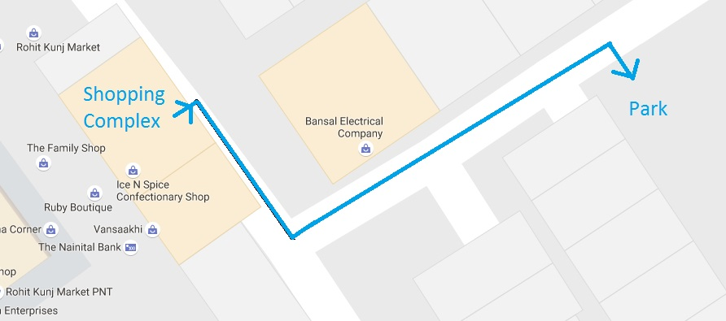This park is just 120 m from the market complex and can be used in case of any emergency by the whole colony to protect themselves from Earthquakes.

### Retreat Zone

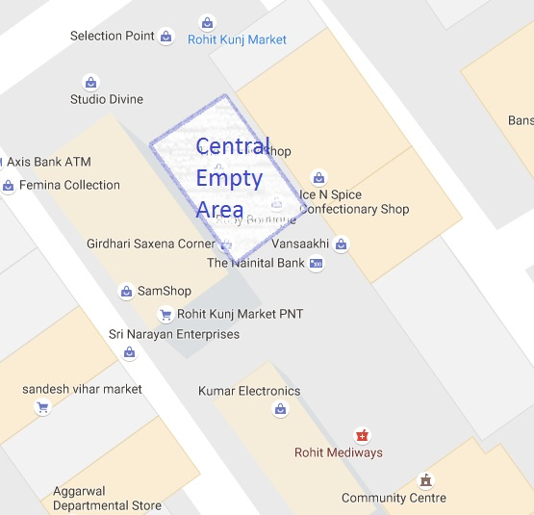This is a central area between the Market complex which is empty of any carts or shops and can be used as a safe zone in case of any emergency where anyone can easily retreat from fire or falling debris.

### Nearest Hospital (Max Super Specialty Hospital)

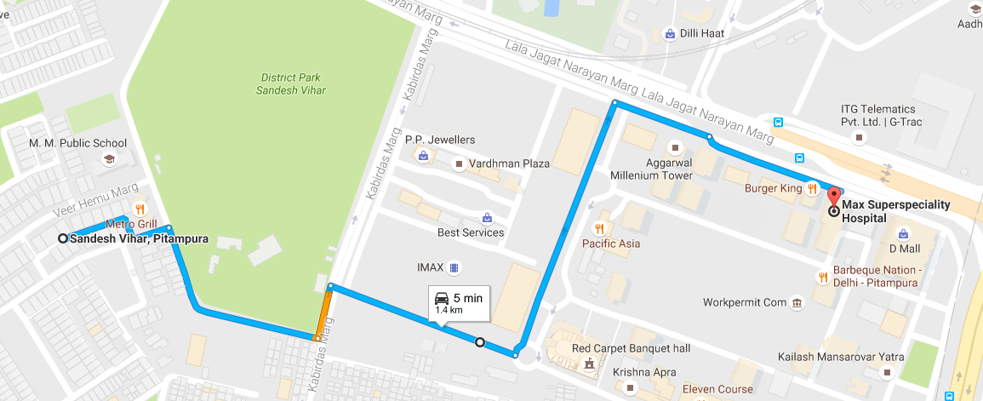This is the nearest hospital to the D.D.A Rohit Kunj Market Complex which is only a meager 1.4 km away from the disaster site and can be reached within a matter of minutes in case of emergency.

### Nearest Police Station

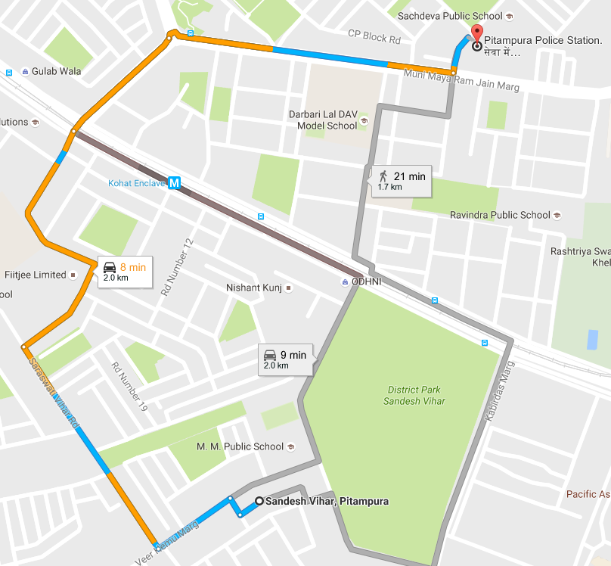

The police station at Deepali chowk is the nearest police station in the vicinity of the Rohit Kunj D.D.A. Market Complex which is only 2 km away and can be easily used in a case of disaster emergency.

### Fire Station

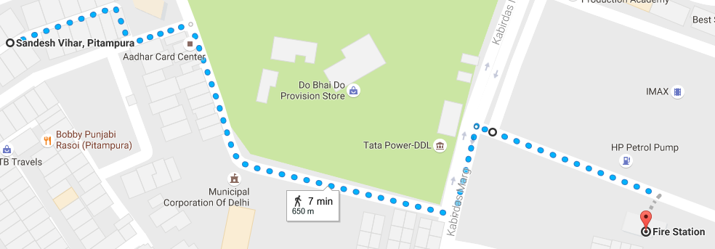This is the nearest fire station in the vicinity of the disaster and a fire truck at it’s average speed can reach us in under 5 min, but due to the size of our colony gate being small and also multiple cars being parked at the entry gate making the road even narrower it would be impossible for a fire truck to enter the colony in time hence making the market place extremely vulnerable to a fire hazard. This situation is further aggravated by the fact that no one in the market place owns a fire extinguisher or that there is no hose or water outlet in the market at all!

To conclude, I would like to report that the fire truck is ready for us, but we are not ready to protect our assets from a fire any time soon, fire truck there or not.

## Vulnerable Locations

In my assessment of the D.D.A. Rohit Kunj Market Complex I found several vulnerable locations in the complex. First of all there was a very big kitchen in the central market that dealed with several gas cylinders and oil every day from 9:00 in the morning to up to 11:00 in the night with no counter measure for any fire.

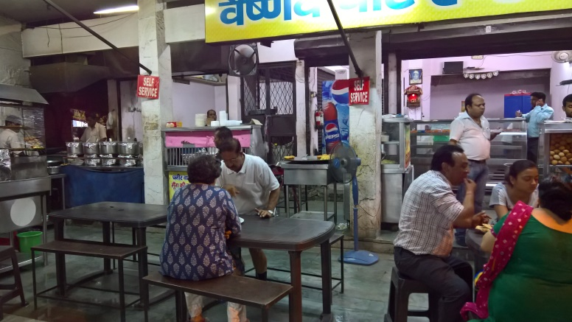 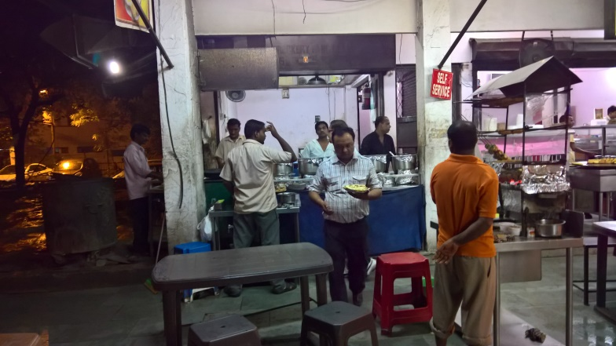

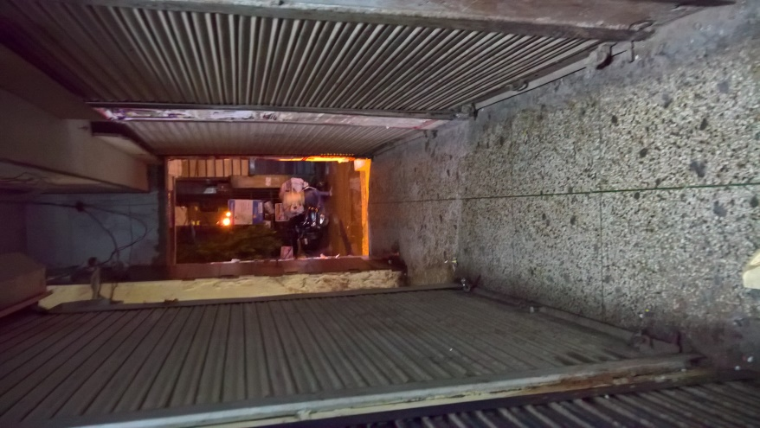Another disadvantage of the shop is the very narrow passage lanes between consecutive shops and no way to figure out whether one shop is part of one building or the other. These passage lanes are run everywhere. The first floor of the complex is built in a similar haphazard manner and the shops have expanded in another haphazard manner, some expanding behind and others across and some expanding by purchasing the land directly above them and breaking the walls just to make a staircase.

This arrangement of narrow passageways is very dangerous because if any of the shops were to catch fire, due to the proximity of the other shops, the whole D.D.A Rohit Kunj Market Complex will be in danger of catching fire. The narrow passageways will make it easier for fire to spread from one shop to another and difficult for people to get out of the complex using the passageways, trapping people inside until the fire is put out. The department responsible for putting out fire cannot access our market due to the narrow roads and hence the fire truck will be of no use. Also, there is no fire extinguisher in the market and no water hose making it impossible for anyone inside the market to put out the fire, making these narrow passageways much more risky than they look.

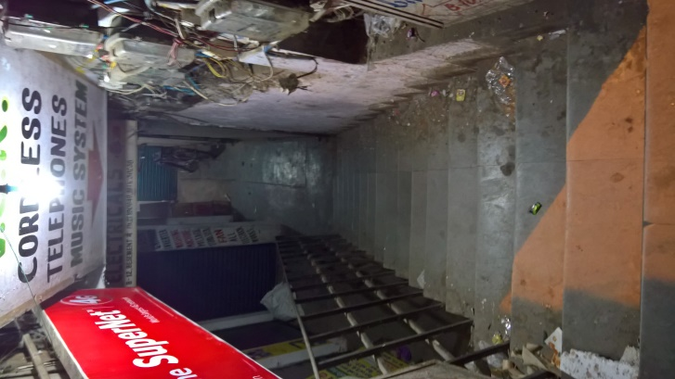The shop consists of a basement complex which is at maximum risk in case of any disaster or fire. The basement complex consists of congested shops only a total of 3 passageways to get out. It isn’t equipped with any sort of safety device at all!

The basement consists usually shops related to electrical devices, LED’s and their repairs. Every other shop has a soldering iron and other such heavy instruments which can be extremely dangerous. The effect is only compounded by the fact that all of them deal in this business and are located at such a close proximity in area with almost no exit makes the situation extremely dangerous.

The market complex also has a first floor which is almost an exact replica of the basement; narrow passageways, small shops, heavily congested on only a limited 3 exits. The building is poorly constructed and the shops more so. In case of an Earthquake the building will not be able to take it due to all the faulty construction and the waning strength of the old building. The shops will definitely collapse at some places more so than the others creating a rift on the first floor of the market and causing the people to be trapped. In case of a fire there is only one exit of each section and if it were to be blocked, no one could be saved.

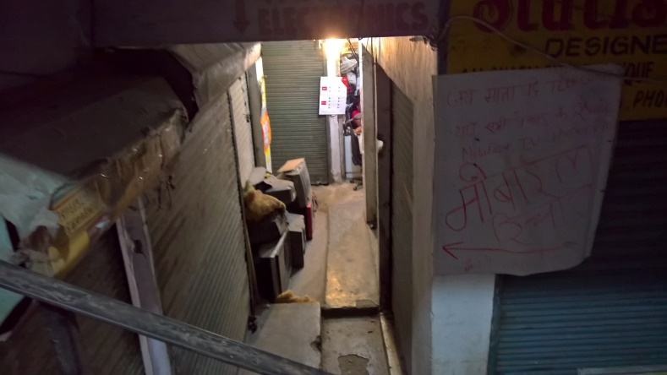

## Resource Map

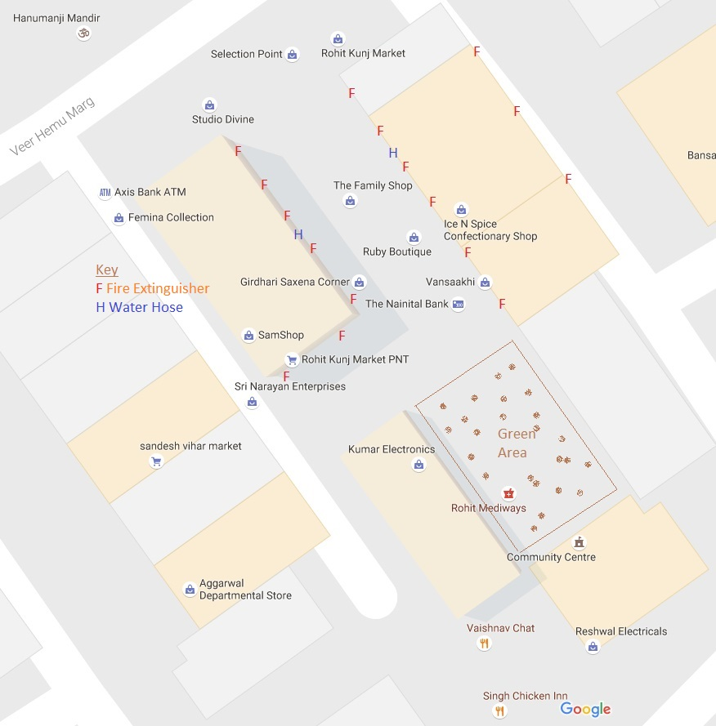

This is the ideal resource map that our building should possess. In inclusion to this map our building should also be equipped with fire alarms on the first floor and especially in the basement (Unable to show that on the map). This map also includes a very good green area that will help beautify the complex and is also environment friendly. It also acts as a safe zone in any case of disaster.

## Evacuation Map

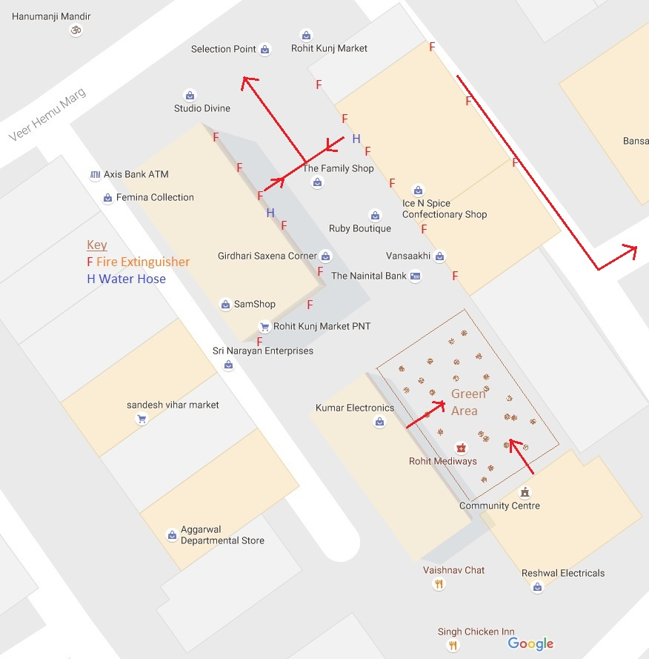

People facing the front street should move towards the street and away from the complex. People that are in a central position in the complex should move towards the empty area and head out of the complex towards the road, whilst calling for help. People that are far away from the open ground that exits into the road can go to the safe ground right in front of them and stay there as the it is a safe place and exit once the situation has been handled.

# C:\Users\Family\Desktop\Major_Disasters_in_India.jpgTask 4: Building Safe Environment

## India’s Disaster Management

India has been traditionally vulnerable to natural disasters on account of its unique geo-climatic conditions. Floods, droughts, cyclones, earthquakes and landslides have been a recurrent phenomena. About 60% of the landmass is prone to earthquakes of various intensities; over 40 million hectares is prone to floods; about 8% of the total area is prone to cyclones and 68% of the area is susceptible to drought. In the decade 1990-2000, an average of about 4344 people lost their lives and about 30 million people were affected by disasters every year. The loss in terms of private, community and public assets has been astronomical.

At the global level, there has been considerable concern over natural disasters. Even as substantial scientific and material progress is made, the loss of lives and property due to disasters has not decreased. In fact, the human toll and economic losses have mounted. It was in this background that the United Nations General Assembly, in 1989, declared the decade 1990-2000 as the International Decade for Natural Disaster Reduction with the objective to reduce loss of lives and property and restrict socio-economic damage through concerted international action, especially in developing countries.

The super cyclone in Orissa in October, 1999 and the Bhuj earthquake in Gujarat in January, 2001 underscored the need to adopt a multi-dimensional endeavor involving diverse scientific, engineering, financial and social processes; the need to adopt multi-disciplinary and multi sectorial approach and incorporation of risk reduction in the developmental plans and strategies.

The political scenario and the Institutions that are required in a country during a disaster are largely in place in India, but as these are governed by a lot of corruption, bad politics, red tapism and don’t function properly. Due to this many a times the complete action that needs to be taken in a situation is not taken and the situation is not resolved with a vigor as it should be, hence the disaster sites and the victims of a disaster suffer despite the fact that many NGO’s and even the government seem to cooperate and provide funds. So, institutionally speaking our country is well equipped for a disaster and is also very proactive in disaster management, but functionally is not what it should be.

### Some Terrestrial Disasters

## Government Agencies in Disaster Management

Over the past couple of years, the Government of India has brought about a paradigm shift in the approach to disaster management. The new approach proceeds from the conviction that development cannot be sustainable unless disaster mitigation is built into the development process. Another corner stone of the approach is that mitigation has to be multi-disciplinary spanning across all sectors of development. The new policy also emanates from the belief that investments in mitigation are much more cost effective than expenditure on relief and rehabilitation.

The governments, including India’s have a framework in place that is implemented in case of disasters which includes the following processes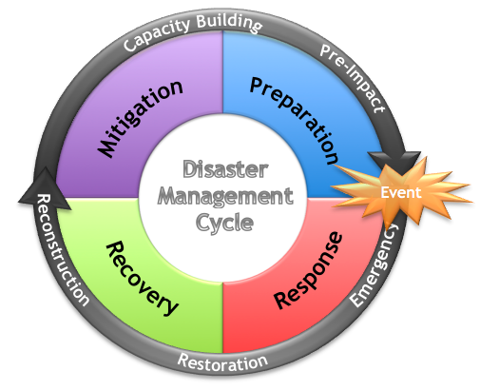:-

**National Crisis Management Committee (NCMC):** Cabinet Secretary, who is the highest executive officer, heads the NCMC. Secretaries of all the concerned Ministries /Departments as well as organizations are the members of the Committee The NCMC gives direction to the Crisis Management Group as deemed necessary. The Secretary, Ministry of Home Affairs is responsible for ensuring that all developments are brought to the notice of the NCMC promptly. The NCMC can give directions to any Ministry/Department/Organization for specific action needed for meeting the crisis situation.

**Crisis Management Group:** The Central Relief Commissioner in the Ministry of Home Affairs is the Chairman of the CMG, consisting of senior officers (called nodal officers) from various concerned Ministries. The CMG’s functions are to review every year contingency plans formulated by various Ministries/Departments/Organizations in their respective sectors, measures required for dealing with natural disasters, coordinate the activities of the Central Ministries and the State Governments in relation to disaster preparedness and relief and to obtain information from the nodal officers on measures relating to above. The CMG, in the event of a natural disaster, meets frequently to review the relief operations and extend all possible assistance required by the affected States to overcome the situation effectively. The Resident Commissioner of the affected State is also associated with such meetings

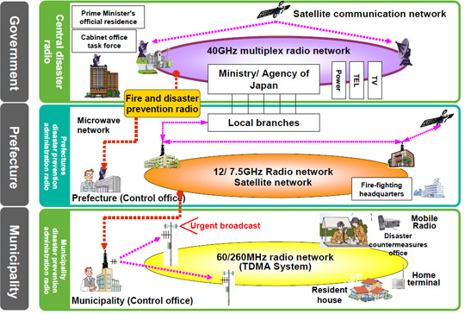**Control Room (Emergency Operation Room):** An Emergency Operations Center (Control Room) exists in the nodal Ministry of Home Affairs, which functions round the clock, to assist the Central Relief Commissioner in the discharge of his duties. The activities of the Control Room include collection and transmission of information concerning natural calamity and relief, keeping close contact with governments of the affected States, interaction with other Central Ministries/Departments/Organizations in connection with relief, maintaining records containing all relevant information relating to action points and contact points in Central Ministries etc., keeping up-to-date details of all concerned officers at the Central and State levels.

**Contingency Action Plan:** A National Contingency Action Plan (CAP) for dealing with contingencies arising in the wake of natural disasters has been formulated by the Government of India and it had been periodically updated. It facilitates the launching of relief operations without delay. The CAP identifies the initiatives required to be taken by various Central Ministries/Departments in the wake of natural calamities, sets down the procedure and determines the focal points in the administrative machinery.

**State Relief Manuals:** Each State Government has relief manuals/codes which identify that role of each officer in the State for managing the natural disasters. These are reviewed and updated periodically based on the experience of managing the disasters and the need of the State.

**Funding mechanisms:** The policy and the funding mechanism for provision of relief assistance to those affected by natural calamities is clearly laid down. These are reviewed by the Finance Commission appointed by the Government of India every five years. The Finance Commission makes recommendation regarding the division of tax and non-tax revenues between the Central and the State Governments and also regarding policy for provision of relief assistance and their share of expenditure thereon. A Calamity Relief Fund (CRF) has been set up in each State as per the recommendations of the Eleventh Finance Commission. The size of the Calamity Relief Fund has been fixed by the Finance Commission after taking into account the expenditure on relief and rehabilitation over the past 10 years. The Government of India contributes 75% of the corpus of the Calamity Relief Fund in each State. 25% is contributed to by the State. Relief assistance to those affected by natural calamities is granted from the CRF. Overall norms for relief assistance are laid down by a national committee with representatives of States as members. Different States can have State specific norms to be recommended by State level committee under the Chief Secretary. Where the calamity is of such proportion that the funds available in the CRF will not be sufficient for provision of relief, the State seeks assistance from the National Calamity Contingency Fund (NCCF) - a fund created at the Central Government level. When such requests are received, the requirements are assessed by a team from the Central Government and thereafter the assessed requirements are cleared by a High Level Committee chaired by the Deputy Prime Minister. In brief, the institutional arrangements for response and relief are well established and have proved to be robust and effective.

This is the fundamental framework used by governments in case of disaster management to reduce losses and to call upon a quick action without people panicking where everyone has a pre requisite job which is carried out efficiently. Reduced loss of assets, both government and personal and also a quick relief to the victims of the disasters are only some of the advantages of disaster risk reduction.

## How Do We Prepare Against Disasters?

We can also better prepare against disasters and especially Earthquakes by following these simple steps:

1. Have an earthquake readiness plan.
2. Consult a professional to learn how to make your home sturdier, such as bolting bookcases to wall studs, installing strong latches on cupboards, and strapping the water heater to wall studs.
3. Locate a place in each room of the house that you can go to in case of an earthquake. It should be a spot where nothing is likely to fall on you.
4. Keep a supply of canned food, an up-to-date first aid kit, 3 gallons (11.4 liters) of water per person, dust masks and goggles, and a working battery-operated radio and flashlights.

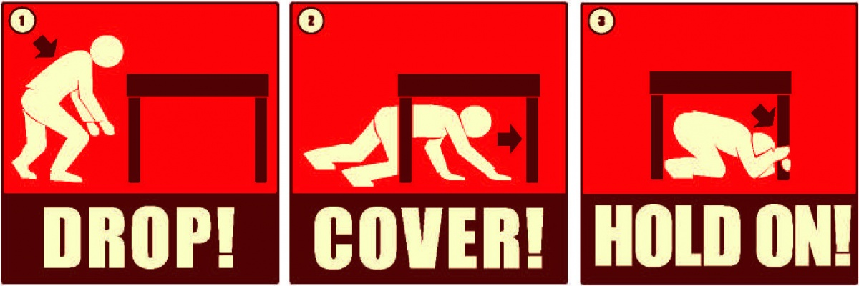

In case if shaking starts:

1. Drop down; take cover under a desk or table and hold on.
2. Stay indoors until the shaking stops and you're sure it's safe to exit.
3. Stay away from bookcases or furniture that can fall on you.
4. Stay away from windows. In a high-rise building, expect the fire alarms and sprinklers to go off during a quake.
5. If you are in bed, hold on and stay there, protecting your head with a pillow.
6. If you are outdoors, find a clear spot away from buildings, trees, and power lines. Drop to the ground.
7. If you are in a car, slow down and drive to a clear place. Stay in the car until the shaking stops.

All family members should know how and when to turn off the utilities: gas, electric and water.

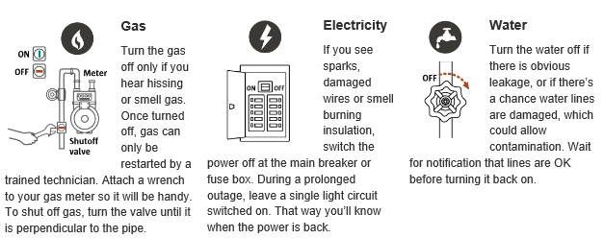

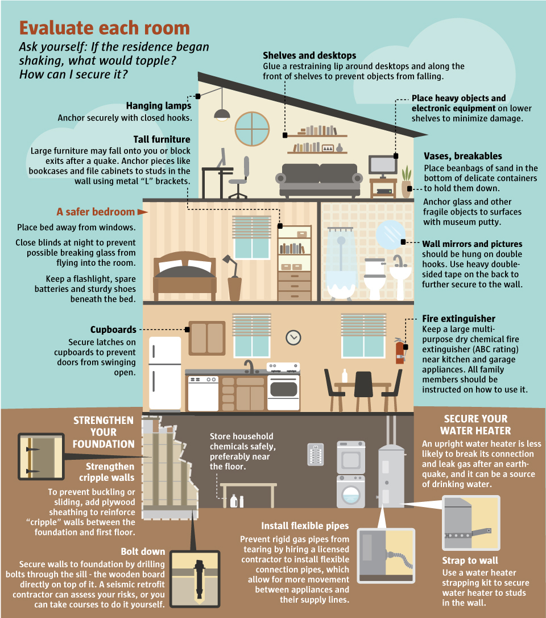

## Safe Community Builds Safe Nation

We all live in a community, a society and can only survive if we co-exist harmoniously with each other. In cases of a disaster or any other emergency we must strive to help each other, as we live in a common community and must help each other, as we would expect ourselves to be helped if we were in any trouble.

We can help each other by calling out the necessary helplines in case of any disaster, as whosever in the community will call for help the fastest will benefit not just himself, but the whole community to whom the help will arrive.

The community an also collaborate in the building of the common areas in the colonies such as colony markets, parks etc. that are common to the community to make sure that they are accessible during any disaster and also that their construction isn’t faulty taking care of their infrastructure and evacuation planning during the construction itself.

The community can also lead various campaigns in their respective communities and at their own level to increase awareness about disasters and conduct drills such as evacuation drills and other such practices to make the people completely aware about the various disaster situations and also well prepared.

The communities of our nations and the world form an aggregate that we call nations. If the communities are safe at their level, so will the nation be, hence “A safe community builds a safe nation and safe world”.

Fascinations breeds preparedness, and preparedness, survival.

~Peter Benchley

# Task 5: Awareness Generation

I created a blog about disaster awareness, especially earthquakes in 2013 on my brother’s Google ID on Blogger (Google’s Blogging Tool). Link: <http://fightagainstearthquake.blogspot.in/>

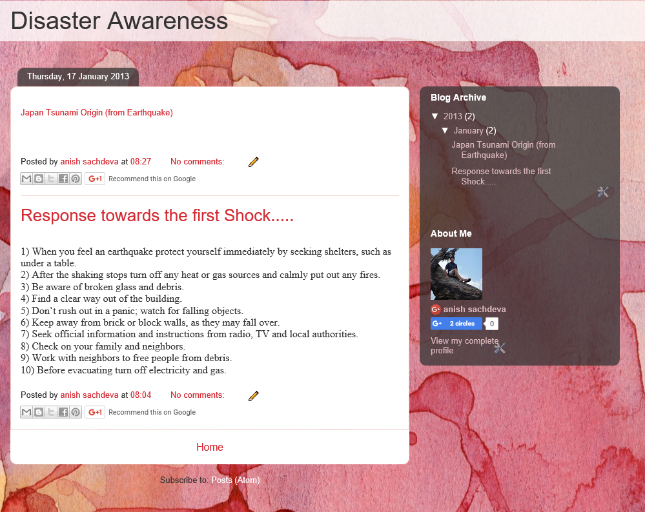

# Annexure

## Questionnaire

Full Name\_\_\_\_\_\_\_\_\_\_\_\_\_\_\_\_\_\_\_\_\_\_\_\_\_\_\_\_\_\_\_\_\_\_\_\_\_\_\_\_\_\_\_\_\_\_\_\_\_\_\_\_\_\_\_\_\_\_\_\_\_\_\_\_\_\_\_\_\_\_\_\_\_\_\_\_\_\_\_\_\_\_\_\_\_

Age \_\_\_\_\_\_\_\_\_\_\_\_\_

Address\_\_\_\_\_\_\_\_\_\_\_\_\_\_\_\_\_\_\_\_\_\_\_\_\_\_\_\_\_\_\_\_\_\_\_\_\_\_\_\_\_\_\_\_\_\_\_\_\_\_\_\_\_\_\_\_\_\_\_\_\_\_\_\_\_\_\_\_\_\_\_\_\_\_\_\_\_\_\_\_\_\_\_\_\_\_\_\_

Job Occupation\_\_\_\_\_\_\_\_\_\_\_\_\_\_\_\_\_\_\_\_\_\_\_\_\_\_\_\_\_\_\_\_\_\_\_\_\_\_\_\_\_\_\_\_\_\_\_\_\_\_\_\_\_\_\_\_\_\_\_\_\_\_\_\_\_\_\_\_\_\_\_\_\_\_\_\_\_\_\_\_\_\_

What do you know about Earthquakes and the disaster that they can cause? \_\_\_\_\_\_\_\_\_\_\_\_\_\_\_\_\_\_\_\_\_\_\_\_\_\_\_\_\_\_\_\_\_\_\_\_\_\_\_\_\_\_\_\_\_\_\_\_\_\_\_\_\_\_\_\_\_\_\_\_\_\_\_\_\_\_\_\_\_\_\_\_\_\_\_\_\_\_\_\_\_\_\_\_\_\_\_\_\_\_\_\_\_\_\_\_\_\_\_\_\_\_\_\_\_\_\_\_\_\_\_\_\_\_\_\_\_\_\_\_\_\_\_\_\_\_\_\_\_\_\_\_\_\_\_\_\_\_\_\_\_\_\_\_\_\_\_\_\_\_\_\_\_\_\_\_\_\_\_\_\_\_\_\_\_\_\_\_\_\_\_\_\_\_\_\_\_\_\_\_\_\_\_\_\_\_\_\_\_\_\_\_\_\_\_\_\_\_\_\_\_\_\_\_\_\_\_\_\_\_\_\_\_\_\_\_\_\_\_\_\_\_\_\_\_\_\_\_\_\_\_\_\_\_\_\_\_\_\_\_\_\_\_\_\_\_\_\_\_\_\_\_\_\_\_\_\_\_\_\_\_\_\_\_\_\_\_\_\_\_\_\_\_\_\_\_\_\_\_\_\_\_

Is your shop/home prone to earthquakes?\_\_\_\_\_\_\_\_\_\_\_\_\_\_\_\_\_\_\_\_\_\_\_\_\_\_\_\_\_\_\_\_\_\_\_\_\_\_\_\_\_\_\_\_\_\_\_\_\_\_\_\_\_\_\_\_\_\_\_\_

Have you ever experienced any tremors in your lifetime? How did you respond to the situation? Did you panic? What did you do, please describe? \_\_\_\_\_\_\_\_\_\_\_\_\_\_\_\_\_\_\_\_\_\_\_\_\_\_\_\_\_\_\_\_\_\_\_\_\_\_\_\_\_\_\_\_\_\_\_\_\_\_\_\_\_\_\_\_\_\_\_\_\_\_\_\_\_\_\_\_\_\_\_\_\_\_\_\_\_\_\_\_\_\_\_\_\_\_\_\_\_\_\_\_\_\_\_\_\_\_\_\_\_\_\_\_\_\_\_\_\_\_\_\_\_\_\_\_\_\_\_\_\_\_\_\_\_\_\_\_\_\_\_\_\_\_\_\_\_\_\_\_\_\_\_\_\_\_\_\_\_\_\_\_\_\_\_\_\_\_\_\_\_\_\_\_\_\_\_\_\_\_\_\_\_\_\_\_\_\_\_\_\_\_\_\_\_\_\_\_\_\_\_\_\_\_\_\_\_\_\_\_\_\_\_\_\_\_\_\_\_\_\_\_\_\_\_\_\_\_\_\_\_\_\_\_\_\_\_\_\_\_\_\_\_\_\_\_\_\_\_\_\_\_\_\_\_\_\_\_\_\_\_\_\_\_\_\_\_\_\_\_\_\_\_\_\_\_\_\_\_\_\_\_\_\_\_\_\_\_\_\_\_\_\_\_\_\_\_\_\_\_\_\_\_\_\_\_\_\_\_\_\_\_\_\_\_\_\_\_\_\_\_\_\_\_\_\_\_\_\_\_\_\_\_\_\_\_\_\_\_\_\_\_\_\_\_\_\_\_\_\_\_\_\_\_\_\_\_\_\_\_\_\_\_\_\_\_\_\_\_\_\_\_\_\_\_\_\_\_\_\_\_\_\_\_\_\_

What would you do if you ever felt tremors at your shop? \_\_\_\_\_\_\_\_\_\_\_\_\_\_\_\_\_\_\_\_\_\_\_\_\_\_\_\_\_\_\_\_\_\_\_\_\_\_\_\_\_\_\_\_\_\_\_\_\_\_\_\_\_\_\_\_\_\_\_\_\_\_\_\_\_\_\_\_\_\_\_\_\_\_\_\_\_\_\_\_\_\_\_\_\_\_\_\_\_\_\_\_\_\_\_\_\_\_\_\_\_\_\_\_\_\_\_\_\_\_\_\_\_\_\_\_\_\_\_\_\_\_\_\_\_\_\_\_\_\_\_\_\_\_\_\_\_\_\_\_\_\_\_\_\_\_\_\_\_\_\_\_\_\_\_\_\_\_\_\_\_\_\_\_\_\_\_\_\_\_\_\_\_\_\_\_\_\_\_\_\_\_\_\_\_\_\_\_\_\_\_\_\_\_\_\_\_\_\_\_\_\_\_\_\_\_\_\_\_\_\_\_\_\_\_\_\_\_\_\_\_\_\_\_\_\_\_\_\_\_\_\_\_\_\_\_\_\_\_\_\_\_\_\_\_\_\_\_\_\_\_\_\_\_\_\_\_\_\_\_\_\_\_\_\_\_\_\_\_\_\_\_\_\_\_\_\_\_\_\_\_\_

Do you have any evacuation plan or any other contingency for such a happening? \_\_\_\_\_\_\_\_\_\_\_\_\_\_\_\_\_\_\_\_\_\_\_\_\_\_\_\_\_\_\_\_\_\_\_\_\_\_\_\_\_\_\_\_\_\_\_\_\_\_\_\_\_\_\_\_\_\_\_\_\_\_\_\_\_\_\_\_\_\_\_\_\_\_\_\_\_\_\_\_\_\_\_\_\_\_\_\_\_\_\_\_\_\_\_\_\_\_\_\_\_\_\_\_\_\_\_\_\_\_\_\_\_\_\_\_\_\_\_\_\_\_\_\_\_\_\_\_\_\_\_\_\_\_\_\_\_\_\_\_\_\_\_\_\_\_\_\_\_\_\_\_\_\_\_\_\_\_\_\_\_\_\_\_\_\_\_\_\_\_\_\_\_\_\_\_\_\_\_\_\_\_\_\_\_\_\_\_\_\_\_\_\_\_\_\_\_\_\_\_\_\_\_\_\_\_\_\_\_\_\_\_\_\_\_\_\_\_\_\_\_\_\_\_\_\_\_\_\_\_\_\_\_\_\_\_\_\_\_\_\_\_\_\_\_\_\_\_\_\_\_\_\_\_\_\_\_\_\_\_\_\_\_\_\_\_\_\_\_\_\_\_\_\_\_\_\_\_\_\_\_\_

Are you aware of the Richter scale and what do the readings mean? \_\_\_\_\_\_\_\_\_\_\_\_\_\_\_\_\_\_\_\_\_\_\_\_\_\_\_\_\_\_\_\_\_\_\_\_\_\_

What damage would an average earthquake of 5 Richter scale cause to your unit/home? \_\_\_\_\_\_\_\_\_\_\_\_\_\_\_\_\_\_\_\_\_\_\_\_\_\_\_\_\_\_\_\_\_\_\_\_\_\_\_\_\_\_\_\_\_\_\_\_\_\_\_\_\_\_\_\_\_\_\_\_\_\_\_\_\_\_\_\_\_\_\_\_\_\_\_\_\_\_\_\_\_\_\_\_\_\_\_\_\_\_\_\_\_\_\_\_\_\_\_\_\_\_\_\_\_\_\_\_\_\_\_\_\_\_\_\_\_\_\_\_\_\_\_\_\_\_\_\_\_\_\_\_\_\_\_\_\_\_\_\_\_\_\_\_\_\_\_\_\_\_\_\_\_\_\_\_\_\_\_\_\_\_\_\_\_\_\_\_\_\_\_\_\_\_\_\_\_\_\_\_\_\_\_\_\_\_\_\_

Have you ever taken part of a mock drill in your society or educational institute? ­­­­­­­­­­­­­­­­­­­­­­­­­­­­­­­­­­­­­­­­­­­­\_\_\_\_\_\_\_\_\_\_\_\_\_\_\_\_\_\_\_\_\_\_\_\_\_\_\_\_

Have you ever discussed disaster preparedness with your family and kids? \_\_\_\_\_\_\_\_\_\_\_\_\_\_\_\_\_\_\_\_\_\_\_\_\_\_\_\_\_\_\_\_\_

Do you have any resource in the building that can be used in case of a disaster emergency? \_\_\_\_\_\_\_\_\_\_\_\_\_\_\_\_\_\_\_\_\_\_\_\_\_\_\_\_\_\_\_\_\_\_\_\_\_\_\_\_\_\_\_\_\_\_\_\_\_\_\_\_\_\_\_\_\_\_\_\_\_\_\_\_\_\_\_\_\_\_\_\_\_\_\_\_\_\_\_\_\_\_\_\_\_\_\_\_\_\_\_\_\_\_\_\_\_\_\_\_\_\_\_\_\_\_\_\_\_\_\_\_\_\_\_\_\_\_\_\_\_\_\_\_\_\_\_\_\_\_\_\_\_\_\_\_\_\_\_\_\_\_\_\_\_\_\_\_\_\_\_\_\_\_\_\_\_\_\_\_\_\_\_\_\_\_\_\_\_\_\_\_\_\_\_\_\_\_\_\_\_\_\_\_\_\_\_\_

# Bibliography

## Websites

1. Google (Search Engine)

[www.google.com](http://www.google.com)

1. Wikipedia (Online Encyclopedia)

[www.wikipedia.com](http://www.wikipedia.com)

1. Map Report (Disaster Website)

[www.mapreport.com/subtopics/d/countries/india.html](http://www.mapreport.com/subtopics/d/countries/india.html)

1. Bing (Search engine)

[www.bing.com](http://www.bing.com)

1. Quotes Website

[www.brainyquote.com/quotes/keywords/earthquake.html](http://www.brainyquote.com/quotes/keywords/earthquake.html)

1. Google Maps

[www.maps.google.com](http://www.maps.google.com)

1. Prevention from Earthquakes

<http://old.seattletimes.com/html/localpages/2021941030_earthquakegraphic.html>

## Online PDF’s

1. Disaster management in India

[www.unisdr.org/2005/mdgs-drr/national-reports/India-report.pdf](http://www.unisdr.org/2005/mdgs-drr/national-reports/India-report.pdf)

## Books

1. NCERT Geography Textbook

Chapter: Climate